**MAHATMA GANDHI MEMORIAL COLLEGE**

**UDUPI – 576102**

**Accredited by NAAC with “A+” Grade (CGPA 3.36)**



**2023-2024**

**PROJECT REPORT ON**

**“IKSHAK JEWELLERS”**

**DEVELOPED BY**

**Dhanyashree U05MG21S0126**

**Varshini. R U05MG21S0161**

**Aishwarya U05MG21S0148**

**Under The Guidance Of**

**“Prof. Rashmi”**

**Department of Computer Science**

**Submitted to the Mangalore University in partial fulfilment of the**

**Award Bachelor in Computer Application**

**MANGALORE UNIVERSITY**

**DEPARTMENT OF COMPUTER SCIENCE**

**MAHATMA GANDHI MEMORIAL COLLEGE**

**UDUPI –576102**

**2023 –2024**

**INDEX**

|  |  |  |  |
| --- | --- | --- | --- |
| **Chapter No** |  | **Title** | **P.No** |
| **1** |  | **Introduction** | 1 |
| **i)** | **Introduction of the System** | 1 |
|  | **a) Project Title** | 1 |
|  | **b) Category** | 1 |
| **ii)** | **Objective of the system** | 1 |
| **iii)** | **Scope of the System** | 1 |
| **iv)** | **Structure of the system** | 2 |
| **v)** | **System architecture** | 2 |
| **vi)** | **Software/Hardware used for the developments** | 3 |
| **2** |  | **SRS** | 4 |
| **i)** | **Introduction** | 4 |
| **ii)** | **Overall Description** | 4 |
|  | **a) Product Perspective** | 4 |
|  | **b) Product Functions** | 4 |
|  | **c) User Characteristics** | 4 |
|  | **d) General Constraints** | 5 |
|  | **e) Assumptions** | 5 |
| **iii)** | **Special Requirements** | 5 |
| **iv)** | **Functional Requirements** | 5 |
|  | **a) Module 1** | - |
|  | **b) Module 2** | - |
| **v)** | **Design Constraints** | 6 |
| **vi)** | **System Attributes** | 6 |
| **vii)** | **Other Requirements** | 7 |
| **3** |  | **System Design** | 8 |
| **i)** | **Context Flow Diagram** | 8 |
| **ii)** | **Data Flow Diagram** | 9-11 |  |

|  |  |  |  |
| --- | --- | --- | --- |
| **4** |  | **Database Design** | 12 |
| **i)** | **Introduction** | 12 |
| **ii)** | **Purpose and Scope** | 12 |
| **iii)** | **Table Definition** | 13-16 |
| **iv)** | **Data Dictionary** | 16-18 |
| **v)** | **ER Diagram** | 19-21 |
| **5** |  | **Program Code Listing** | 22-58 |
| **6** |  | **User Interface** | 59-68 |
| **i)** | **Login** | - |
| **ii)** | **Main screen / Home page** | - |
| **iii)** | **Validation** | - |
| **iv)** | **View** | - |
| **v)** | **On screen reports** | - |
| **vi)** | **Data Reports** | - |
| **7** | **Testing** | | 69 |
| **Introduction** | | 70 |
| **ii) Test Reports** | | 71-75 |
| **a) Unit Testing** | | - |
| **b) Integrate Testing** | | - |
| **c) System Testing** | | - |
|  | **Limitations** | | 76 |
|  | **Scope for enhancement** | | 76 |
|  | **Abbreviations and Acronyms** | | 76 |
|  | **Bibilography / Referrences** | | 76 |

**ACKNOWLEDGEMENT**

Behind every achievement, there is a sea of gratitude to those who have activated this project. The magnitude of this project demanded the co-operation, guidance and help of many people. We have been fortunate enough to have this in the entire task of completion of our project on “**IKSHAK JEWELLERS**”.

We would like to thank our principal **Prof. Dr. Lakshmi Narayan Karanth** for giving us opportunity to carry out our project.

We thank **Mr. M. Vishwanath Pai**, a source of inspiration and encouragement, head of the Department of Computer Science, Mahatma Gandhi Memorial College, Udupi for having permitted us to carry out our project work.

We are extremely grateful to express our overwhelming gratitude to our guide **Prof. Rashmi**, Lecturer of Computer Science Department, Mahatma Gandhi Memorial College Udupi for giving us valuable guidance to undertake this project.

Last but not the least, we are indebted to all teaching and non-teaching staff members, Mahatma Gandhi Memorial College Udupi for making this project successful.

Thanking you

Dhanyashree

Varshini.R

Aishwarya

**1 Synopsis**

**1.1 Introduction**

The Automated Jewellery Management System Website aims to streamline the process of managing jewellery inventory, orders, and customer interactions through an automated online platform. The objectives include providing a user-friendly interface for clients to browse and purchase jewellery, enabling efficient inventory management for the host, and facilitating seamless transactions. The scope encompasses developing modules for login, sign-up, product browsing, order placement, and payment processing.

**1.1.1 Title of the project**

“IKSHAK JEWELLERS”

**1.1.2 Project Category**

Client Server/Web Application.

**1.2 Objectives**

* To create a secure and user-friendly website for jewellery management.
* To automate the process of ordering, payment of jewellery items.
* To provide customers with detailed information about jewellery designs, prices, and
* availability.
* To enable administrators to efficiently manage inventory, orders, and customer data.
* To enhance the overall customer experience by offering convenient online services.

**1.3 Scope:**

* Less time consumption.
* Clarity to the customer about the product ordered.
* system will include modules for managing inventory, user accounts, and administrative
* access.
* The scope of the project covers the development of key features such as user authentication, product listing, order management, payment processing.

**1.4 Structure Of The Project :**

**Modules used:**

* **Customer**
* Login
* Customer information
* View product
* Cart
* Wishlist
* Process order
* View Billing details
* Payment
* **Admin**
* Login
* Add/remove item
* View stock inventory
* View order details
* View payment details
* View customer details
* View feedbacks

**1.5 System Architecture:**

* **Admin:**

A module which is responsible for managing the entire website. An admin has a separate username and password. Has the supreme power to add, delete, and update the products and can access the database.

* **Login**: A module that authenticates the admin for his admin rights.
* **Add/Remove Item:** A module that allows the admin to add, delete, or update details of item.
* **View Stock Inventory**: This module provides the details of the available product.
* **View Order Details**: This module provides the details relating to the order, the description of the product, the cost of the product, etc.
* **View Payment Details:** This module provides the details about the payment done by the customer
* **Customer:**

A module that represents the buyer who browses products and places orders on the need on the website

* **Login**: A module that authenticates the user for his user rights.
* **Customer Information**: This module is used to store the information about the customer.
* **View Product**: This module is used to view the details of the product
* **Cart**: A cart is used to store the buying products.
* **Wishlist**: A wishlist is used to store the liked products of users.
* **Process Order**: This module allows the buyer to place order for the product of his interest.
* **View Billing Details**: This module generate a report which consist of total amount of product.
* **Payment**: This module allows buyers to pay for the product purchased in both online and offline module.

**1.6 Software/Hardware Used For The Development**

* **Hardware Requirement:**
* **Disk Space**: 8GB or more
* **RAM**: 4GB or more
* **OS**: Microsoft Windows 7 or later
* **Software Requirement:**
* **Operating System:** Microsoft Windows 7 or later
* **Programming Language:** PHP
* **Frontend:** HTML, CSS, JavaScript ,PHP
* **Back End:** SQL Server

**2.SRS**

**2.1 Introduction :**

A software Requirements Specification (SRS) is a document that describes what the software will do and how it will be expected to perform. It also describes the functionality the product need to fulfill all stakeholders need.

**2.2 Overall description**

**2.2.1 Product perspective**

The product of this project is software that reduces the work, that is handled manually by event manager. There are many modules to be maintained such as check availability module, booking services module, etc. Handling these modules is a different task for the admin. This product provides an easy way of maintaining detail

**2.2.2 Product functions**

The graphical user interface is provided by html css. This is user-friendly in nature. All the manual handling procedures for maintaining records of events are replaced by software. Admin can easily be known about the customer, feedback, order, payment, and cancelation information.

**2.2.3 User characteristics**

Users need to have minimum knowledge to use operate system. Admin needs the knowledge of computer as well as manage activities of discussion forum.

**Admin:**

The admin does all the main functions of the website such as

* Managing Categories.
* Managing images.
* Managing Quantity.

**User:**

* Selecting Categories.
* View Product
* Buy a product

**2.2.4 General constraints:**

* The developed system should run under any platform (Windows etc…) that Contains a web browser that supports PHP and JavaScript.
* Login and password are used for identification of the user
* Minimum 4GB RAM and Disk Space of 8GB or more.

**2.2.5Assumptions:**

* User should provide correct details about them.
* User should provide a valid username, email, phone number, security code and password to access the website.
* User has an active internet connection.

**2.3 Special Requirements**

* **External Interface Requirements:**

Not Applicable

* **User Interfaces:**

Each part of the user interface intends to be as user-friendly as possible. This application provides a good graphical interface for the user and the administrator to operate the system and perform the requested task. The fonts and buttons used will be intended to be very fast and easy to load on web pages.

* **Communication Interfaces:**

Communication interface deals with the communication between the users.

**2.4 Function requirements :**

* **Front end:**
* **HTML(Hyper Text Markup Language)**

It is the standard markup language for documents designed to be displayed in a web browser. It can be assisted by technologies such as cascading style sheets(CSS) and scripting languages such as JavaScript. Web browsers receive html documents into multimedia webpages. HTML describes the structure of a webpage semantically or originally included cues for the appearance of the document.

* **CSS(Cascading Style Sheets)**

It is a stylesheet language used for describing a presentation of a document written in a markup language like HTML. CSS is a corner store technology of the World Wide Web, alongside HTML and JavaScript. CSS is designed to enable the separation of presentation and content, including layout, colors, and fonts. This separation can improve content accessibility, provide more flexibility and control in specification of presentation characteristics, enable multiple webpages to share formatting by specifying the relevant CSS in a separate .css file, and reduce complexity and repetition in structural content.

* **PHP(Hypertext Pre-processor**)

PHP is a recursive acronym for PHP - “Hypertext Pre-processor”. PHP is a server-side scripting language that is embedded in HTML. It is used to manage dynamic content, database, session tracking, even build entire ecommerce sites. It is integrated with a number of popular database, including MySQL, PostgreSQL, Oracle, Sybase, Informix and Microsoft SQL server. PHP support a large number of major protocols such as P0P3, IMAP and LDAP. PHP4 added support for java and distributed data architecture(COM and COBRA), making n-tier development a possibility for the first time.

* **Back end:**

**• MySQL:**

MySQL is an open-source relational database management system. Its name is a combination of "My", the name of co-founder Michael Widenius's daughter My, and "SQL", the acronym for Structured Query Language. MySQL is a relational database management system. The database structure is organized into physical files optimized for speed. The logical data model, with objects such as data tables, views, rows, and columns, offers a flexible programming environment.

**2.5 Design constraints:**

* **Hardware constraints :**
* Processor Intel(R) Core(TM) required
* Minimum 4GB RAM required
* Minimum 40GB HARD DISK required

* **Software constraints :**
* Wamp server.
* MY SQL.

**2.6 System Attributes :**

* **Reliability**

The reliability of the system is the backup of the database which is continuously maintained and updated to reflect recent changes.

* **Availability:**

Available 24 X 7 only restricted by the downtime of the server on which the system runs.

**2.7 Performance Requirement:**

* **Hardware Interfaces:**
* **Processor** - Intel(R) Core(TM) i3-7020U CPU.
* **RAM** – 4GB.
* **Input Device** – Keyboard, mouse.
* **Output Device** – Monitor, Printer.

* **Software Interfaces:**
* **Operating System** – Windows 10.
* **Data Base** – MYSQL.
* **Front end** - HTML, CSS, JavaScript,PHP.
* **Back end -** MY SQL, PHP.

**3.System Design**

**3.1. Description of programs**

**3.1.1 Context Flow Diagram (CFD):**

* CFD are used to describe the detailed logic of a business process or a business rule.
* The Context Flow Diagram is one in which the entire system is treated as a single process.
* It lists all the major inputs and outputs of the system.
* It will show the flow of control through the different program.
* The CFD shows the external entity acting in the software.
* The process is shown here in CFD as a single process or a bubble

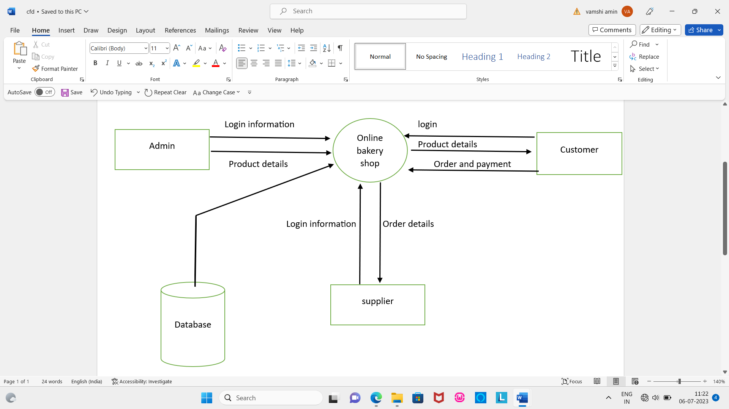

**3.1.2 Data Flow Diagram (DFD):**

The DFD is graphical representation that depicts information flow and the transforms that are applied as data move from input to output. The DFD may be used to represent a system or a software at any level of abstraction DFD’s may be partitioned into level’s that represent increasing information flow and functional details. The DFD’s provide a mechanism for functional modeling as well as information flow modeling.

A level ‘0’ DFD also called as fundamental system model or a context model represents the entire software element as a single bubble with input and output data indicated by incoming and outgoing arrows respectively

A level ’1’ DFD , the context diagram is decomposed into multiple bubbles/processes. In this level we highlight the main function of the system and break down the high level process of 0 level DFD into sub processes.

Level ‘2’ DFD goes one step deeper into parts of 1-level DFD. It can be used to plan or record the specific/necessary details about the systems functioning.

|  |  |
| --- | --- |
| **Notations** | **Description** |
|  | **Process:-**  A circle represents a process or transformation that is applied to the data or control and change it on same ways. |
|  | **Source or Sink:-**  A rectangle represents an external entity that is a system, element or another system that produces information for transformation by software or receives information produced by the software. |
|  | **Data Flow:-**  An arrow represents one or more data items or data objects. |
|  | **File or Database:-**  The open box represents data store, stored information that is used by the software. |

**Level 1 DFD**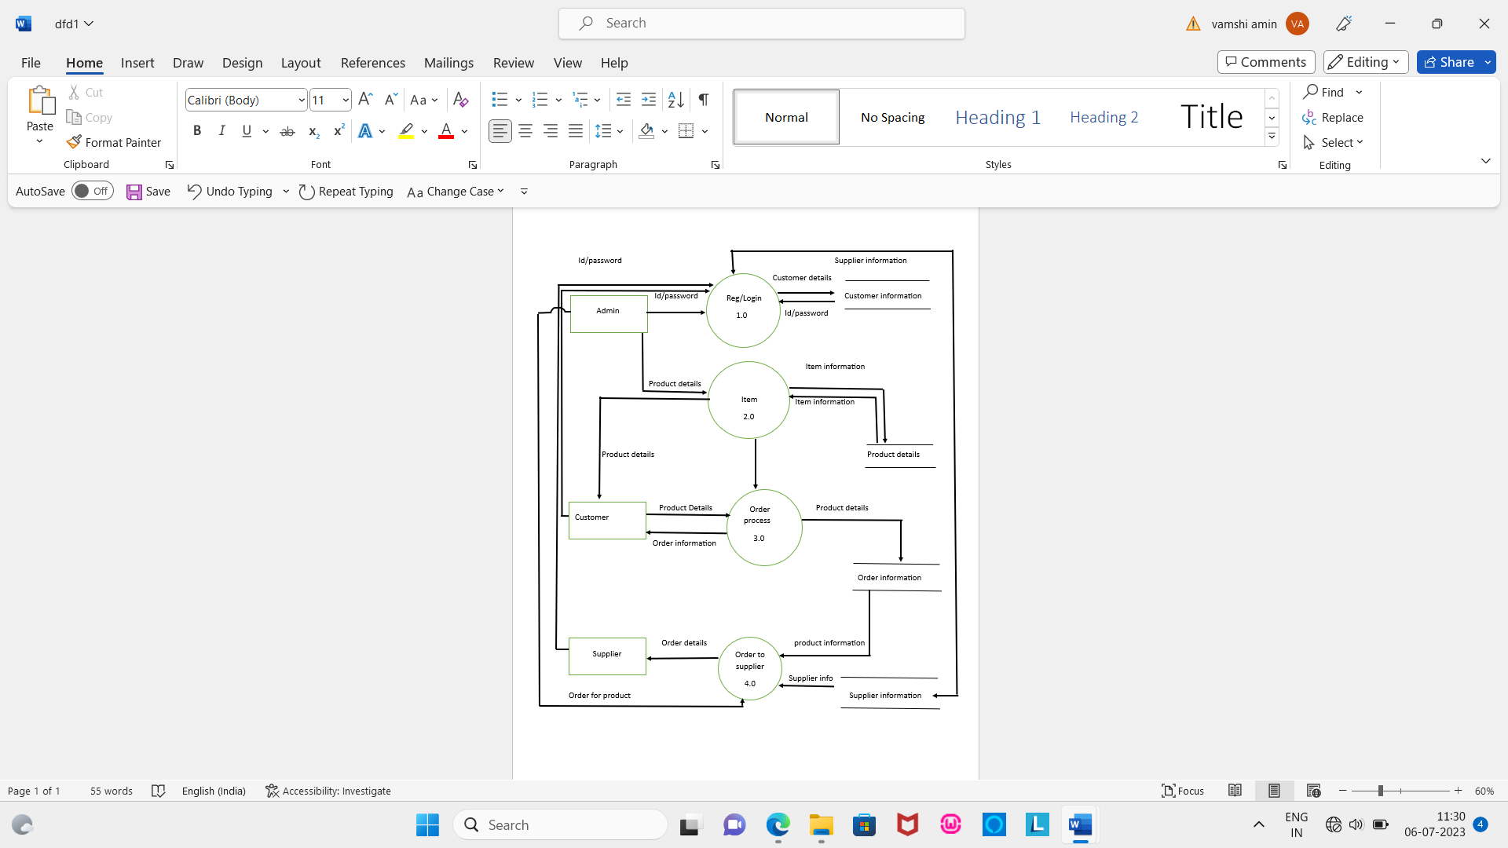

**Level 2 DFD**

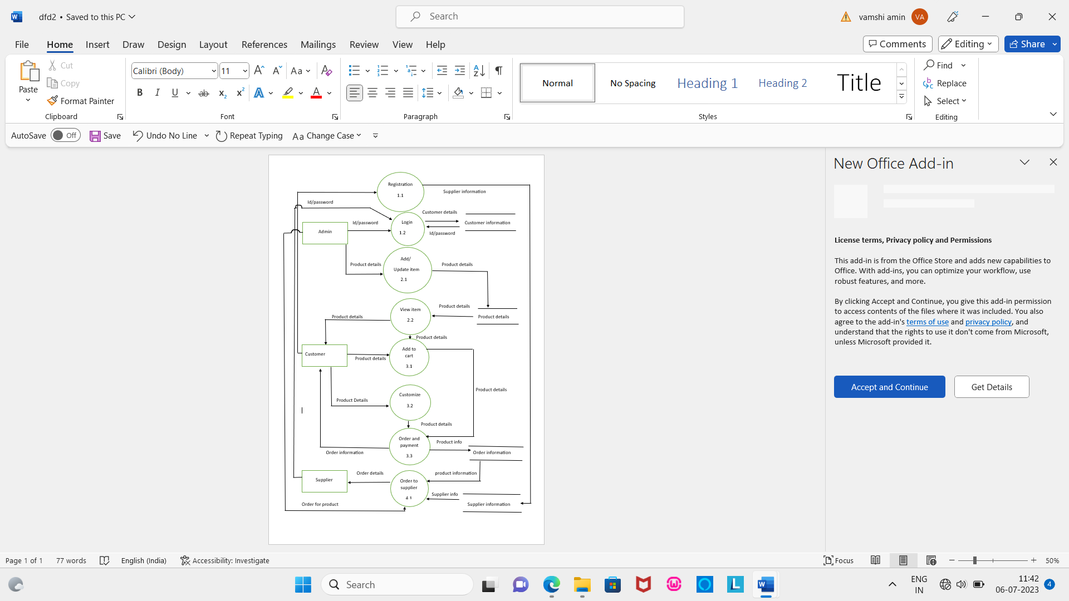

**4.Database Design**

**TCUSTOMER: SUPPLIER ORDER:**

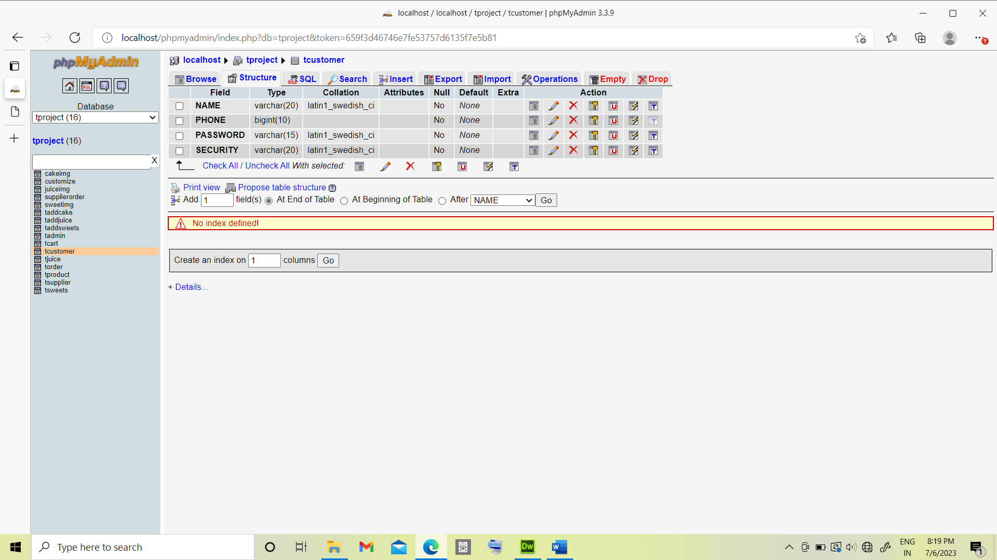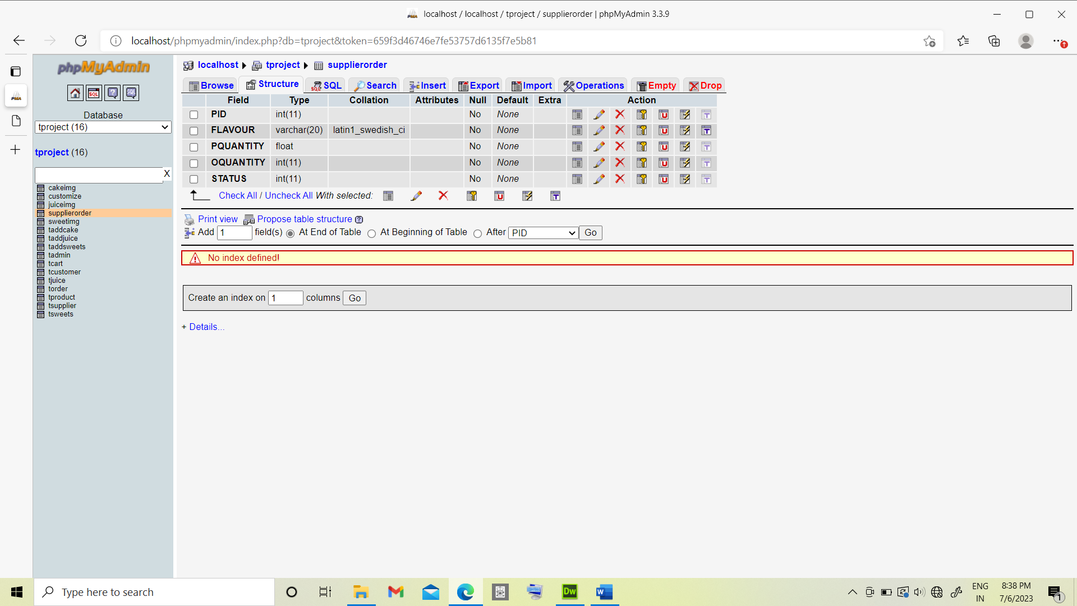

**TADMIN : TSUPLLIER :**

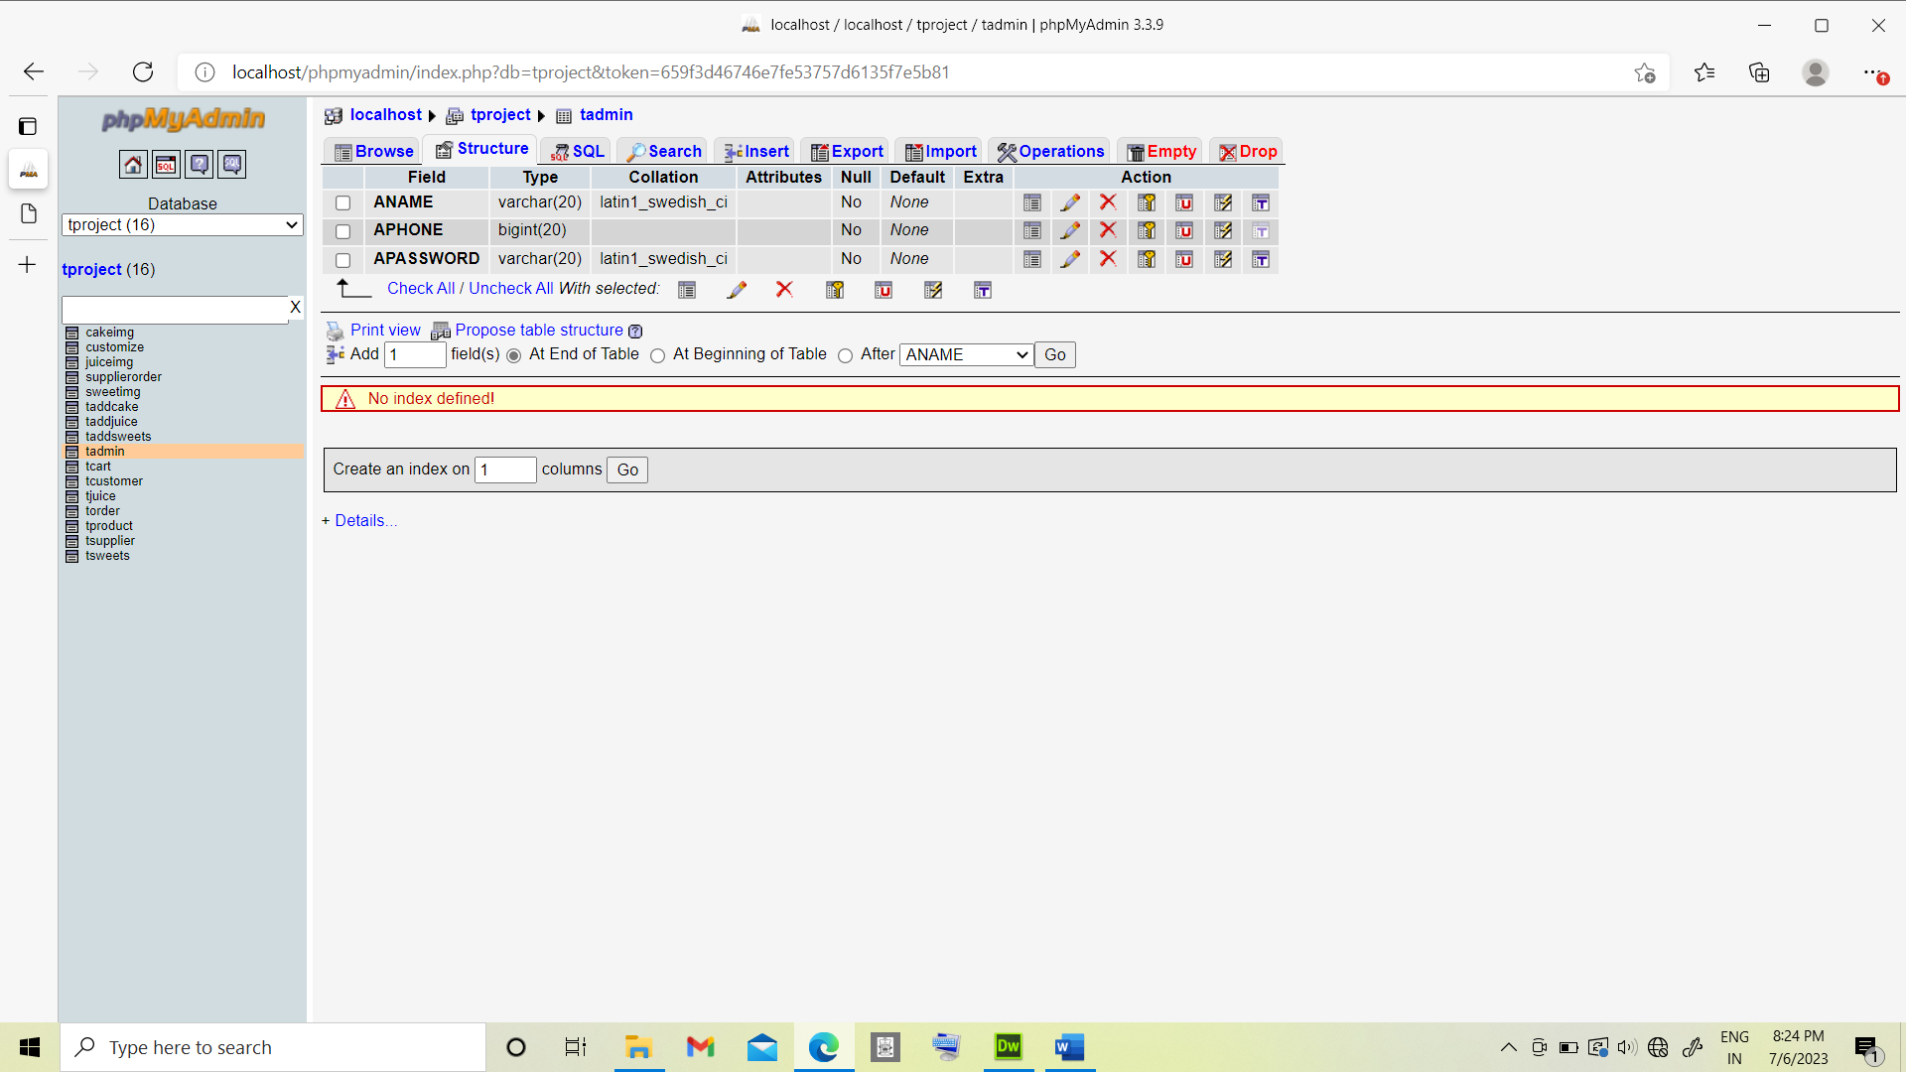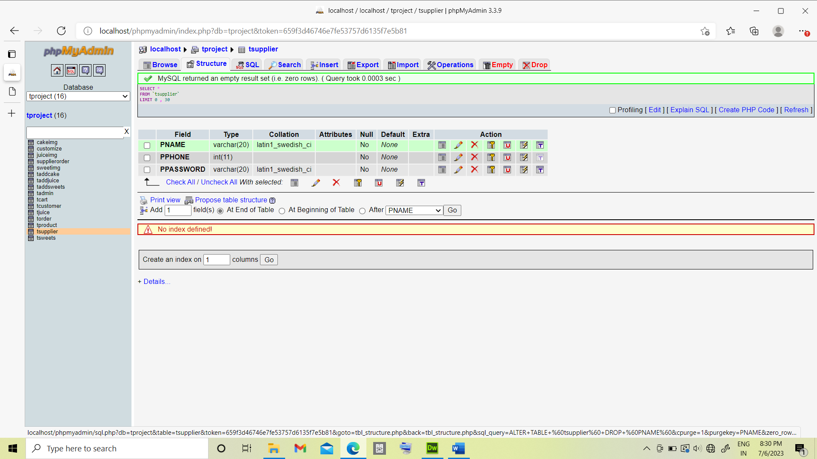

**TADDCAKE : TADDCAKE :**

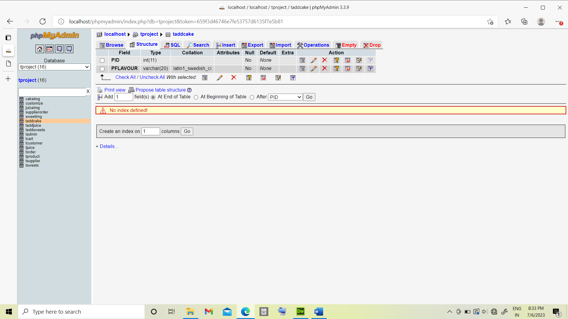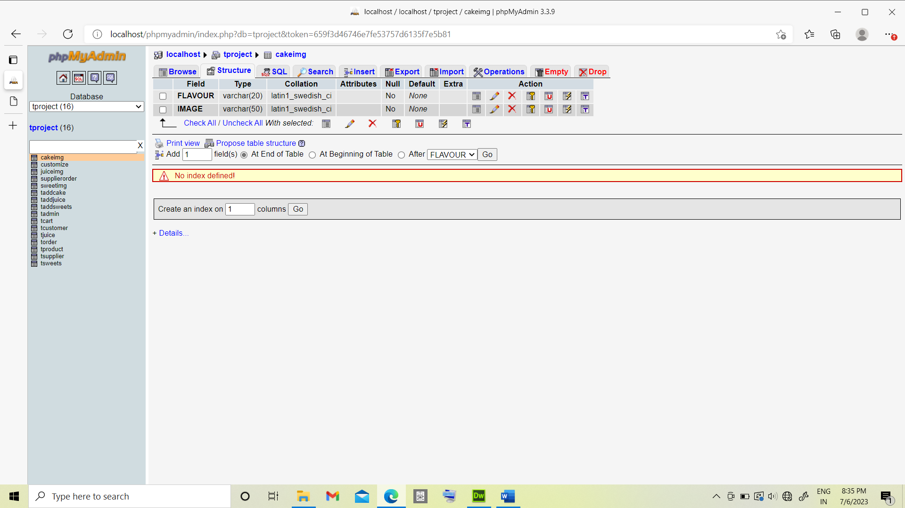

**TPRODUCT: TCART:**

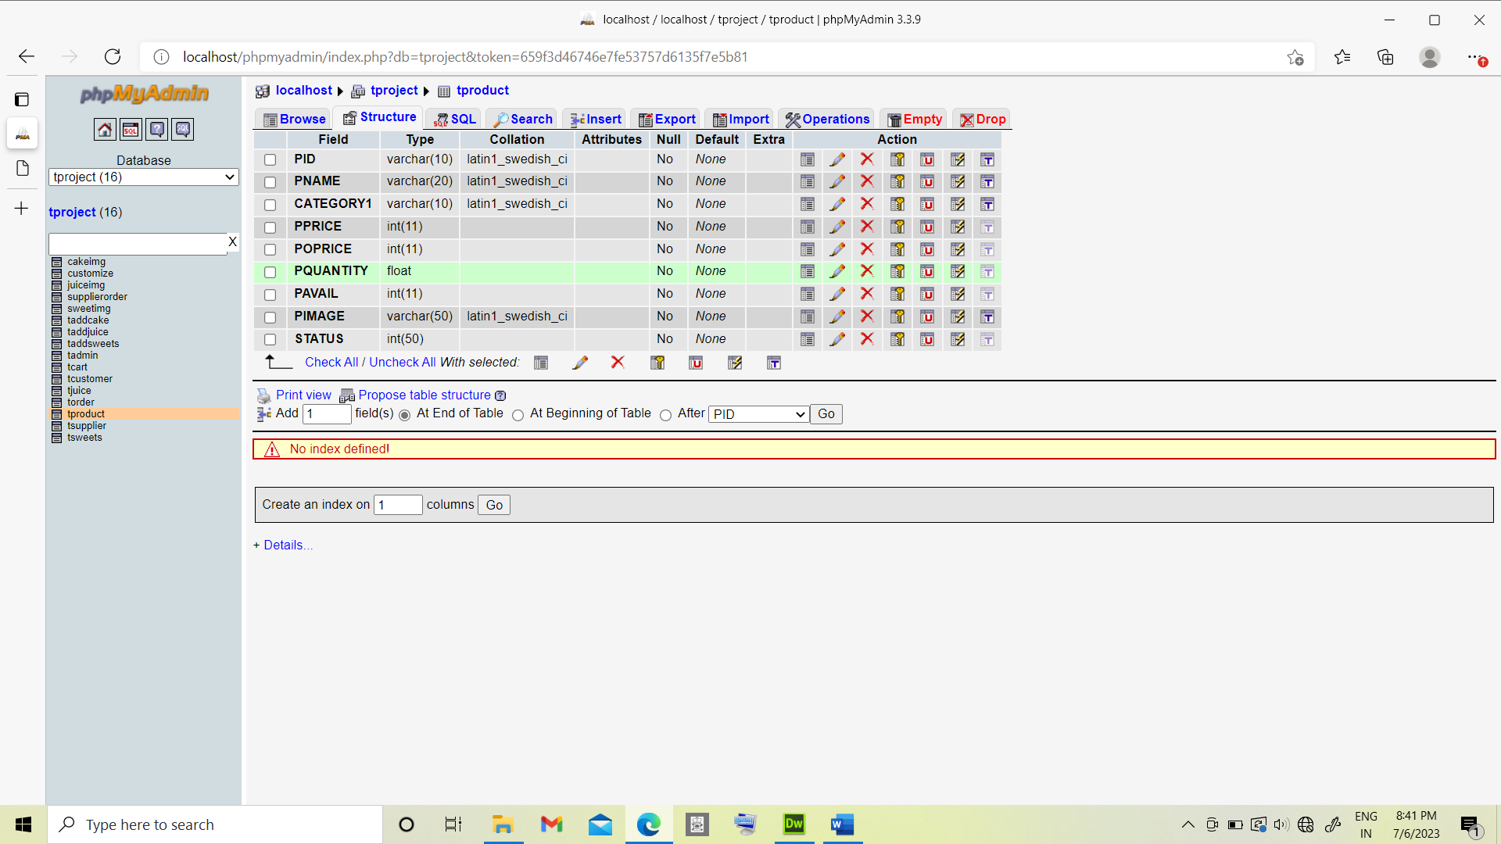 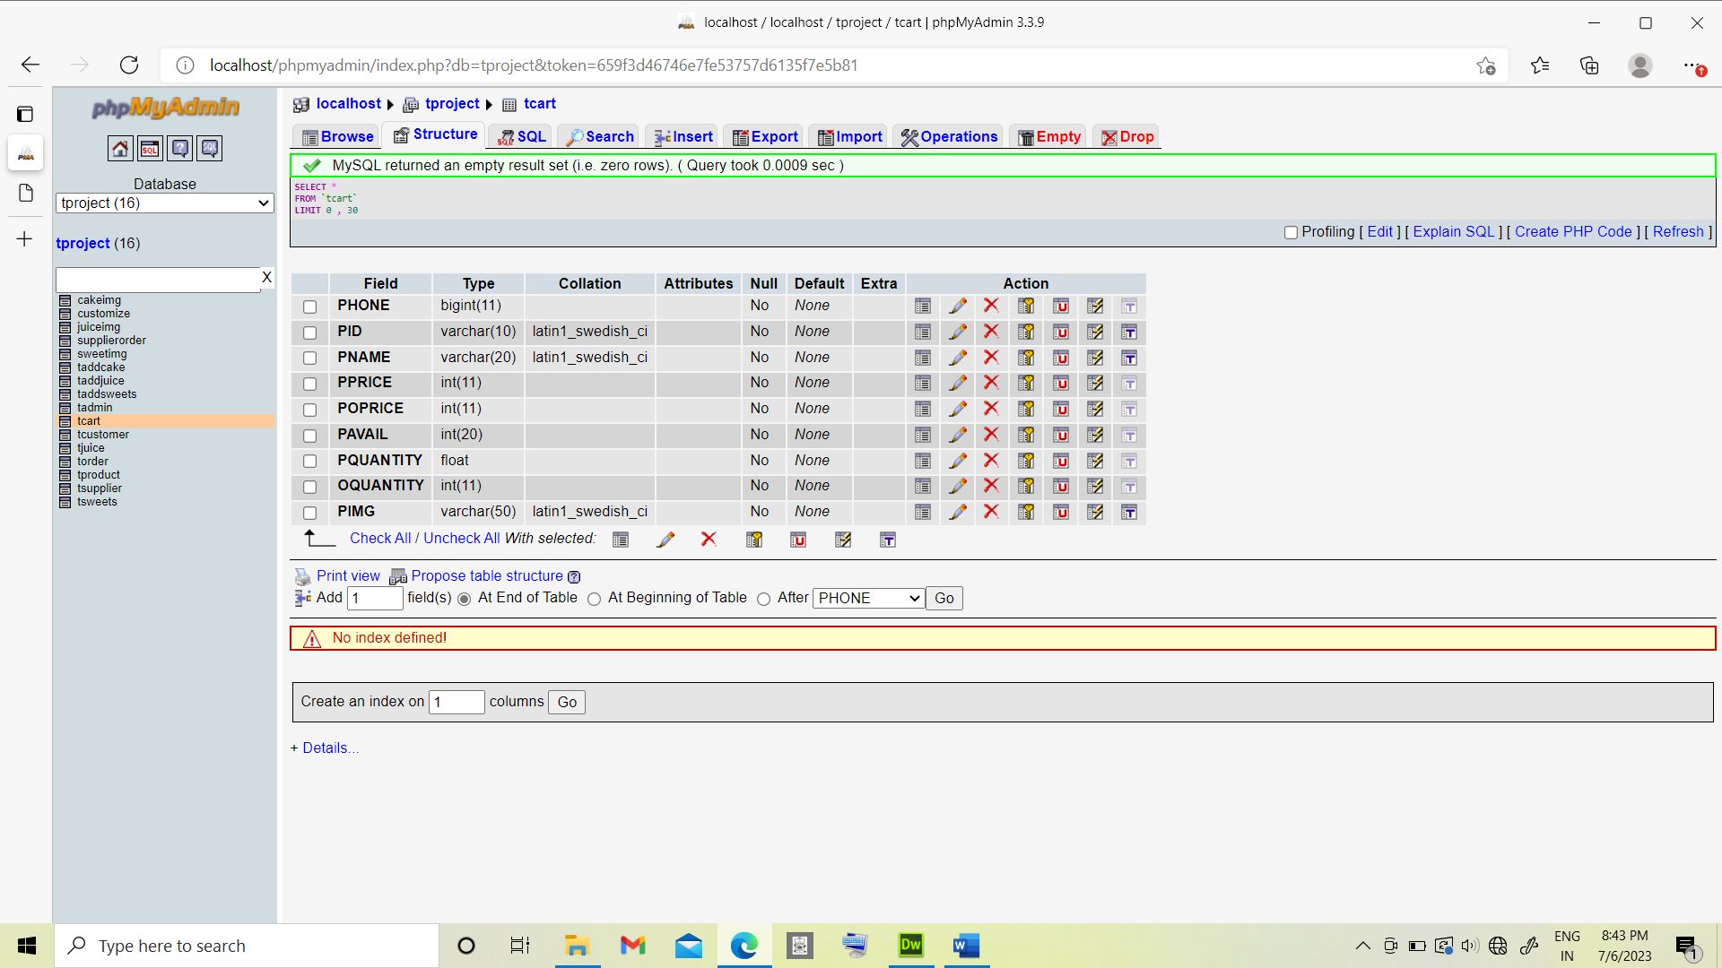

**TORDER : CUSTOMIZE:**

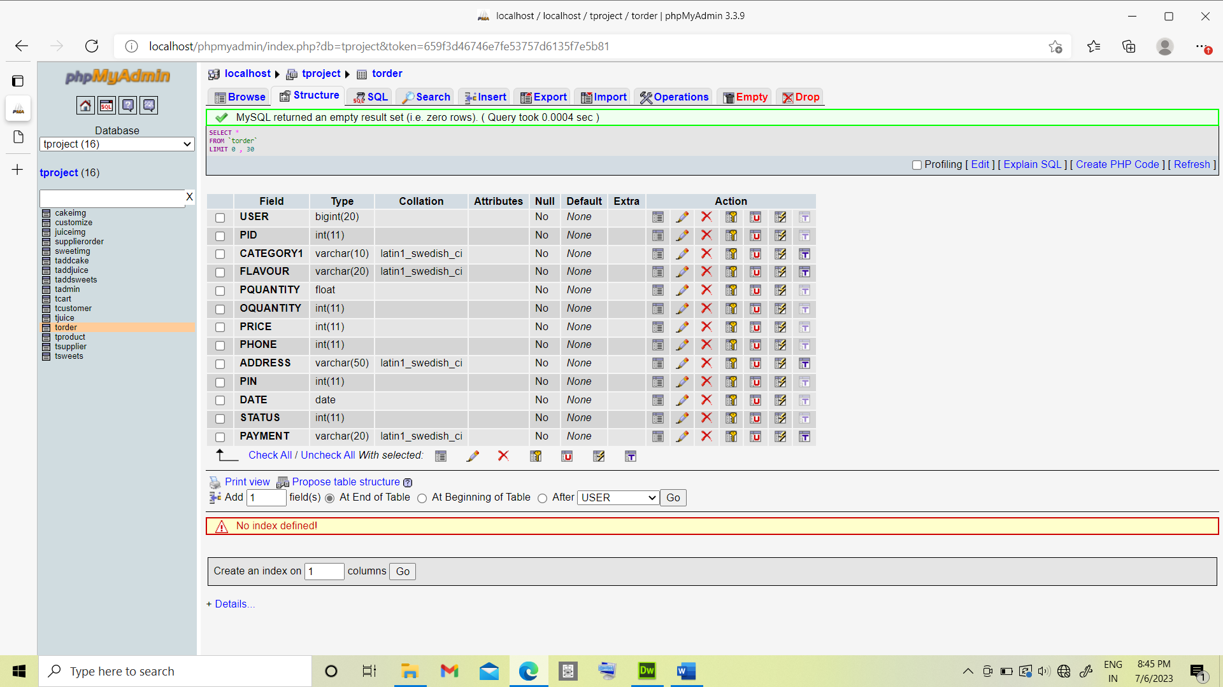 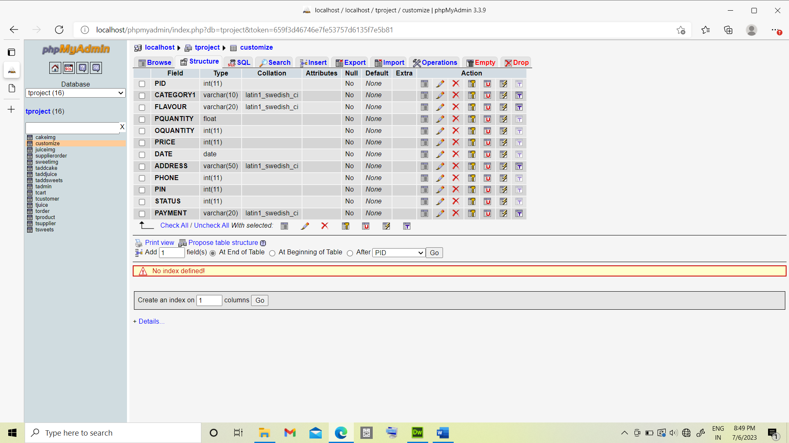

**4.2 Table Structure :**

**TCUSTOMER:**

|  |  |
| --- | --- |
| Field | Type |
| NAME | Varchar(20) |
| PHONE | Bigint(10) |
| PASSWORD | Varchar(15) |
| SECURITY | Varchar(20) |

**SUPPLIER ORDER:**

|  |  |
| --- | --- |
| Field | Type |
| PID | Int(11) |
| FLAVOUR | Varchar(20) |
| PQUANTITY | Float |
| OQUANTITY | Int(11) |
| STATUS | Int(11) |

**TADMIN :**

|  |  |
| --- | --- |
| Field | Type |
| ANAME | Varchar(20) |
| APHONE | Bigint(20) |
| APASSWORD | Varchar(20) |

**TSUPPLIER :**

|  |  |
| --- | --- |
| Field | Type |
| PNAME | Varchar(20) |
| PPHONE | Int(10) |
| PPASSWORD | Varchar(20) |

**TADDCAKE:**

|  |  |
| --- | --- |
| Field | Type |
| PID | Int(11) |
| PFLAVOUR | Varchar(20) |

**CAKEIMAGE:**

|  |  |
| --- | --- |
| Field | Type |
| FLAVOUR | Varchar(20) |
| IMAGE | Varchar(50) |

|  |  |
| --- | --- |
| Field | Type |
| PHONE | Bigint(110 |
| PID | Varchar(10) |
| PNAME | Varchar(10) |
| PPRICE | Int(11) |
| POPRICE | Int(11) |
| PAVAIL | Int(20) |
| PQUANTITY | Float |
| OQUANTITY | Int(11) |
| PIMG | Varchar(50) |

**TPRODUCT:**

|  |  |
| --- | --- |
| Field | Type |
| PID | Varchar(10) |
| PNAME | Varchar(20) |
| CATEGORY | Varchar(20) |
| PPRICE | Int(11) |
| POPRICE | Int(11) |
| PQUANTITY | Float |
| PAVAIL | Int(11) |
| PIMAGE | Varchar(50) |
| STATUS | Int(10) |

**TCART**

**TORDER**

|  |  |
| --- | --- |
| Field | Type |
| USER | Bigint(20) |
| PID | Int(11) |
| CATEGORY1 | Varchar(10) |
| FLAVOUR | Varchar(20) |
| PQUANTITY | float |
| OQUANTITY | Int(11) |
| PRICE | Int(11) |
| PHONE | Bigint(11) |
| ADDRESS | Varchar(50) |
| PIN | Int(11) |
| DATE | Date |
| STATUS | Int(11) |
| PAYMENT | Varchar(20) |

**CUSTOMIZE:**

|  |  |
| --- | --- |
| Field | Type |
| PID | int(11) |
| CATEGORY1 | varchar(10) |
| FLAVOUR | varchar(20) |
| PQUANTITY | int(11) |
| OQUANTITY | int(11) |
| PRICE | int(11) |
| DATE | Date |
| ADDRESS | varchar(50) |
| PHONE | Bigint(11) |
| PIN | int(11) |
| STATUS | int(11) |
| PAYMNT | Varchar(20) |

**4.3 Data Dictionary :**

The data dictionary is repository of various data flow defined in DFD. The DFD preciously states the structure of data flow in the DFD.

1. **TCUSTOMER=NAME+@PHONE+PASSWORD+SECURITY**

NAME= {A-Z/a-z}

PHONE={0-9}

PASSWORD={a-z/A-Z/0-9}

SECURITY={A-Z/a-z}

1. **TADMIN=ANAME+@APHONE+APASSWORD**

ANAME={A-Z/a-z}

APHONE={0-9}

APASSWORD={A-Z/a-z}

1. **TSUPPLIER=PNAME+@PPHONE+PPASSWORD**

PNAME={A-Z/a-z}

PPHONE={0-9}

PPASSWORD={A-Z/a-z}

1. **TADDCAKE=@PID+PFLAVOUR**

PID={1-9}

PFLAVOUR={A-Z/a-z}

1. **CAKEIMAGE=FLAVOUR+IMAGE**

FLAVOUR={A-Z/a-z}

IMAGE={valid URL}

1. **SUPPLIERORDER=@PID+FLAVOUR+PQUANTITY+OQUANTITY+STATUS**

PID={1-9}

FLAVOUR={A-Z/a-z}

PQUANTITY={0-9}

OQUANTITY={0-9}

STATUS={0-9}

**7.TPRODUCT=@PID+PNAME+CATEGORY1+PPRICE+POPRICE+PQUANTITY+PAVAIL+PIMAGE+**

**STATUS**

PID={1-9}

PNAME={A-Z/a-z}

CATEGORY1={A-Z/a-z}

PPRICE={0-9}

POPRICE={0-9}

PQUANTITY={0-9}

PAVAIL={0-9}

PIMAGE={valid URL}

STATUS={0-9}

**8.TCART=PHONE+PID+PNAME+PPRICE+POPRICE+PAVAIL+PQUANTITY+OQUANTITY+PIMG**

PHONE={0-9}

PID={0-9}

PNAME={A-Z/a-z}

PPRICE={0-9}

POPRICE={0-9}

PAVAIL={0-9}

PQUANTITY={0-9}

OQUANTITY={0-9}

PIMG={valid URL}

**9.TORDER=USER+PID+CATEGORY1+FLAVOUR+PQUANTITY+OQUANTITY+PRICE+PHONE+ADDRESS+PIN+DATE+STATUS+PAYMENT**

USER={0-9}

PID={0-9}

CATEGORY1

FLAVOUR={A-Z/a-z}

PQUANTITY={0-9}

OQUANTITY={0-9}

PRICE={0-9}

PHONE={0-9}

ADDRESS=={A-Z/a-z}

PIN={0-9}

DATE+{valid date}

STATUS={0-9}

PAYMENT={A-Z/a-z}

**10.CUSTOMIZE=PID+CATEGORY1+FLAVOUR+PQUANTITY+OQUANTITY+PRICE+DATE+ADDRESS+PHONE+PIN+STATUS+PAYMENT**

PID={0-9}

CATEGORY1={A-Z/a-z}

FLAVOUR={A-Z/a-z}

PQUANTITY={0-9}

OQUANTITY={0-9}

PRICE={0-9}

DATE{valid date}

ADDRESS={A-Z/a-z}

PHONE={0-9}

PIN={0-9}

STATUS={0-9}

PAYMENT={A-Z/a-z}

**4.4 Entity Relationship Diagram [ERD]:**

The Entity Relationship Diagram ERD is popular high level conceptual model. This model and its variation are frequently used for the conceptual design of database application and many database design tools employ its concepts. We describe the basic structuring concepts and constraints of ER model and discuss their use in the design of conceptual schemes for database application. We also present the diagrammatic notation known as ER-Diagram.

The main focus of ER-modeling is data items in the system and relationship between them its main aim is to create an Er-Model for the data and user perspective. The sentence can be used during the development of the database and there are methods that use Er-Model to design the database for different database modules are frequently representing as Er diagram through the model can also be represented in mathematical forms.

An entity types defines the collection of entries that have same attributes. Each entity type in database is described by its name and attributes. The collection of all entries of a particular entity types in the database at any point in the time is called as entity set. An entity describes the schema or intention for the set of entries that share same structure. The collection of entities of particular entity type is grouped into an entity set, which is also called extensions of entity type. An important constraint on the entities of an entity type is the key constraints on the attributes.

An Entity is usually has an attribute whose values are distinct for each individual entity in entity set. Such attribute is called key attribute and its value can be used to identify each entity uniquely.

**Summary of Notations of ERD:-**

Entity types are shown in rectangles boxes. Relationship-types are shown in diamond shape boxes attached to the participating entity types with straight lines. Attributes are shown in ovals, straight line to its entity type or relationship type attaches each attribute.

Component attributes of a composite attributes are attached to a oval representing the composite attributes, multi values attribute are shown in the double ovals. Key attributes have their names underlined. Derived attributes are shown in the dotted oval.

**Basic of Entity Relationship Notation:-**

|  |  |
| --- | --- |
| **Symbol** | **Mean** |
|  | Entity |
|  | Weak Entity |
|  | Relationship |
|  | Identifying Relationship |
|  | Attribute |
|  | Key Attribute |
|  | Multivalued Attribute |
|  | Composite Attribute |
| E2  E1  R | Total participation of E2 in R |
| R  1 N  E2  E1 | Cardinality ratio 1:N for E1:E2 in R |
| (Min,Max)  E  R | Structured constraint (Min, Max) on participation of E in R |
|  | Derived Attribute |

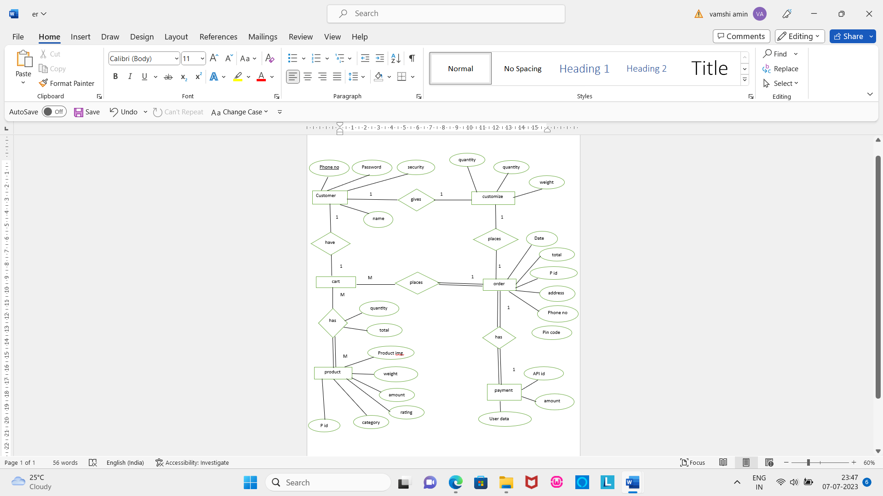

**5.Coding**

**Connection code**

<?php

$link=mysql_connect('localhost','root','');

if(!$link){

die('connection failed'.mysql_error());

}

$db=mysql_select_db('TPROJECT');

if(!$db){

die('selected database unavailable'.mysql_error());

}

?>

**Login and registration**

<div class="login-box">

<div class="botton-box">

<div id="btn-list"></div>

<button type="button" class="toggle-btn" onclick="login()">LOG IN</button>

<button type="button" class="toggle-btn" onclick="register()" id="registerbtn">Register</button>

</div>

<form id="login" class="input-group" action="" method="post">

Enter phone number<br />

<input type="text" class="input-info" placeholder="phone number" name="loginphone" required /><br /><br />

Enter password<br />

<input type="password" class="input-info" placeholder="password" name="loginpassword" required />

<button type="submit" class="submit-btn" name="login-btn" value="login">LOG IN</button>

<button type="button" class="close-btn" name="closebtn" value="closebtn">Close</button>

</form>

<form action="" method="post">

<button type="submit" id="forgot-pass" name="forgot-pass" value="forgot-pass">forgot password</button><br /><br />

</form>

<form id="register" class="input-group" action="" method="post">

Enter name<br />

<input type="text" class="input-info" placeholder="enter your name" name="registername" required/>

Enter phone number<br />

<input type="text" class="input-info" placeholder="phone number" name="registerphone" required />

Enter password<br />

<input type="password" class="input-info" placeholder="password" name="registerpassword" required /><br />

Enter your favourite teacher name<br />

<input type="text" class="input-info" name="security" required /><br />

<button type="submit" class="register-btn" name="register-btn" value="register">Register</button>

<button type="reset" class="reset-btn">Reset</button>

</form>

</div>

**Handling login and registration**

<?php

session_start();

if(isset($_POST['login-btn'])){

$pn=$_POST['loginphone'];

$_SESSION['user']=$pn;

$sql="Select * from TCUSTOMER where PHONE='$pn'";

$query=mysql_query($sql);

$result=mysql_fetch_array($query);

if($result){

$sql1="select PASSWORD FROM TCUSTOMER where PHONE='$pn'";

$query1=mysql_query($sql1);

$result1=mysql_fetch_array($query1);

$password=$_POST["loginpassword"];

if($result1["PASSWORD"]==$password){

header("Location:customerhome.php");

}

else{

echo '<script>alert("wrong password..")</script>';

}

}

else{

echo '<script>alert("please register..")</script>';

}

}

if(isset($_POST['register-btn'])){

$pnpattern='/^\d{10}$/';

$pn=$_POST['registerphone'];

$namepattern='/^[a-zA-Z_]{3,20}$/';

$name=$_POST['registername'];

if(preg_match($pnpattern,$pn)){

if(preg_match($namepattern,$name)){

$name=$_POST['registername'];

$pn=$_POST['registerphone'];

$ps=$_POST['registerpassword'];

$security=$_POST['security'];

$sql="Select * from TCUSTOMER where PHONE='$pn'";

$query=mysql_query($sql);

$result=mysql_fetch_array($query);

if($result){

echo '<script>alert("already exist..")</script>';

}

else

{

$sql1="insert into TCUSTOMER(NAME,PHONE,PASSWORD,SECURITY)values('$name','$pn','$ps','$security')";

$query1=mysql_query($sql1);

echo '<script>alert("registered succssfully...")</script>';

}

}

else{

echo '<script>alert("invalid username")</script>';

}

}

else{

echo '<script>alert("invalid phone number")</script>';

}

}

**Display product**

<div class="container">

<div class="row text-center py-3 px-3">

<?php

$user=$_SESSION['user'];

$sql="Select * from TPRODUCT where PAVAIL>0";

$result=mysql_query($sql,$link);

while($row=mysql_fetch_array($result)){

$decodedimg=urldecode($row['PIMAGE']);

component($row['PNAME'],$row['PPRICE'],$row['POPRICE'],$decodedimg,$row['PID'],$row['PAVAIL'],$row['PQUANTITY'],$row['CATEGORY1']);

}

if(isset($_POST['add'])){

$pid=$_POST['add'];

$sql3="Select * from TCART where PID='$pid' AND PHONE='$user'";

$query3=mysql_query($sql3);

$result3=mysql_fetch_array($query3);

if($result3){

echo '<script>alert("product already exist in cart")</script>';

}

else

{

$sql1="Select * from TPRODUCT where PID='$pid'";

$result1=mysql_query($sql1,$link);

while($row1=mysql_fetch_array($result1)){

$pname=$row1['PNAME'];

$pprice=$row1['PPRICE'];

$poprice=$row1['POPRICE'];

$pavail=$row1['PAVAIL'];

$pquantity=$row1['PQUANTITY'];

$pimg=urlencode($row1['PIMAGE']);

$oqty="1";

$sql2="insert into TCART(PHONE,PID,PNAME,PPRICE,POPRICE,PAVAIL,PQUANTITY,OQUANTITY,PIMG)values('$user','$pid','$pname','$pprice','$poprice','$pavail','$pquantity','$oqty','$pimg')";

$query2=mysql_query($sql2,$link);

if($query2>0){

echo '<script>alert("added to cart successfully")</script>';

}

else{

echo '<script>alert("add to cart again")</script>';

}

}

}

}

?>

</div>

</div>

<?php

functioncomponent($productname,$productprice,$productoprice,$productimg,$productid,$productavail,$productquantity,$cat1){

echo '

<div class="col-md-3 col-sm-6 my-2 my-md-0">

<form action="" method="post">

<div class="card shadow">

<div>

<img src='."$productimg".' alt="image1" class="img-fluid card-img-top" />

</div>

<div class="card-body">

<h5 class="card-title">'.$productname.'</h5>

<h6>

<i class="fas fa-star"></i>

<i class="fas fa-star"></i>

<i class="fas fa-star"></i>

<i class="fas fa-star"></i>

<i class="far fa-star"></i>

</h6>

<p class="card-text">quantity:'.$productquantity.' </p>

<p class="card-text"> '.$cat1.'cake </p>

<h5>

<small><s>$'.$productoprice.'</s></small>

<span class="price">$'.$productprice.' </span>

</h5>

<button type="submit" name="add" value='."$productid".' class="btn btn-warning my-3">

ADD to Cart

<i class="fas fa-shopping-cart"> </i>

</button>

</div>

</div>

</form>

</div>

';

}

?>

**Order process**

<?php

session_start();

$user=$_SESSION['user'];

$total=0;

$tax=0;

$subtotal=0;

$itemcount=0;

$sql="Select * from TCART where PHONE='$user'";

$result=mysql_query($sql,$link);

echo '

<div class="small-container cart-page">

<table class="cart-table">

<tr>

<th>PRODUCT</th>

<th>QUANTITY</th>

<th>SUBTOTAL</th>

</tr>

</table>

</div>';

while($row=mysql_fetch_array($result)){

$pname=$row['PNAME'];

$pquantity=$row['PQUANTITY'];

$poprice=$row['POPRICE'];

$pprice=$row['PPRICE'];

$pid=$row['PID'];

$pavail=$row['PAVAIL'];

$qty=$row['OQUANTITY'];

$pimg=urldecode(urldecode($row['PIMG']));

$psprice=$pprice*$qty;

echo'

<div class="small-container cart-page">

<form action="" method="post">

<table class="cart-table">

<tr>

<td>

<div class="cart-info">

<img src='."$pimg".' />

<div>

<p>'.$pname.'</p>

<p>quantity:'.$pquantity.'</p>

<small><s>'.$poprice.'</s></small>

<small>'.$pprice.'</small><br /></br>

<button type="submit" id="remove" name="remove" value='."$pid".'>Remove</button>

</div>

</div>

</td>

<td>

<button type="submit" name="minus" value='."$pid".'>-</button>

<input type="text" name="quantity" value='."$qty".'>

<button type="submit" name="plus" value='."$pid".'>+</button>

</td>

<td>'.$psprice.'</td>

</tr>

</table>

</form>

</div>

</div>

';

$subtotal=$subtotal+$psprice;

$itemcount=$itemcount+1;

}

if(isset($_POST['plus'])){

$qtyid=$_POST['plus'];

$sql="Select * from TCART where PHONE='$user' AND PID='$qtyid'";

$query=mysql_query($sql,$link);

while($result1=mysql_fetch_array($query)){

$oqty1=$result1['OQUANTITY'];

$avail=$result1['PAVAIL'];

if($oqty1<$avail){

$oqty1=$oqty1+1;

}

}

$sql2="update TCART set OQUANTITY='$oqty1' where PID='$qtyid' AND PHONE='$user'";

$query2=mysql_query($sql2);

header("Location:tcustomerpage1.php");

}

if(isset($_POST['minus'])){

$qtyid=$_POST['minus'];

$sql="Select * from TCART where PHONE='$user' AND PID='$qtyid'";

$query=mysql_query($sql,$link);

while($result1=mysql_fetch_array($query)){

$oqty1=$result1['OQUANTITY'];

if($oqty1>1){

$oqty1=$oqty1-1;

}else{

$oqty1=1;

}

$sql2="update TCART set OQUANTITY='$oqty1' where PID='$qtyid' AND PHONE='$user'";

$query2=mysql_query($sql2);

header("Location:tcustomerpage1.php");

}

}

if($itemcount>0){

$tax=($subtotal*5)/100;

$total=$subtotal+$total;

$_SESSION['amount']=$total;

carttotal($subtotal,$tax,$total);

if(isset($_POST['remove'])){

$pid=$_POST['remove'];

$sql1="Delete from TCART where PID='$pid'";

$result1=mysql_query($sql1,$link);

if($result1){

header("Location:tcustomerpage1.php");

}

}

}

if(isset($_POST['buy'])){

echo'

<form action="" method="post">

<table class="totaltable">

<tr>

<td>ENTER ADDRESS</td>

<td><input type="text" name="address"></td>

</tr>

<tr>

<td>ENTER Pin code</td>

<td><select name="pin">

<option value="574118">574118</option>

<option value="576101">576101</option>

<option value="576107">576107</option>

<option value="576120">576120</option>

</select><br/>

</td>

</tr>

<tr>

<td>ENTER PHONE NUMBER</td>

<td><input type="text" name="phone"></td>

</tr>

<tr>

<td>ENTER DATE OF DELIVERY</td>

<td><input type="date" name="date"></td>

</tr>

<tr>

<td>ENTER PAYMENT MODE</td>

<td><select name="payment">

<option value="1">cash on delivery</option>

<option value="2">online payment</option>

</select><br/></td>

</tr>

<tr>

<td><button type="submit" name="proceedorder">PROCEED</button></td>

</tr>

</table>

</form>

';

}

if(isset($_POST['proceedorder'])){

$phone=$_POST['phone'];

$address=$_POST['address'];

$pin=$_POST['pin'];

$date=$_POST['date'];

$payment=$_POST['payment'];

if($payment=="1"){

$paymentsts="pending";

}

else{

$paymentsts="successfull";

}

$currentdate=date("Y-m-d");

if($date>=$currentdate){

$sql="Select * from TCART where PHONE='$user'";

$query=mysql_query($sql);

while($result=mysql_fetch_array($query)){

$pid=$result['PID'];

$cat1="veg";

$flavour=$result['PNAME'];

$pqty=$result['PQUANTITY'];

$oqty=$result['OQUANTITY'];

$price=$psprice;

$status="1";

$rpavail=$result['PAVAIL'];

$pavail=$rpavail-1;

$sql2="update TPRODUCT set PAVAIL='$pavail' where PID='$pid'";

$query2=mysql_query($sql2);

$sql3="update TSWEETS set PAVAIL='$pavail' where PID='$pid'";

$query3=mysql_query($sql3);

$sql4="update TJUICE set PAVAIL='$pavail' where PID='$pid'";

$query4=mysql_query($sql4);

$sql2="insert into TORDER(USER,PID,CATEGORY1,FLAVOUR,PQUANTITY,OQUANTITY,PRICE,PHONE,ADDRESS,PIN,DATE,STATUS,PAYMENT)values('$user','$pid','$cat1','$flavour','$pqty','$oqty','$price','$phone','$address','$pin','$date','$status','$paymentsts')";

$query2=mysql_query($sql2);

}

$sql1="Delete from TCART where PHONE='$user'";

$result1=mysql_query($sql1,$link);

if($payment=="1"){

echo '<script>alert("order successfull..")</script>';

}else{

header("Location:checkout.php?amount=".$total);

}

}

else{

echo '<script>alert("enter valid date")</script>';

}

}

?>

**Customize**

<?php

session_start();

if(isset($_POST['submit'])){

$_SESSION['cat1']=$_POST['cat1'];

$_SESSION['flavour']=$_POST['flavour'];

$_SESSION['quantity']=$_POST['quantity'];

$_SESSION['oquantity']=$_POST['oquantity'];

$_SESSION['price']=$_SESSION['quantity']*$_SESSION['oquantity']*'600';

echo'

<form action="" method="post">

<table class="totaltable">

<tr>

<td>veg/nonveg</td>

<td>'.$_SESSION['cat1'].'</td>

</tr>

<tr>

<td>flavour</td>

<td>'.$_SESSION['flavour'].'</td>

</tr>

<tr>

<td>quantity</td>

<td>'.$_SESSION['quantity'].'</td>

</tr>

<tr>

<td>price</td>

<td>'.$_SESSION['oquantity'].'</td>

</tr>

<tr>

<td>price</td>

<td>'.$_SESSION['price'].'</td>

</tr>

<tr>

<td>ENTER ADDRESS</td>

<td><input type="text" name="address"></td>

</tr>

<tr>

<td>ENTER Pin code</td>

<td><input type="text" name="pin"></td>

</tr>

<tr>

<td>ENTER PHONE NUMBER</td>

<td><input type="text" name="phone"></td>

</tr>

<tr>

<td>ENTER DATE OF DELIVERY</td>

<td><input type="date" name="date"></td>

</tr>

<tr>

<td>ENTER PAYMENT MODE</td>

<td><select name="payment">

<option value="1">cash on delivery</option>

<option value="2">online payment</option>

</select><br/></td>

</tr>

<tr>

<td><button type="submit" name="proceedorder">PROCEED</button></td>

</tr>

</table>

</form>

';

}

if(isset($_POST['proceedorder'])){

$phone=$_POST['phone'];

$address=$_POST['address'];

$pin=$_POST['pin'];

$date=$_POST['date'];

$status='1';

$cat1=$_SESSION['cat1'];

$flavour=$_SESSION['flavour'];

$quantity=$_SESSION['quantity'];

$oqty=$_SESSION['oquantity'];

$total=$_SESSION['price'];

$currentdate=date("Y-m-d");

$payment=$_POST['payment'];

$_SESSION['amount']=$total;

if($payment=="1"){

$paymentsts="pending";

}

else{

$paymentsts="successfull";

}

if($date>=$currentdate){

$sql1="Select PID from CUSTOMIZE ORDER BY PID DESC LIMIT 1";

$result1=mysql_query($sql1);

if($result1){

$row=mysql_fetch_array($result1);

$pid=$row['PID']+1;

}

else

{

$pid=1;

}

$sql2="insert into CUSTOMIZE(PID,CATEGORY1,FLAVOUR,PQUANTITY,OQUANTITY,PRICE,DATE,ADDRESS,PHONE,PIN,STATUS,PAYMENT)values('$pid','$cat1','$flavour','$quantity','$oqty','$total','$date','$address','$phone','$pin','$status','$paymentsts')";

$query2=mysql_query($sql2);

if($payment=="1"){

echo '<script>alert("order successfull..")</script>';

}

else{

header("Location:checkout.php?amount=".$total);

}

}

else{

echo '<script>alert("invalid date")</script>';

}

}

?>

**Admin**

**Inventory managing**

<?php

echo '

<form action="" method="post">

<table border="1px">

<tr>

<th>product id</th>

<th>product name</th>

<th>veg/non-veg</th>

<th>product price</th>

<th>product quantity</th>

<th>product available</th>

<th>status</th>

</tr>

';

$sql="Select * from TPRODUCT where PAVAIL<4";

$result=mysql_query($sql,$link);

while($row=mysql_fetch_array($result)){

$pid=$row['PID'];

$pname=$row['PNAME'];

$cat1=$row['CATEGORY1'];

$pprice=$row['PPRICE'];

$pquantity=$row['PQUANTITY'];

$pavail=$row['PAVAIL'];

$status=$row['STATUS'];

if($status=="1"){

$statustxt="order to supplier";

}

if($status=="2"){

$statustxt="order placed";

}

if($status=="3"){

$statustxt="add product";

}

echo '

<tr>

<td>'.$pid.'</td>

<td>'.$pname.'</td>

<td>'.$cat1.'</td>

<td>'.$pprice.'</td>

<td>'.$pquantity.'</td>

<td>'.$pavail.'</td>

<td><button type="submit" name="status" value='.$pid.'>'.$statustxt.'</td>

</tr>

';

}

$sql="Select * from TSWEETS where PAVAIL<4";

$result=mysql_query($sql,$link);

while($row=mysql_fetch_array($result)){

$pid=$row['PID'];

$pname=$row['PNAME'];

$pprice=$row['PPRICE'];

$pquantity=$row['PQUANTITY'];

$pavail=$row['PAVAIL'];

$status=$row['STATUS'];

if($status=="1"){

$statustxt="order to supplier";

}

if($status=="2"){

$statustxt="order placed";

}

if($status=="3"){

$statustxt="add product";

}

echo '

<tr>

<td>'.$pid.'</td>

<td>'.$pname.'</td>

<td></td>

<td>'.$pprice.'</td>

<td>'.$pquantity.'</td>

<td>'.$pavail.'</td>

<td><button type="submit" name="status" value='.$pid.'>'.$statustxt.'</td>

</tr>

';

}

$sql="Select * from TJUICE where PAVAIL<4";

$result=mysql_query($sql,$link);

while($row=mysql_fetch_array($result)){

$pid=$row['PID'];

$pname=$row['PNAME'];

$pprice=$row['PPRICE'];

$pquantity=$row['PQUANTITY'];

$pavail=$row['PAVAIL'];

$status=$row['STATUS'];

if($status=="1"){

$statustxt="order to supplier";

}

if($status=="2"){

$statustxt="order placed";

}

if($status=="3"){

$statustxt="add product";

}

echo '

<tr>

<td>'.$pid.'</td>

<td>'.$pname.'</td>

<td></td>

<td>'.$pprice.'</td>

<td>'.$pquantity.'</td>

<td>'.$pavail.'</td>

<td><button type="submit" name="status" value='.$pid.'>'.$statustxt.'</td>

</tr>

';

}

echo '

</table>

</form>

';

if(isset($_POST['status'])){

$pid1=$_POST['status'];

$sql3="Select * from TPRODUCT where PID='$pid1'";

$query3=mysql_query($sql3,$link);

$result3=mysql_fetch_array($query3);

$status1=$result3['STATUS'];

$pavail1=$result3['PAVAIL'];

if($status1=="1"){

$sql1="Select * from TPRODUCT where PID='$pid1'";

$result1=mysql_query($sql1,$link);

while($row1=mysql_fetch_array($result1)){

$pid1=$row1['PID'];

$flavour1=$row1['PNAME'];

$qty1=$row1['PQUANTITY'];

$avail=$row1['PAVAIL'];

$oqty="4"-$avail;

$status1="1";

$sql2="insert into SUPPLIERORDER(PID,FLAVOUR,PQUANTITY,OQUANTITY,STATUS)values('$pid1','$flavour1','$qty1','$oqty','$status1')";

$query2=mysql_query($sql2);

if($query2){

echo '<script>alert("order successfull..")</script>';

}

}

$sql2="update TPRODUCT set STATUS='2' where PID='$pid1'";

$query2=mysql_query($sql2);

header("Location:adminhome.php");

}

if($status1=="3"){

$sql5="Select * from SUPPLIERORDER where PID='$pid1'";

$query5=mysql_query($sql5,$link);

$result5=mysql_fetch_array($query5);

$oqty1=$result5['OQUANTITY'];

$avail=$pavail1+$oqty1;

$sql4="update TPRODUCT set PAVAIL='$avail',STATUS='1' where PID='$pid1'";

$query4=mysql_query($sql4);

if($query4){

$sql1="Delete from SUPPLIERORDER where PID='$pid1'";

$result1=mysql_query($sql1,$link);

}

header("Location:adminhome.php");

}

}

**Order display**

<form action="" method="post">

<table border:1px solid red>

<tr>

<td>veg/nonveg</td>

<td>flavour</td>

<td>quantity</td>

<td>order quantity</td>

<td>price</td>

<td>phone</td>

<td>address</td>

<td>pin</td>

<td>date</td>

<td>payment status</td>

<td>status</td>

</tr>

<?php

$sql="Select * from TORDER";

$result=mysql_query($sql,$link);

while($row=mysql_fetch_array($result)){

$pid=$row['PID'];

$cat1=$row['CATEGORY1'];

$flavour=$row['FLAVOUR'];

$quantity=$row['PQUANTITY'];

$oqty=$row['OQUANTITY'];

$price=$row['PRICE'];

$phone=$row['PHONE'];

$address=$row['ADDRESS'];

$pin=$row['PIN'];

$payment=$row['PAYMENT'];

$date=$row['DATE'];

$status=$row['STATUS'];

if($status=="1"){

$statustxt="deliver";

}

echo '

<tr>

<td>'.$cat1.'</td>

<td>'.$flavour.'</td>

<td>'.$quantity.'</td>

<td>'.$oqty.'</td>

<td>'.$price.'</td>

<td>'.$phone.'</td>

<td>'.$address.'</td>

<td>'.$pin.'</td>

<td>'.$date.'</td>

<td>'.$payment.'</td>

<td><button type="submit" name="status" value='.$pid.'>'.$statustxt.'</td>

</tr>

';

}

?>

</table>

</form>

<?php

if(isset($_POST['status'])){

$pid1=$_POST['status'];

$sql1="Delete from TORDER where PID='$pid1'";

$result1=mysql_query($sql1,$link);

echo '<script>alert("order delivered")</script>';

header("Location:orders.php");

}

?>

**Customise order display**

<?php

echo '

<form action="" method="post">

<table border="1px">

<tr>

<td>veg/nonveg</td>

<td>flavour</td>

<td>quantity</td>

<td>order quantity</td>

<td>price</td>

<td>phone</td>

<td>address</td>

<td>pin</td>

<td>date</td>

<td>payment status</td>

<td>status</td>

</tr>

';

$sql="Select * from CUSTOMIZE";

$result=mysql_query($sql,$link);

while($row=mysql_fetch_array($result)){

$pid=$row['PID'];

$cat1=$row['CATEGORY1'];

$flavour=$row['FLAVOUR'];

$quantity=$row['PQUANTITY'];

$oqty=$row['OQUANTITY'];

$price=$row['PRICE'];

$phone=$row['PHONE'];

$address=$row['ADDRESS'];

$pin=$row['PIN'];

$date=$row['DATE'];

$payment=$row['PAYMENT'];

$status=$row['STATUS'];

if($status=="1"){

$statustxt="order to supplier";

}

if($status=="2"){

$statustxt="order placed";

}

if($status=="3"){

$statustxt="Deliver";

}

echo '

<tr>

<td>'.$cat1.'</td>

<td>'.$flavour.'</td>

<td>'.$quantity.'</td>

<td>'.$oqty.'</td>

<td>'.$price.'</td>

<td>'.$phone.'</td>

<td>'.$address.'</td>

<td>'.$pin.'</td>

<td>'.$date.'</td>

<td>'.$payment.'</td>

<td><button type="submit" name="status" value='.$pid.'>'.$statustxt.'</td>

</tr>

';

}

echo '

</table>

</form>

';

if(isset($_POST['status'])){

$pid1=$_POST['status'];

$sql3="Select * from CUSTOMIZE where PID='$pid1'";

$query3=mysql_query($sql3,$link);

$result3=mysql_fetch_array($query3);

$status1=$result3['STATUS'];

if($status1=="1"){

$sql1="Select * from CUSTOMIZE where PID='$pid1'";

$result1=mysql_query($sql1,$link);

while($row1=mysql_fetch_array($result1)){

$pid1=$row1['PID'];

$flavour1=$row1['FLAVOUR'];

$qty1=$row1['PQUANTITY'];

$oqty=$row1['OQUANTITY'];

$status1="1";

$sql2="insert into SUPPLIERORDER(PID,FLAVOUR,PQUANTITY,OQUANTITY,STATUS)values('$pid1','$flavour1','$qty1','$oqty','$status1')";

$query2=mysql_query($sql2);

if($query2){

echo '<script>alert("order successfull..")</script>';

}

}

$sql2="update CUSTOMIZE set STATUS='2' where PID='$pid1'";

$query2=mysql_query($sql2);

header("Location:corder.php");

}

if($status1=="3"){

$sql3="Delete from CUSTOMIZE where PID='$pid1'";

$result3=mysql_query($sql3,$link);

$sql1="Delete from SUPPLIERORDER where PID='$pid1'";

$result1=mysql_query($sql1,$link);

echo '<script>alert("delivered")</script>';

header("Location:corder.php");

}

}

?>

**Add new flavour**

<div class="edit">

<form action="" method="post">

<h2><b><center>ADD Flavour</center></b></h2><br />

<label class="sad">Enter flavour</label>

<input type="text" placeholder="flavour"name="flavour" /><br /><br />

<button type="submit" name="submit">submit</button>

</form>

</div>

<?php

if(isset($_POST['submit'])){

$flavour=$_POST['flavour'];

$sql1="Select PID from TADDCAKE ORDER BY PID DESC LIMIT 1";

$result1=mysql_query($sql1);

if($result1){

$row=mysql_fetch_array($result1);

$lastid=$row['PID']+1;

}

else

{

$lastid=1;

}

$sql="Select * from TADDCAKE where PFLAVOUR='$flavour'";

$query=mysql_query($sql);

$result=mysql_fetch_array($query);

if($result){

echo '<script>alert("already exist..")</script>';

}

else

{

$sql2="insert into TADDCAKE(PID,PFLAVOUR)values('$lastid','$flavour')";

$resul2t=mysql_query($sql2);

if($resul2t){

echo '<script>alert("flavour added")</script>';

}

else

{

echo '<script>alert("retry")</script>';

}

}

}

?>

**Add new image**

<div class="edit">

<form action="" method="post">

<h2><b><center>ADD CAKE IMAGE</center></b></h2><br />

<label class="sad">Enter flavour</label>

<input type="text" placeholder="flavour"name="flavour" /><br /><br />

<label class="sad">Enter URL</label>

<input type="text" placeholder="image url"name="image" /><br /><br />

<button type="submit" name="submit">submit</button>

</form>

</div>

<?php

if(isset($_POST['submit'])){

$flavour=$_POST['flavour'];

$image=urlencode($_POST['image']);

$sql2="insert into CAKEIMG(FLAVOUR,IMAGE)values('$flavour','$image')";

$resul2t=mysql_query($sql2);

if($resul2t){

echo '<script>alert("image added")</script>';

}

else

{

echo '<script>alert("retry")</script>';

}

}

?>

**Add product**

echo '

<div class="edit">

<form class="additem" action="" method="post">

<h2><b><center>ADD CAKE</center></b></h2>

<label class="sad"> VEG/NONVEG</label>

<select name="category1">

<option value="1">veg</option>

<option value="2">non-veg</option>

</select><br/><br/>

<label class="sad">Enter product name</label>

<select name="category2">

';

$sql="Select * from TADDCAKE";

$result=mysql_query($sql,$link);

while($row=mysql_fetch_array($result)){

$flavourid=$row['PID'];

$flavourname=$row['PFLAVOUR'];

echo '

<option value='."$flavourid".'>'.$flavourname.'</option>

';

}

echo '

</select><br /><br/>

<label class="sad">Enter price</label>

<input class="sad" type="text" placeholder="price" name="pprice" /><br /><br />

<label class="sad">Enter original price</label>

<input class="sad" type="text" placeholder="original price" name="poprice"/>

<label class="sad">Enter quantity </label>

<select name="category3">

<option value="1">0.5kg</option>

<option value="2">1kg</option>

<option value="3">1.5kg</option>

<option value="4">2kg</option>

</select><br/><br/>

<label class="sad">Available</label>

<input class="sad" type="text" placeholder="available number" name="pflavour" />

<label class="sad">Enter image url</label>

<select name="pimg">

';

$sql="Select * from CAKEIMG";

$result=mysql_query($sql,$link);

while($row=mysql_fetch_array($result)){

$flavour1=$row['FLAVOUR'];

$image=($row['IMAGE']);

echo '

<option value='."$image".'>'.$flavour1.'</option>

';

}

echo '

</select><br /><br />

<button class="submit" type="submit" name="addcake">submit</button>

<button class="back" type="close" name="backbtn">Back</button>

</form>

</div>

';

if(isset($_POST['addcake'])){

$category1=$_POST['category1'];

$category2=$_POST['category2'];

$category3=$_POST['category3'];

$sql1="Select PFLAVOUR FROM TADDCAKE where PID='$category2'";

$query1=mysql_query($sql1);

$result1=mysql_fetch_array($query1);

$flavour=$result1['PFLAVOUR'];

$pid="1".$category1.$category2.$category3;

if($category1=="1"){

$cat1="veg";

}

else{

$cat1="nonveg";

}

$pprice=$_POST['pprice'];

$poprice=$_POST['poprice'];

if($category3=="1"){

$quantity="0.5kg";

}

if($category3=="2"){

$quantity="1kg";

}

if($category3=="3"){

$quantity="1.5kg";

}

if($category3=="4"){

$quantity="2kg";

}

$pavail=$_POST['pflavour'];

$pimg=($_POST['pimg']);

$sql="Select * from TPRODUCT where PID='$pid'";

$query=mysql_query($sql);

$result=mysql_fetch_array($query);

if($result){

$rpavail=$result['PAVAIL'];

$pavail=$pavail+$rpavail;

$sql2="update TPRODUCT set PAVAIL='$pavail' where PID='$pid'";

$query2=mysql_query($sql2);

echo '<script>alert("product added....")</script>';

}

else

{

$status="1";

$sql1="insert into TPRODUCT(PID,PNAME,CATEGORY1,PPRICE,POPRICE,PQUANTITY,PAVAIL,PIMAGE,STATUS)values('$pid','$flavour','$cat1','$pprice','$poprice','$quantity','$pavail','$pimg','$status')";

$query1=mysql_query($sql1);

echo '<script>alert("product added")</script>';

}

}

if(isset($_POST['backbtn'])){

header("Location:adminhome.php");

}

?>

**Remove cake**

<?php

echo '

<div class="edit">

<form class="removeitem" action="" method="post">

<h2><b><center>REMOVE CAKE</center></b></h2>

<label class="sad"> VEG/NONVEG</label>

<select name="category1">

<option value="1">veg</option>

<option value="2">non-veg</option>

</select><br/><br/>

<label class="sad">Enter product name</label>

<select name="category2">

';

$sql="Select * from TADDCAKE";

$result=mysql_query($sql,$link);

while($row=mysql_fetch_array($result)){

$flavourid=$row['PID'];

$flavourname=$row['PFLAVOUR'];

echo '

<option value='."$flavourid".'>'.$flavourname.'</option>

';

}

echo '

</select><br /><br/>

<label class="sad">Enter quantity </label>

<select name="category3">

<option value="1">0.5kg</option>

<option value="2">1kg</option>

<option value="3">1.5kg</option>

<option value="4">2kg</option>

</select><br/><br/>

<label class="sad">Enter number of cakes</label>

<input class="sad" type="text" placeholder="quantity" name="pavail"?><br/>

<button class="submit" type="submit" name="removecake">submit</button>

<button class="close" type="close" name="backbtn">close</button>

</form>

</div>

';

if(isset($_POST['removecake'])){

$category1=$_POST['category1'];

$category2=$_POST['category2'];

$category3=$_POST['category3'];

$pid="1".$category1.$category2.$category3;

$aqty=$_POST['pavail'];

$sql="Select PAVAIL from TPRODUCT where PID='$pid'";

$query=mysql_query($sql);

$result=mysql_fetch_array($query);

if($result){

$avail=$result['PAVAIL'];

if($avail>$aqty){

$newavail=$avail-$aqty;

$sql="Update TPRODUCT set PAVAIL='$newavail' where PID='$pid'";

$query=mysql_query($sql);

echo '<script>alert("Item removed successfully")</script>';

}

else {

echo '<script>alert("Enter quantity is more than available quantity")</script>';

}

}else{

echo '<script>alert("Product is not available")</script>';

}

}

if(isset($_POST['backbtn'])){

header("Location:adminhome.php");

}

?>

**Add supplier**

<div class="edit">

<form class="ADD" action="" method="post">

<h2><b><center>ADD SUPPLIER</center></b></h2>

<label class="sad"> Enter Supplier name</label>

<input class="sad" type="text" placeholder="name" name="pname"/><br />

<label class="sad"> Supplier phone number</label>

<input class="sad" type="text" placeholder="phone number" name="pphone"/><br />

<label class="sad">create password</label>

<input class="sad" type="text" placeholder="password" name="ppassword"/><br />

<button class="submit" type="submit" name="addsupplier">submit</button>

<button class="close" type="close" name="backbtn">close</button>

</form>

</div>

<?php

if(isset($_POST['addsupplier'])){

$name=$_POST['pname'];

$pn=$_POST['pphone'];

$ps=$_POST['ppassword'];

$sql="Select * from TSUPPLIER where PPHONE='$pn'";

$query=mysql_query($sql);

$result=mysql_fetch_array($query);

if($result){

echo '<script>alert("already exist..")</script>';

}

else

{

$sql1="insert into TSUPPLIER(PNAME,PPHONE,PPASSWORD)values('$name','$pn','$ps')";

$query1=mysql_query($sql1);

echo '<script>alert("registered succssfully...")</script>';

}

}

if(isset($_POST['backbtn'])){

header("Location:adminhome.php");

}

?>

**Remove supplier**

<div class="edit">

<form class="removeitem" action="" method="post">

<h2><b><center>REMOVE SUPPLIER</center></b></h2>

<label class="sad"> Enter supplier id </label>

<input class="sad" type="text" placeholder=" phone number" name="pphone"/><br/>

<button class="submit" type="submit" name="removesupplier">submit</button>

<button class="close" type="close" name="backbtn">close</button>

</form>

</div>

<?php

if(isset($_POST['removesupplier'])){

$pn=$_POST['pphone'];

$sql="Select * from TSUPPLIER where PPHONE='$pn'";

$query=mysql_query($sql);

$result=mysql_fetch_array($query);

if($result){

$sql1="Delete from TSUPPLIER where PPHONE='$pn'";

query1=mysql_query($sql1,$link);

echo '<script>alert("Supplier removed successfully")</script>';

}

else{

echo '<script>alert("Supplier doesnot exist of this id")</script>';

}

}

if(isset($_POST['backbtn'])){

header("Location:adminhome.php");

}

?>

**6. User Interface**

**Admin side view:**

Admin login:

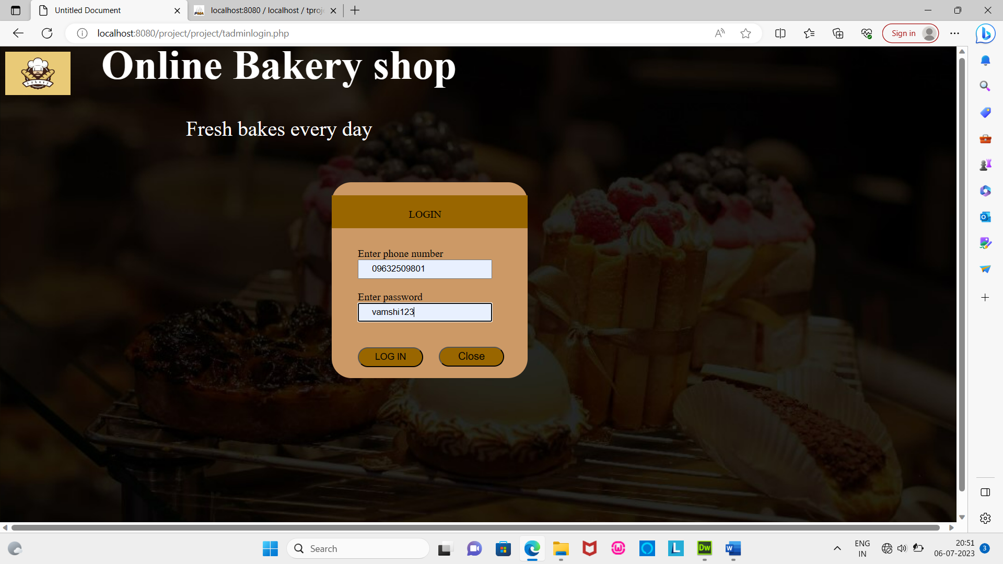

Admin home

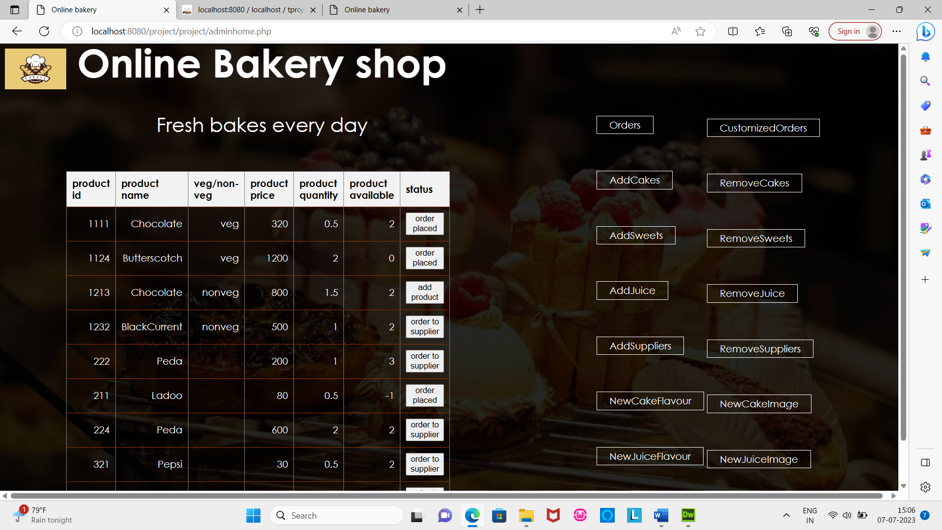

Orders

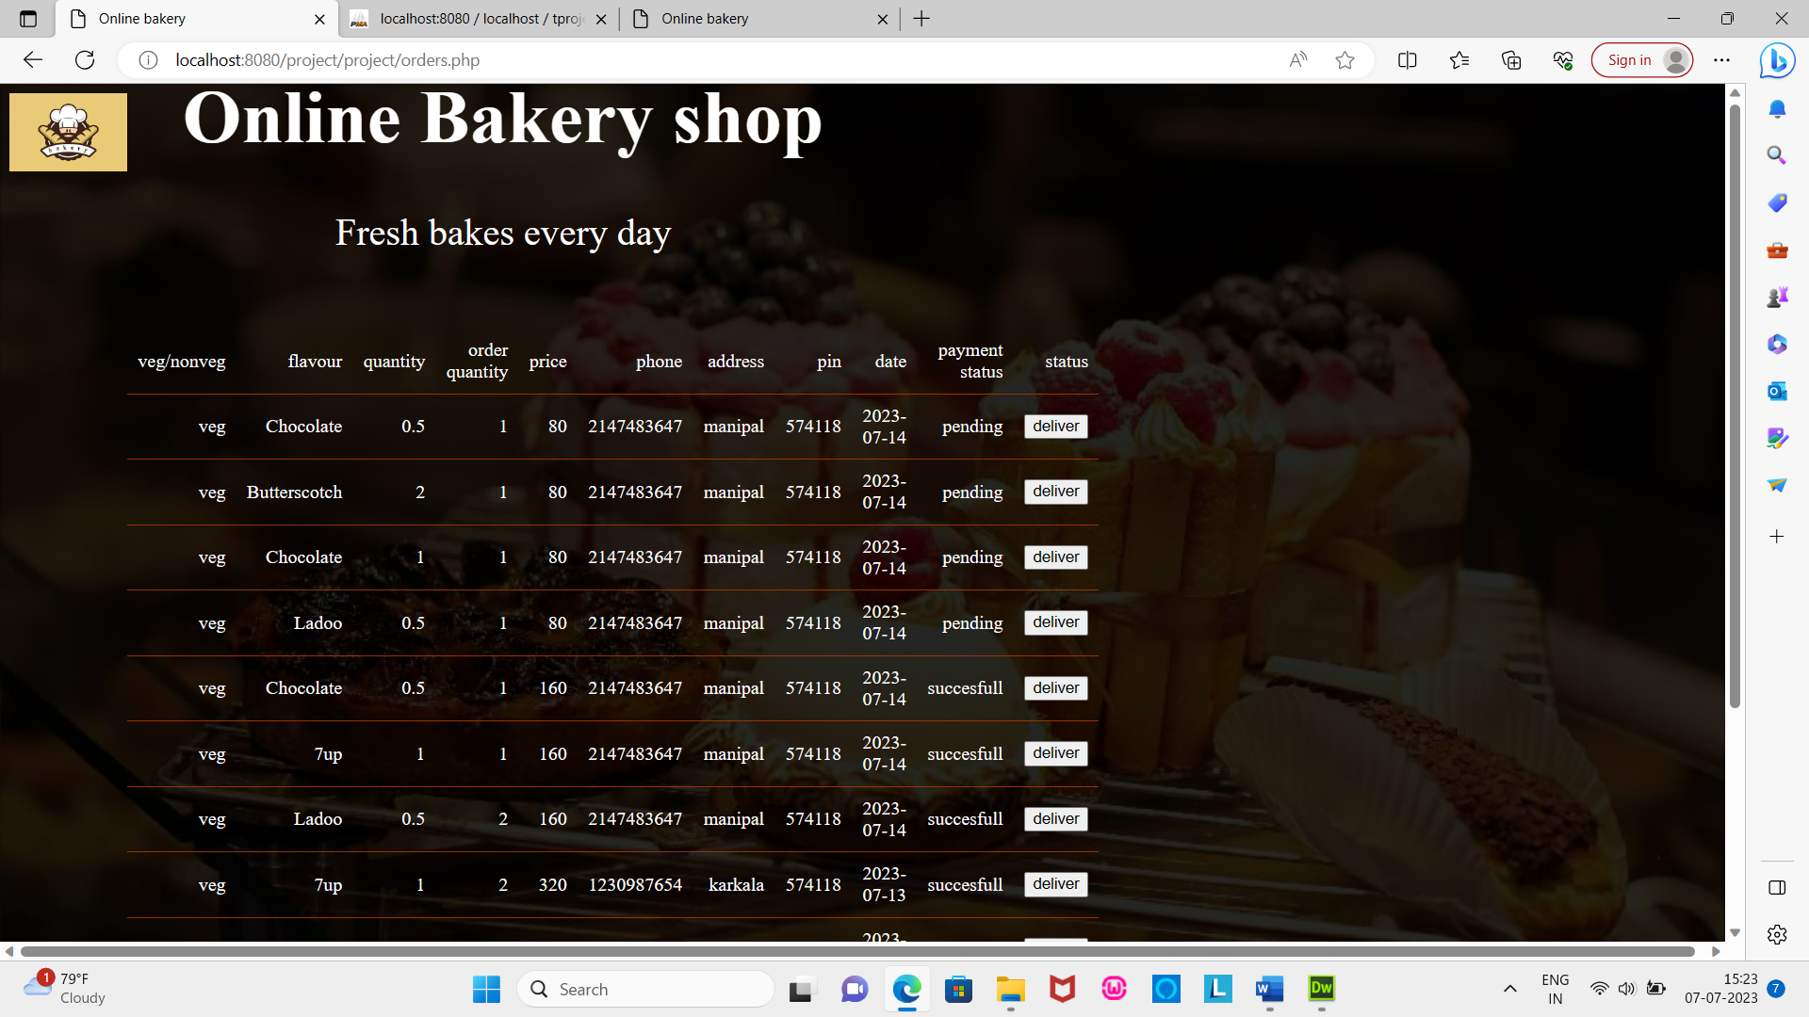

Customize order

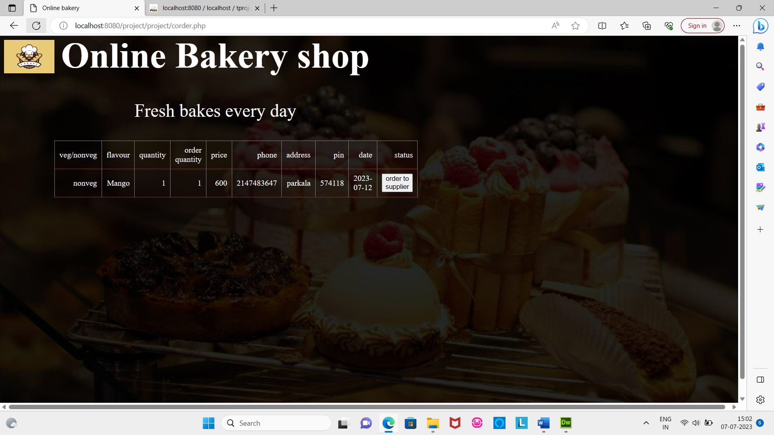

Add supplier

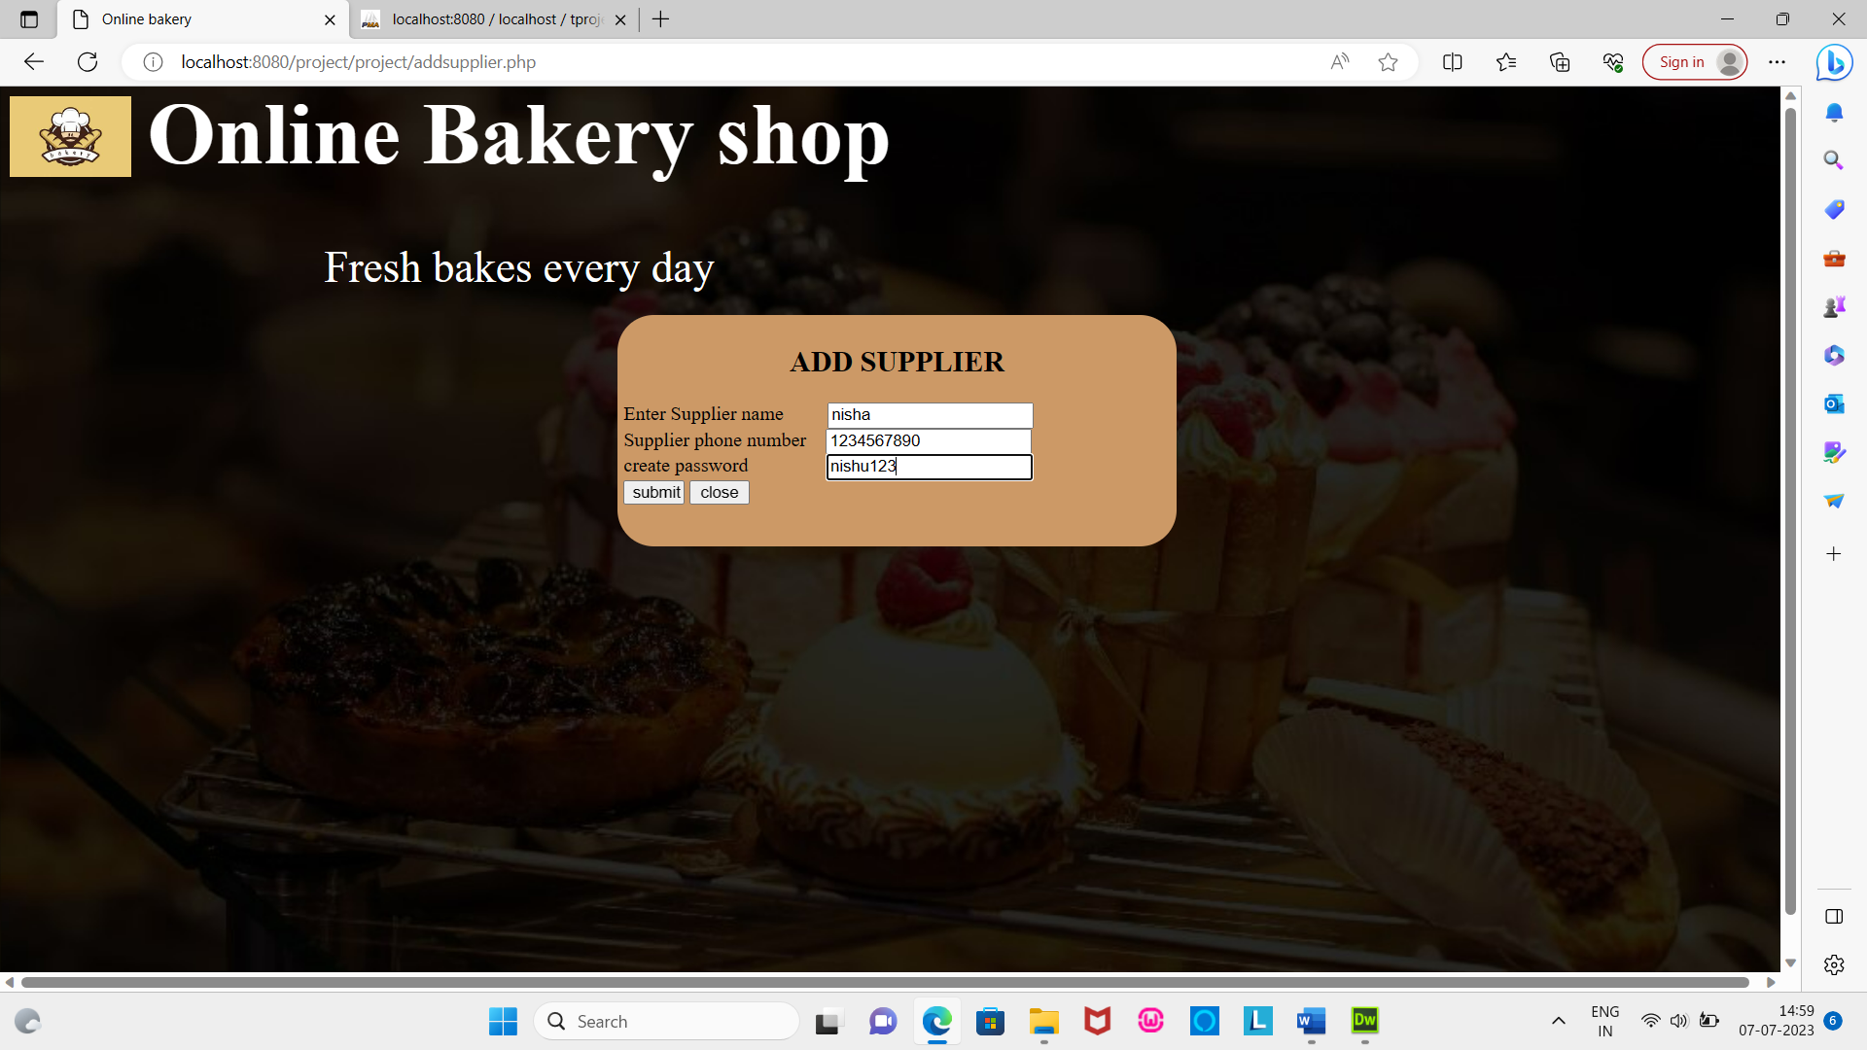

Remove Supplier

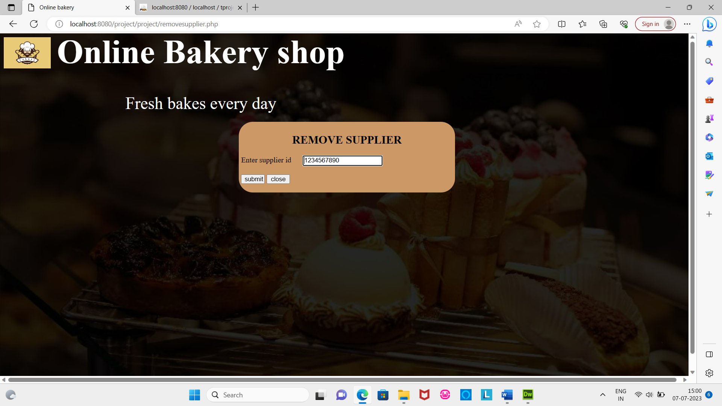

Add cake

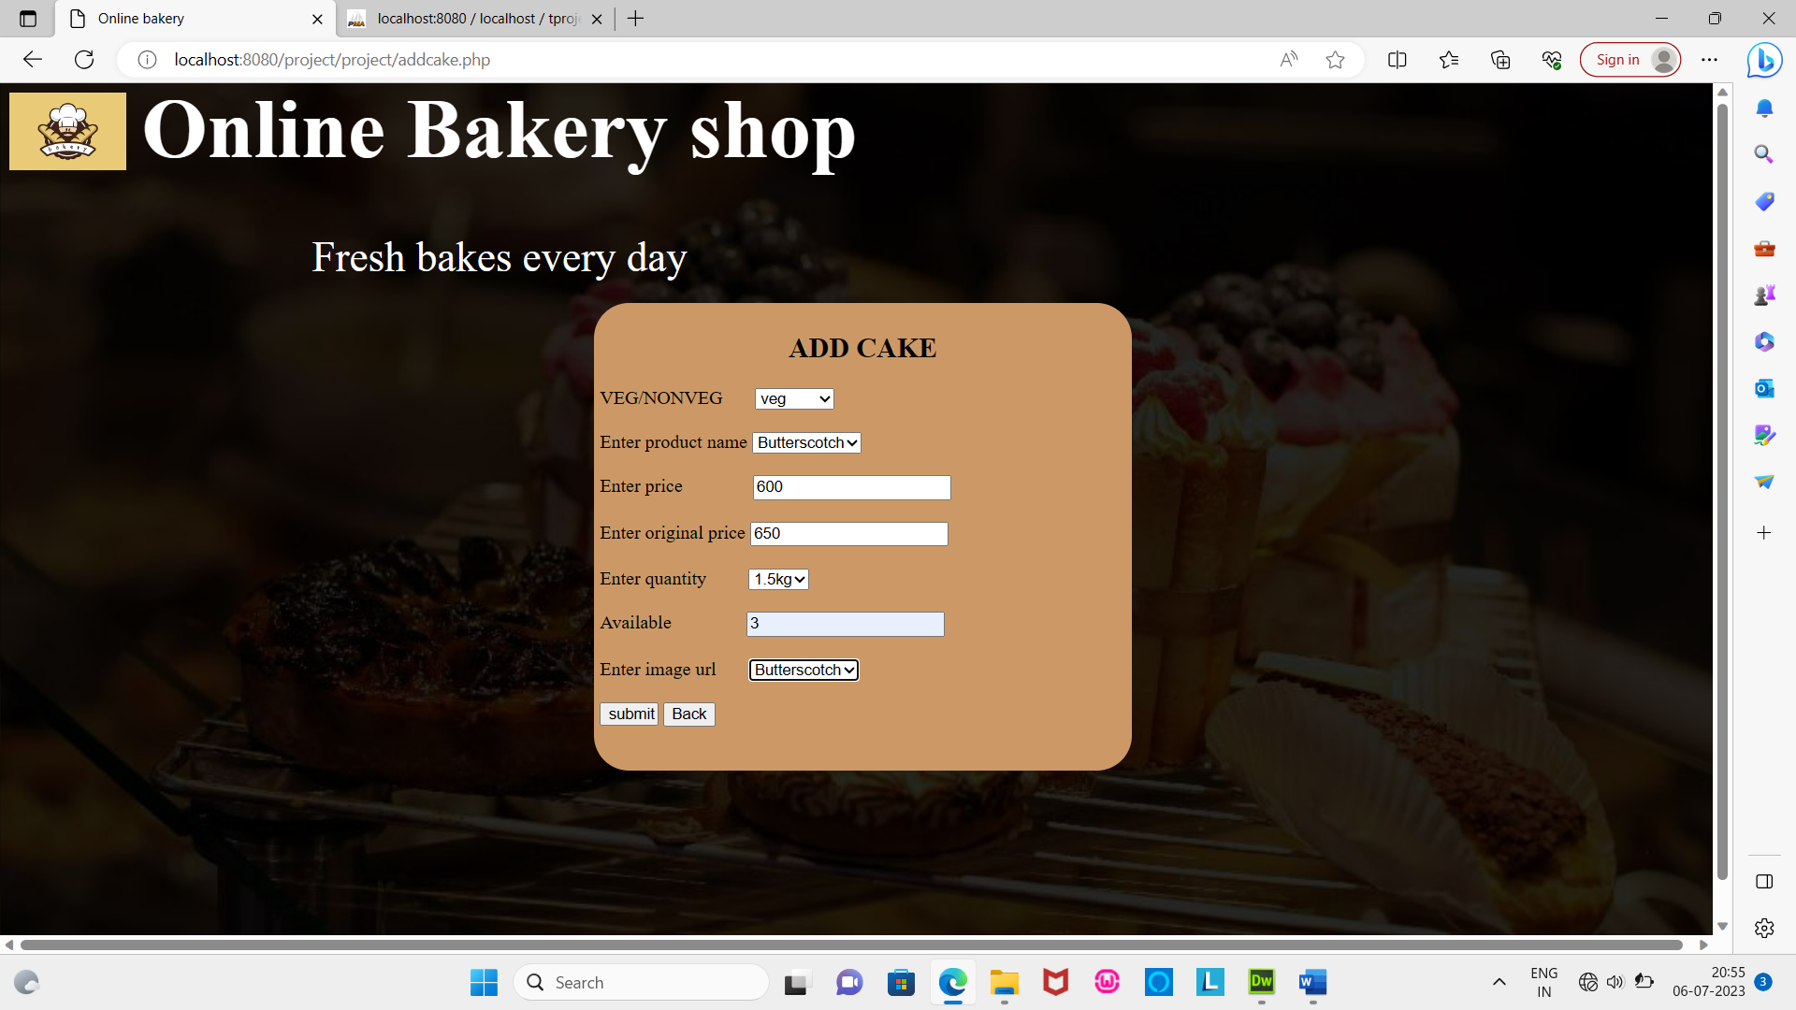

Remove cake

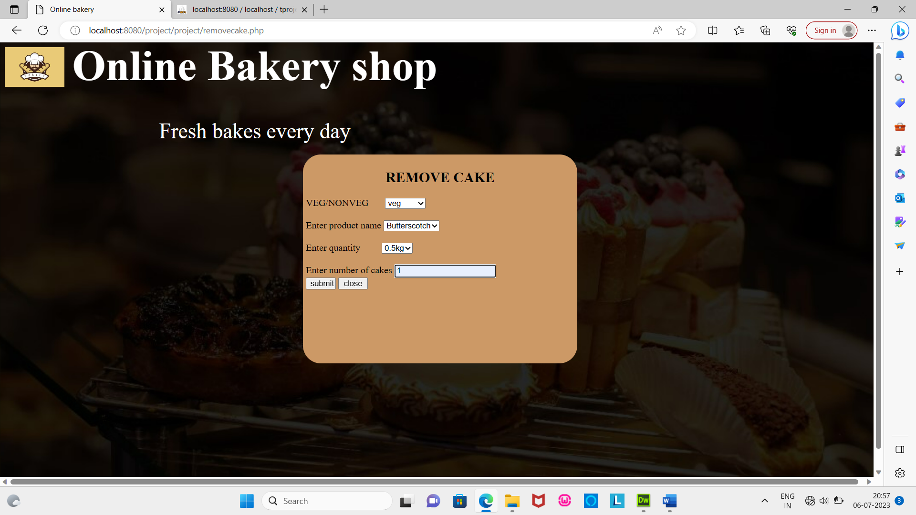

Add sweets

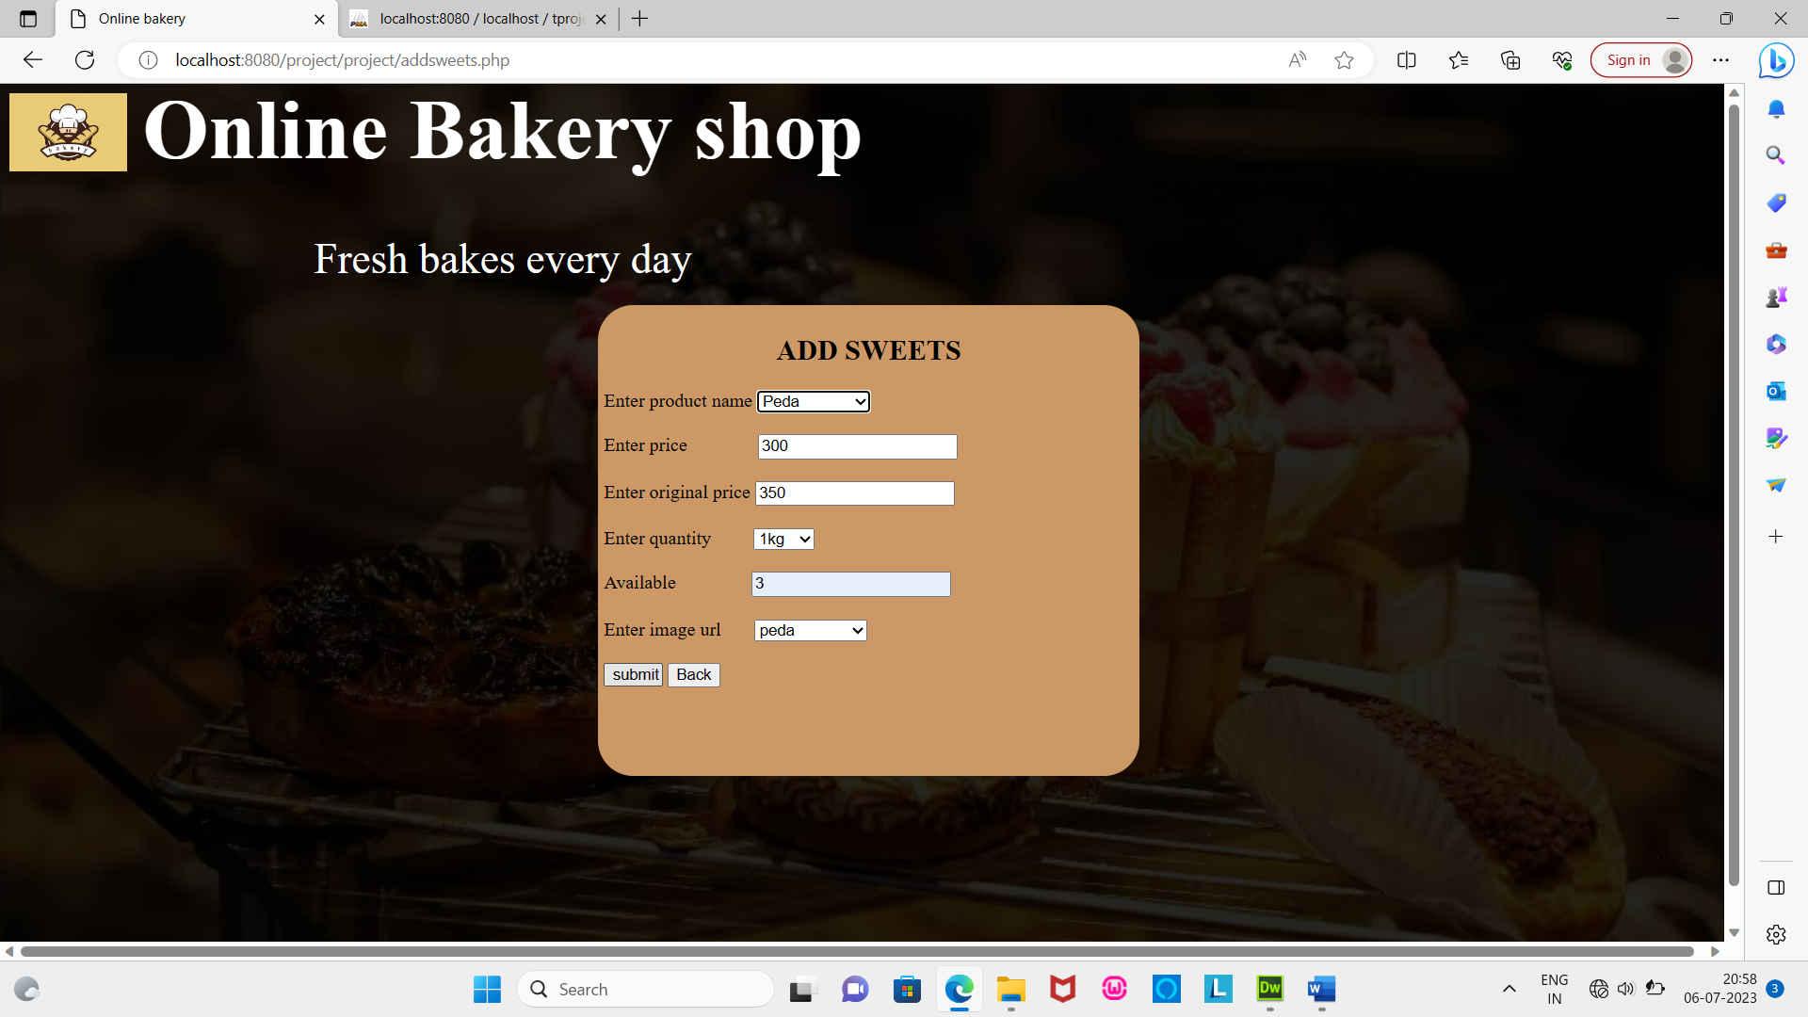

Remove sweets

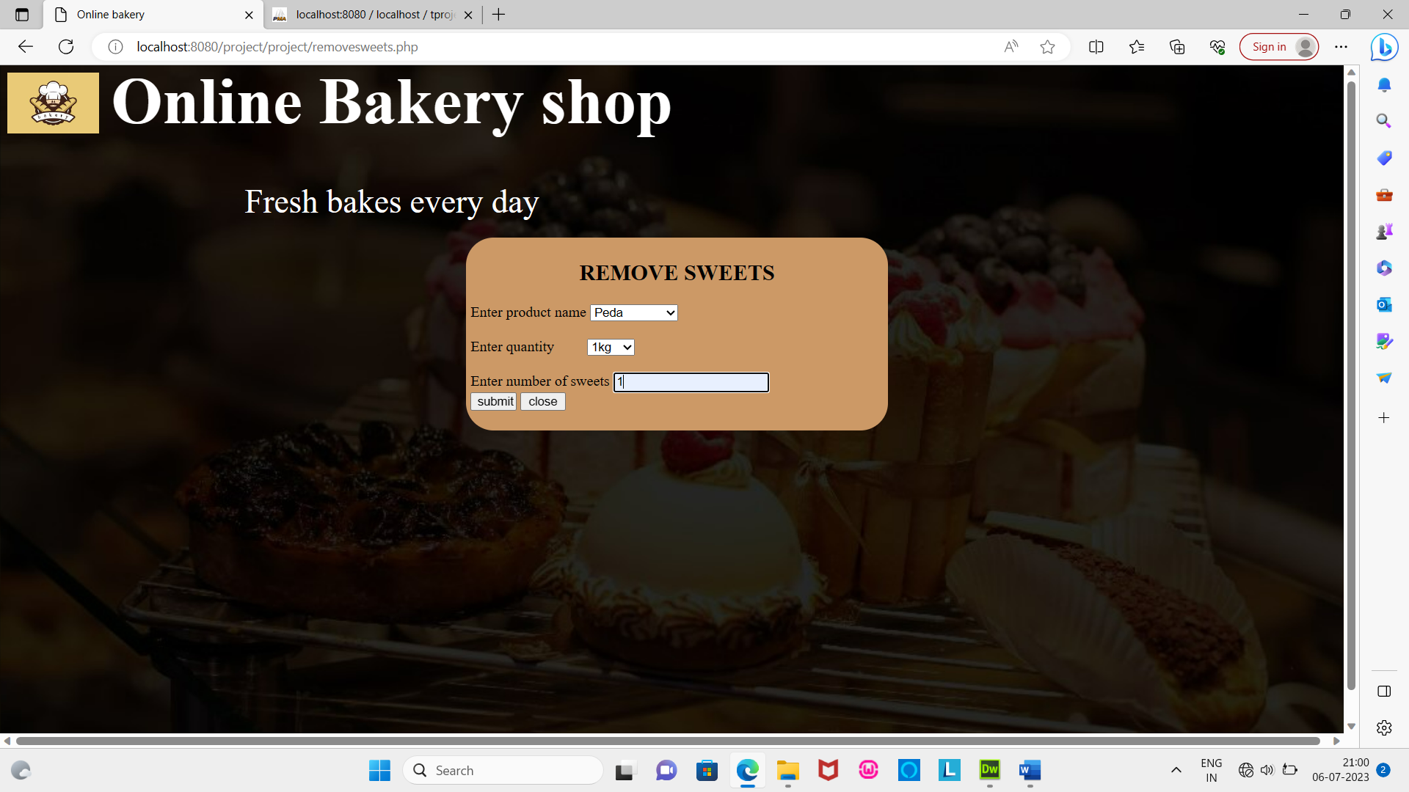

Add juice

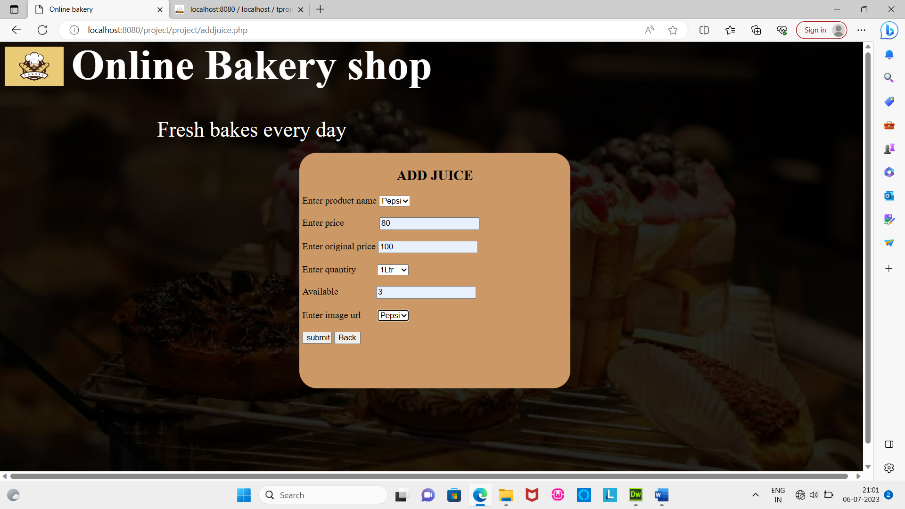

Remove juice

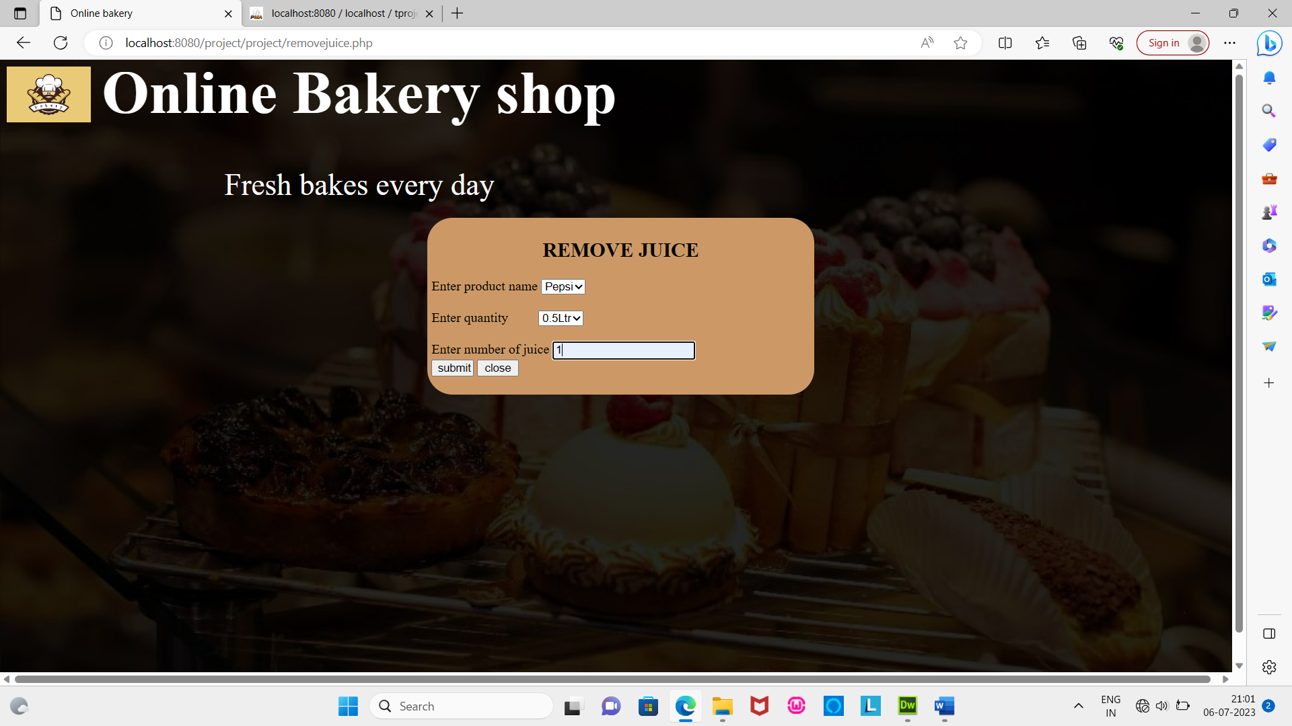

Add new cake flavour and image

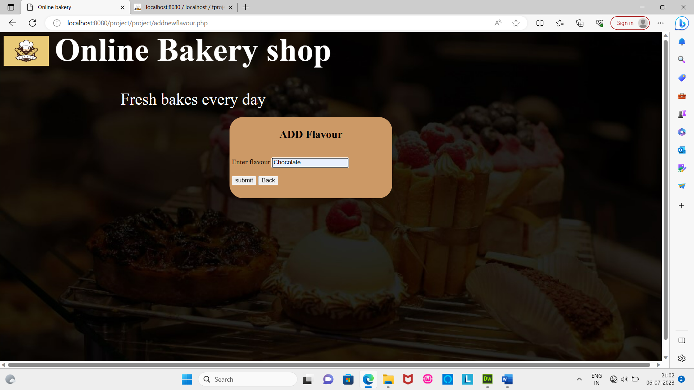 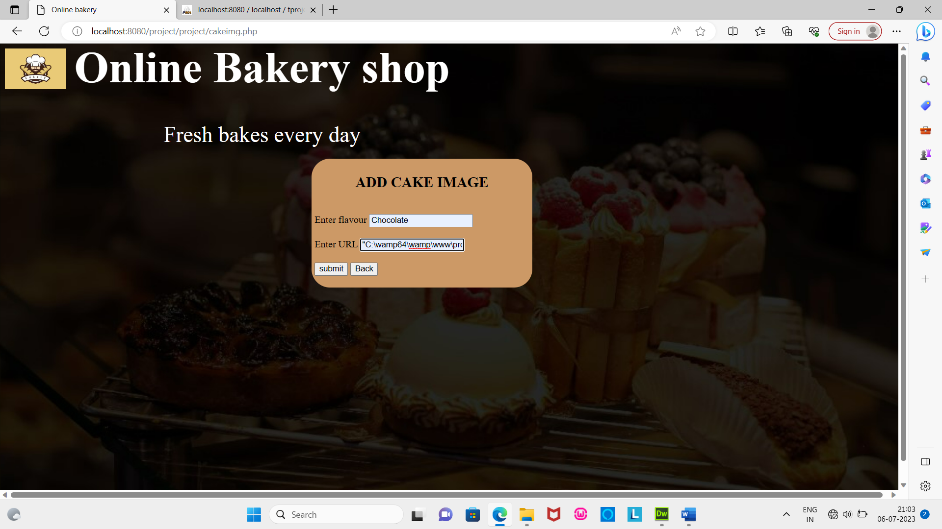

Add new juice flavour and image

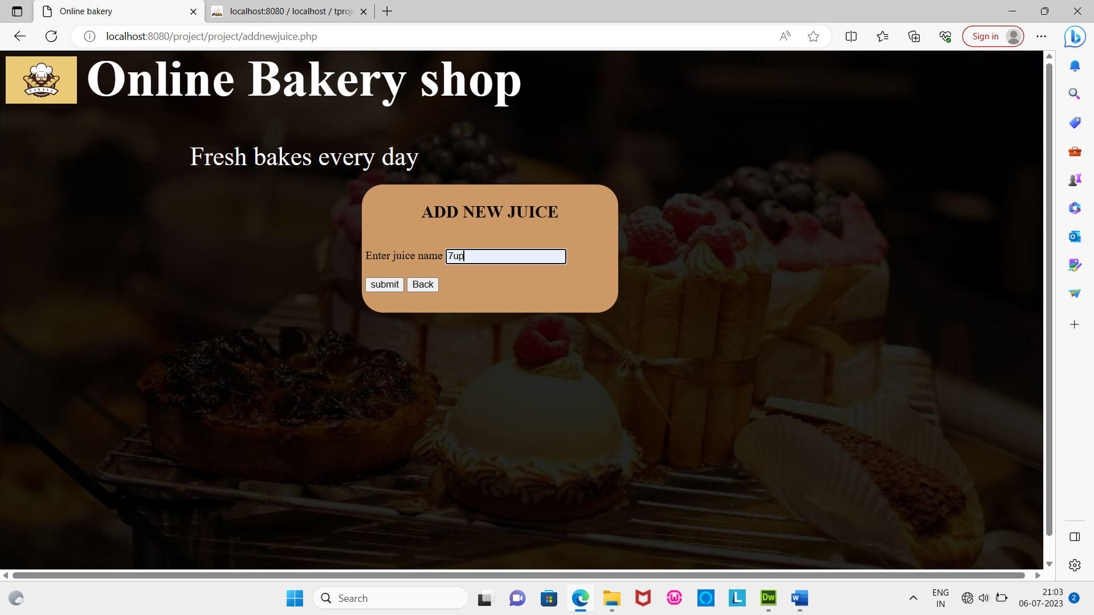 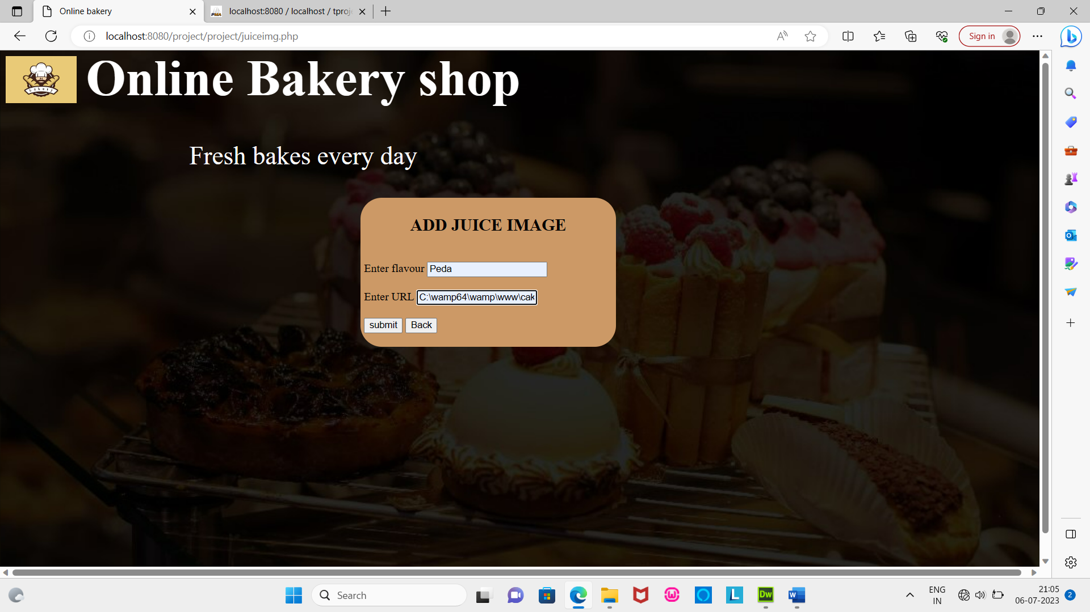

Add new sweet flavour and image

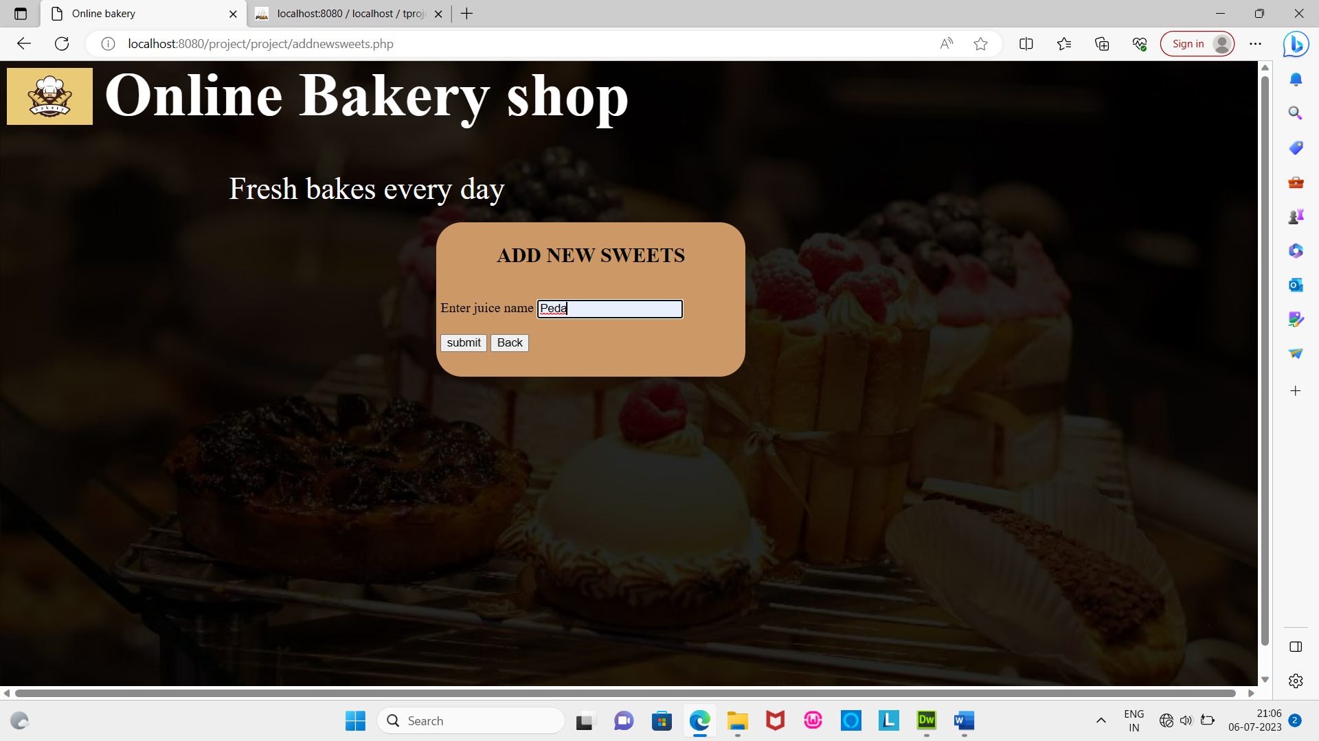 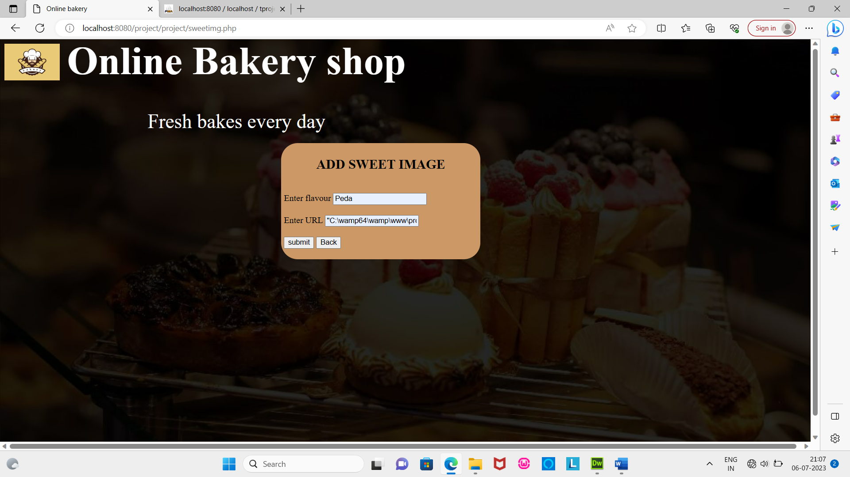

**Customer view:**

Customer Registration:

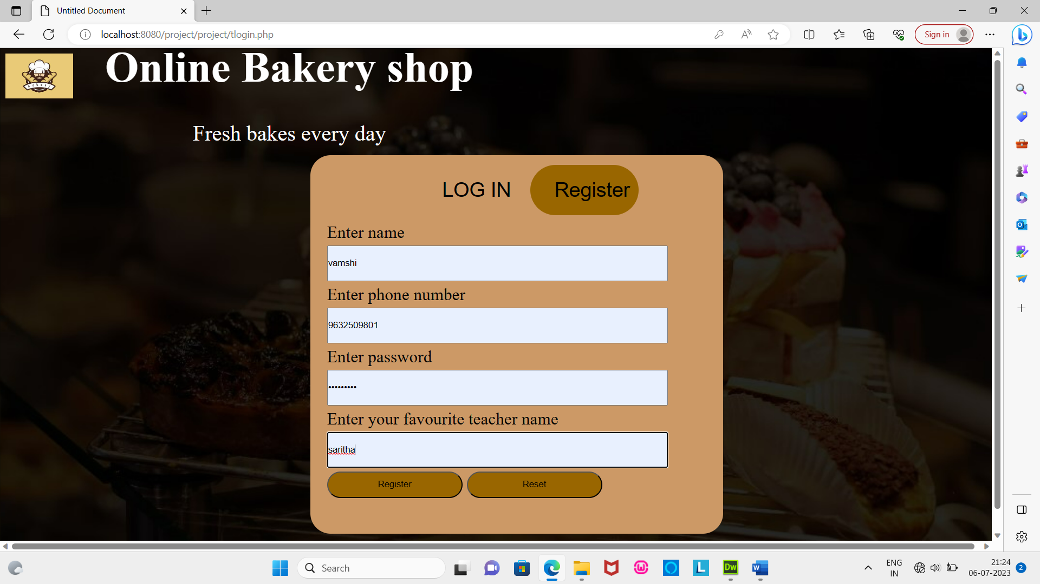

Customer login

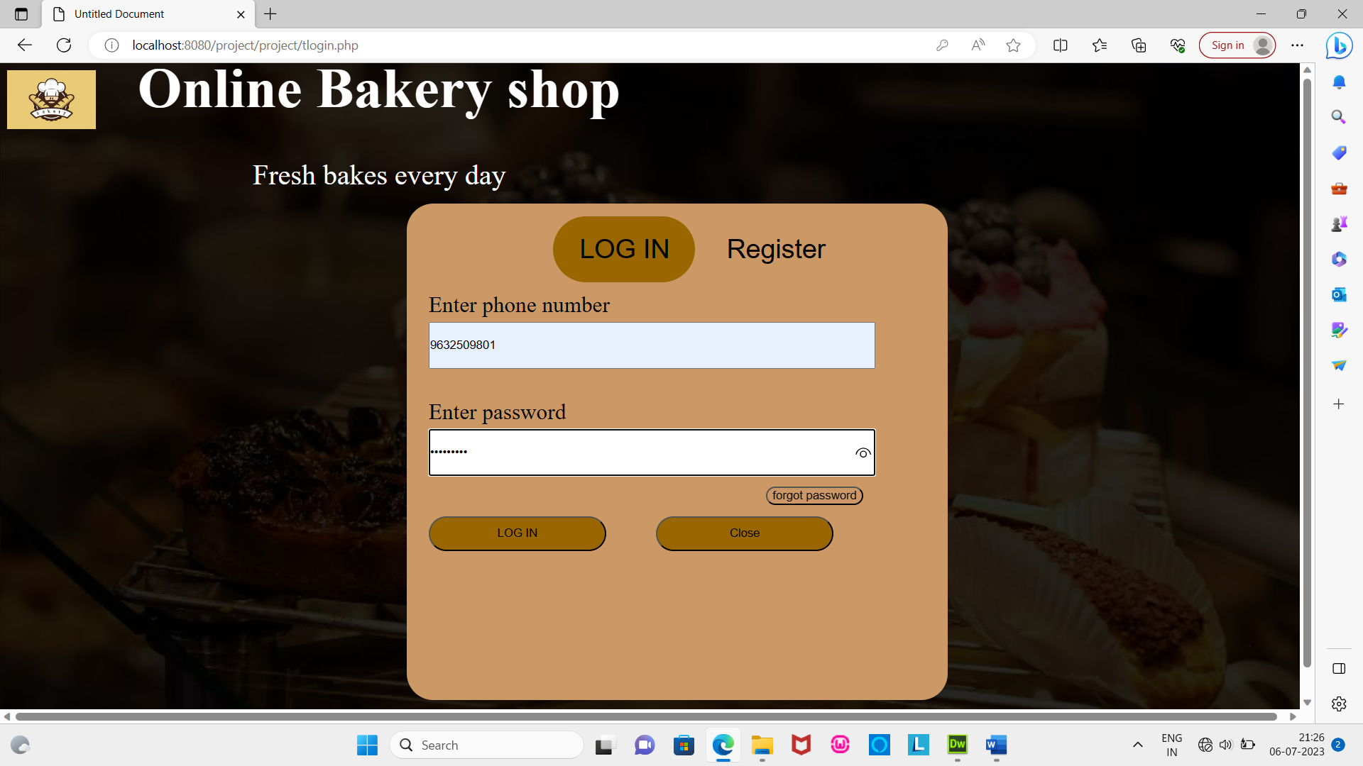

Forgot password

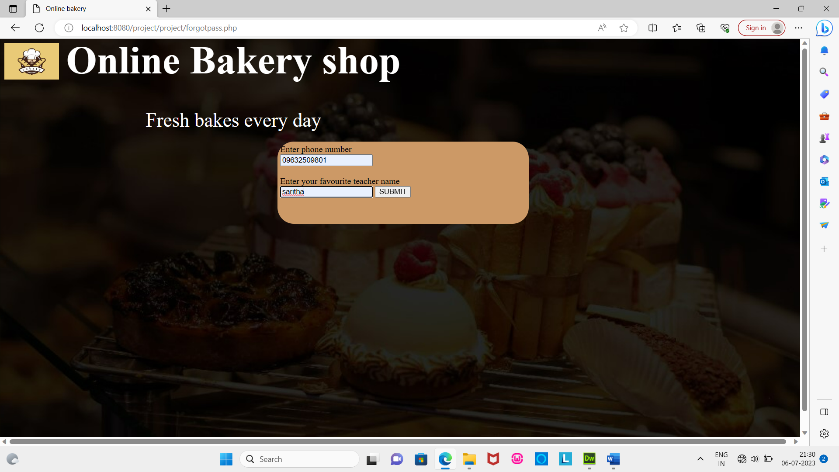

Change password

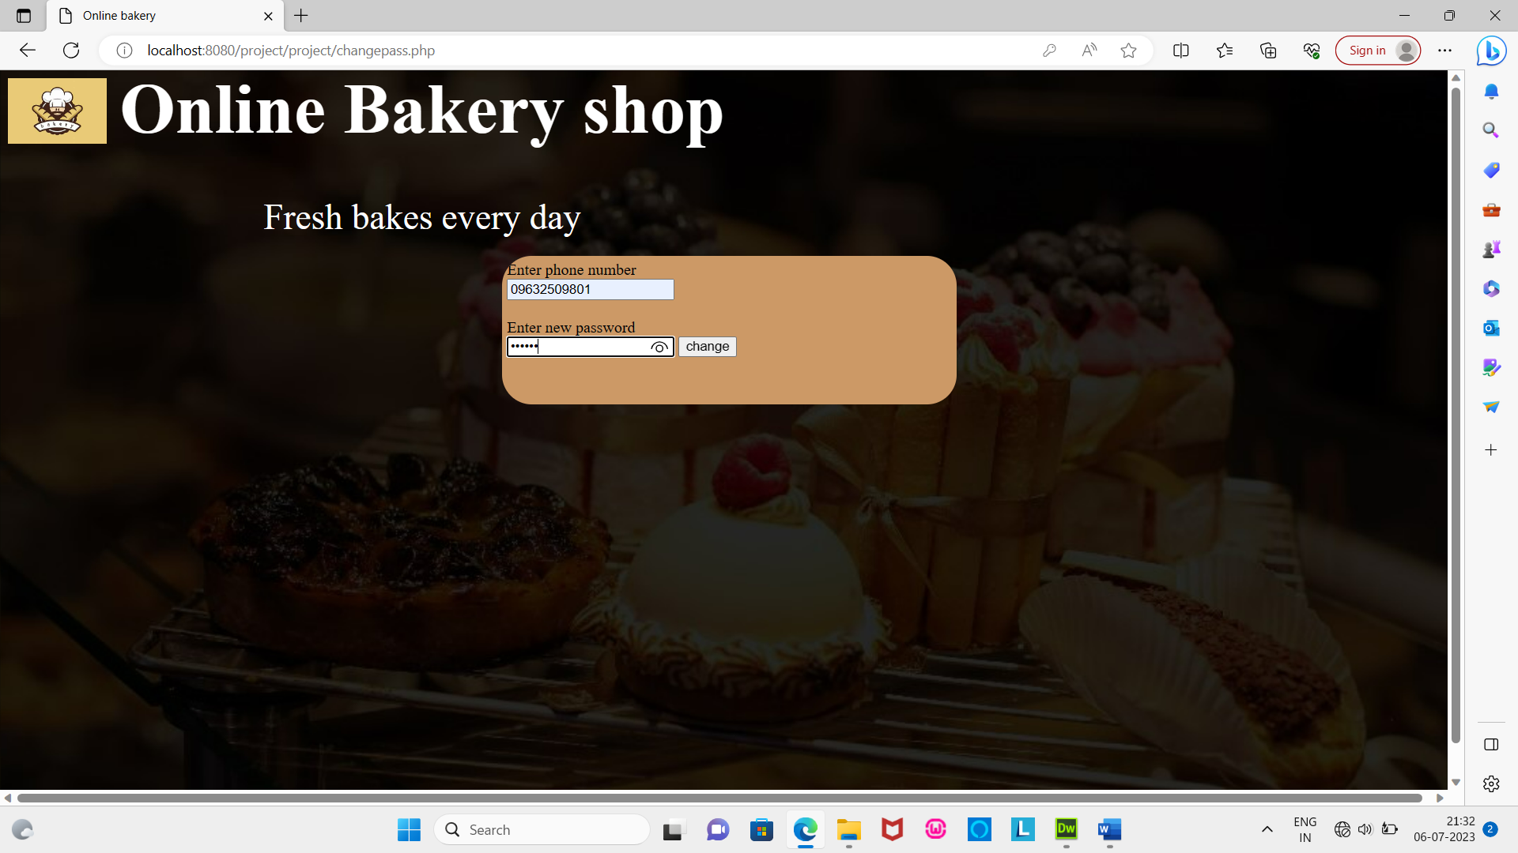

Login

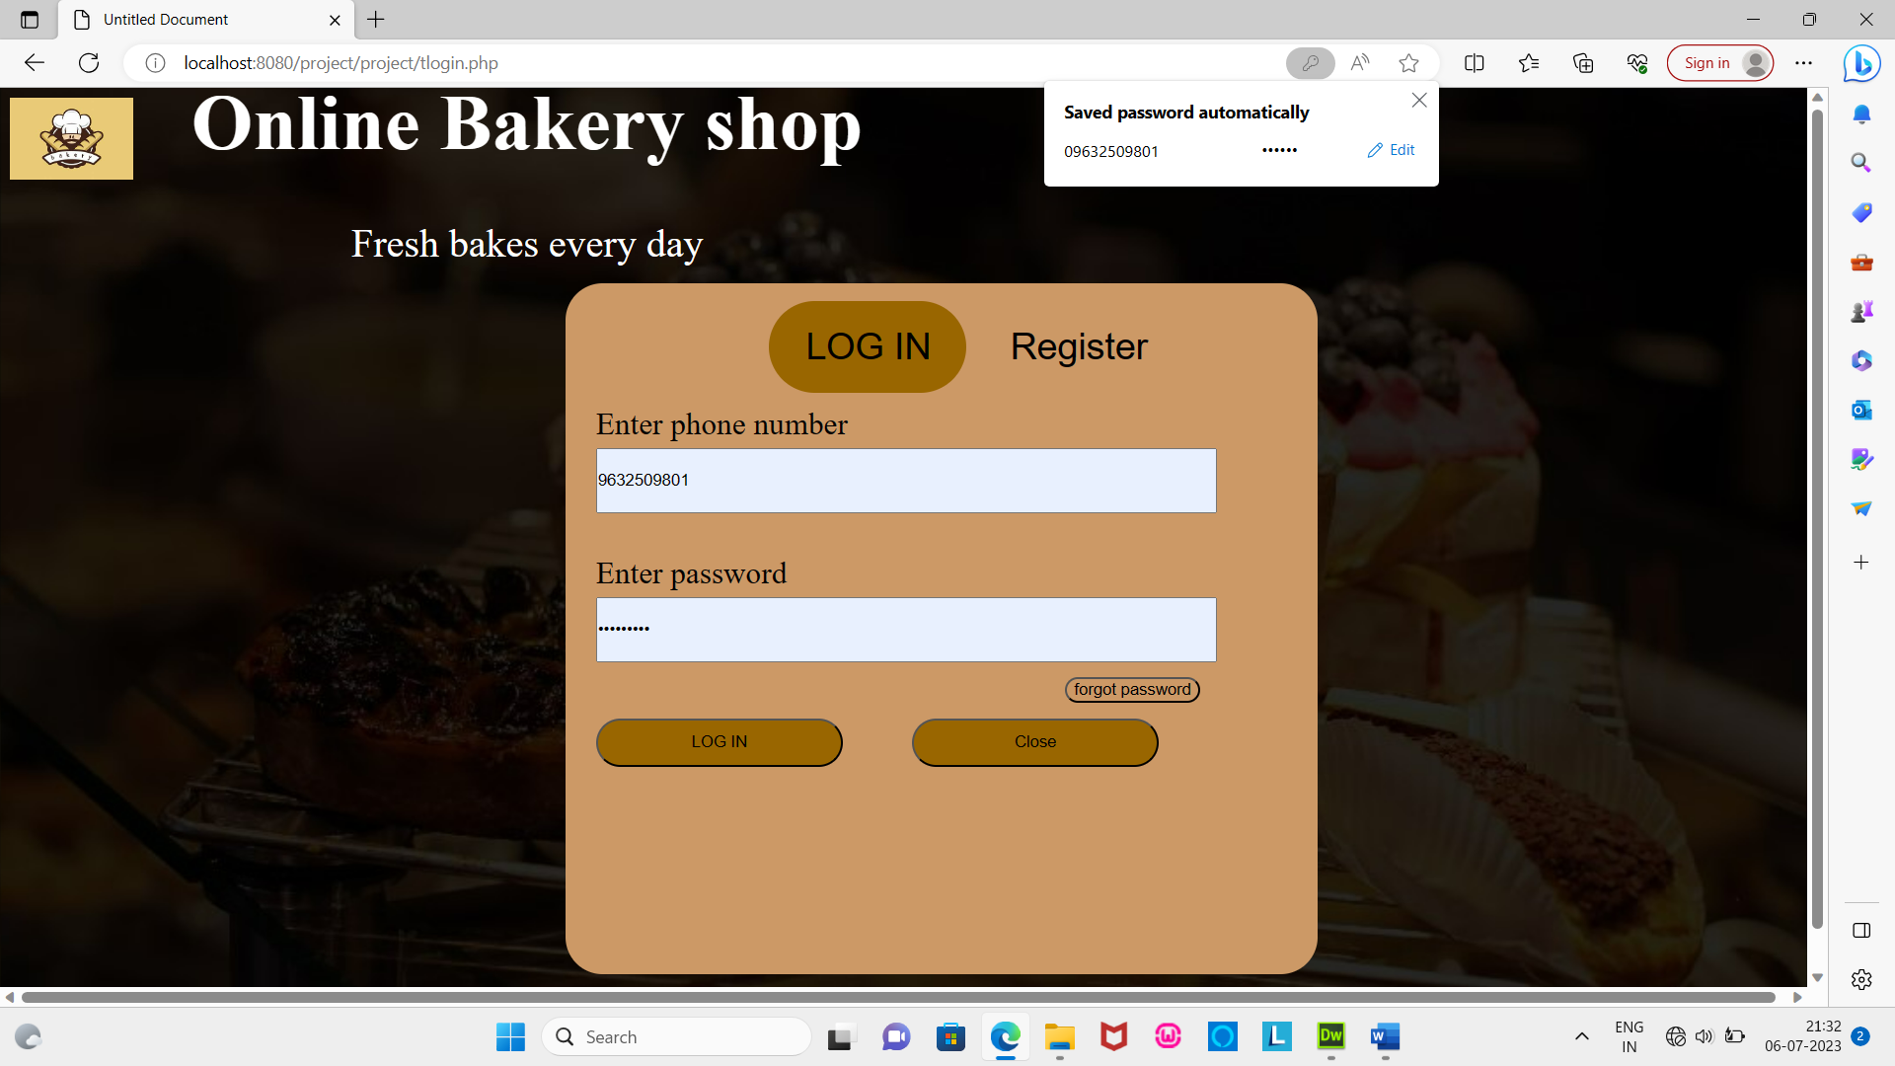

Customer home

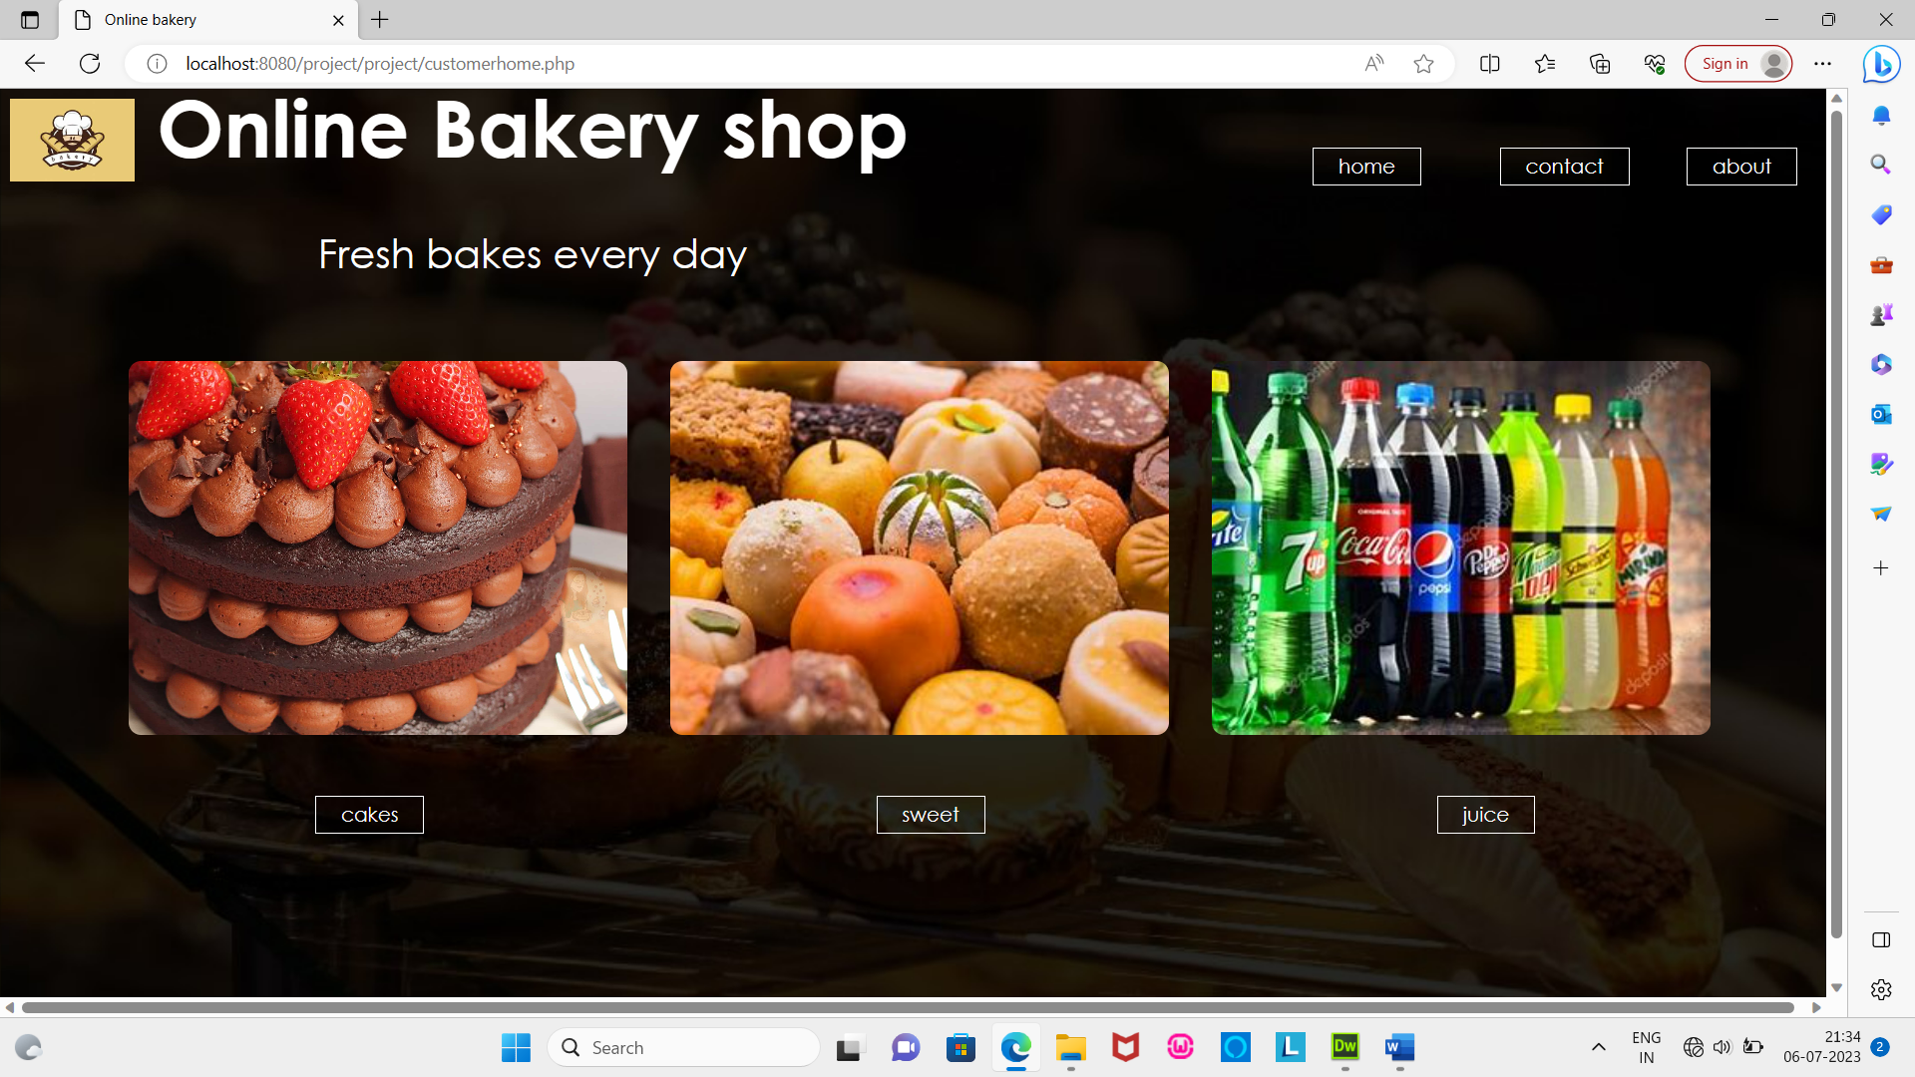

Contact us page

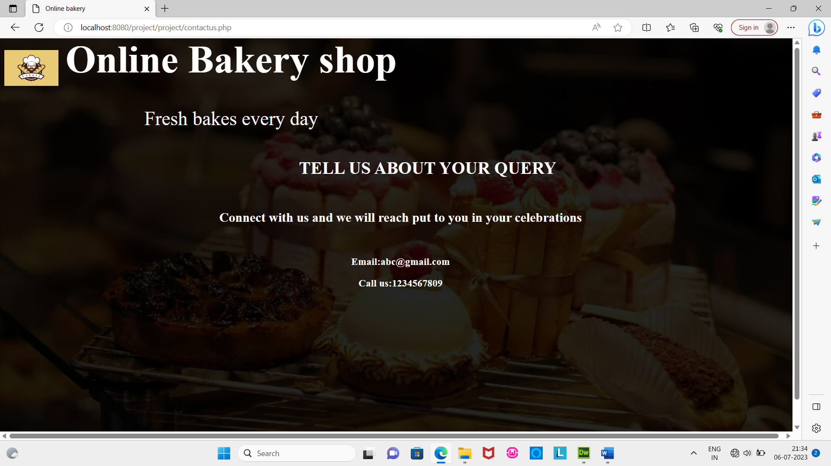

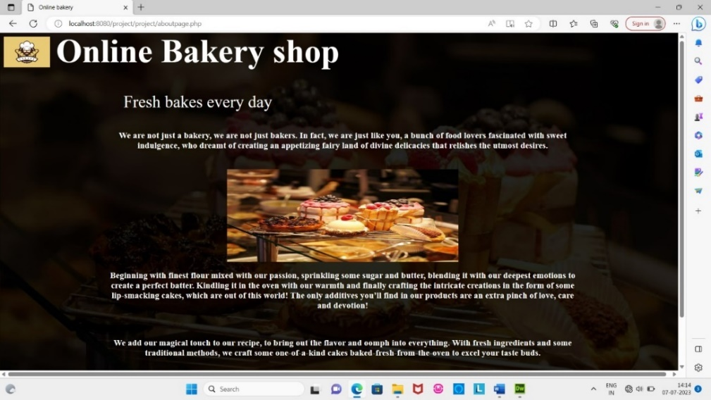About page

Cake Page

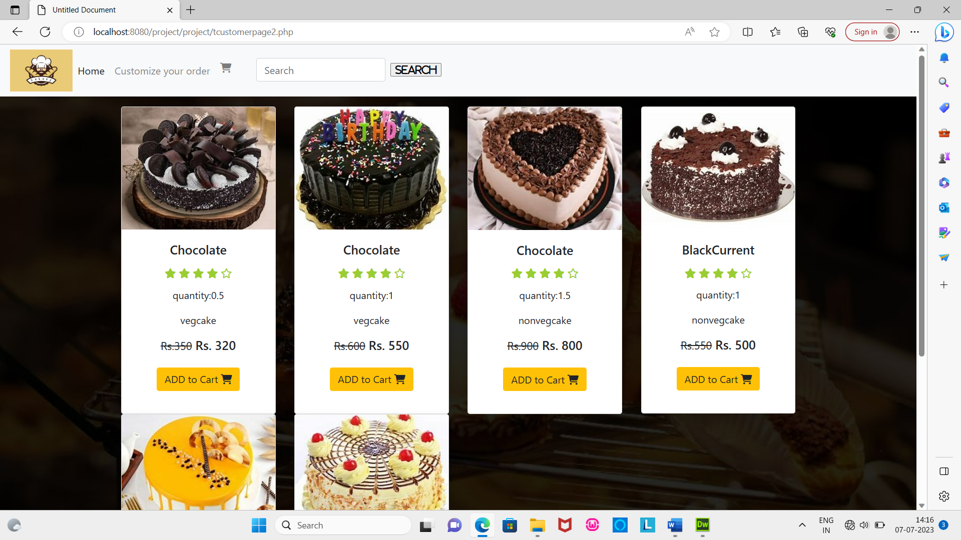  
Customizing the order

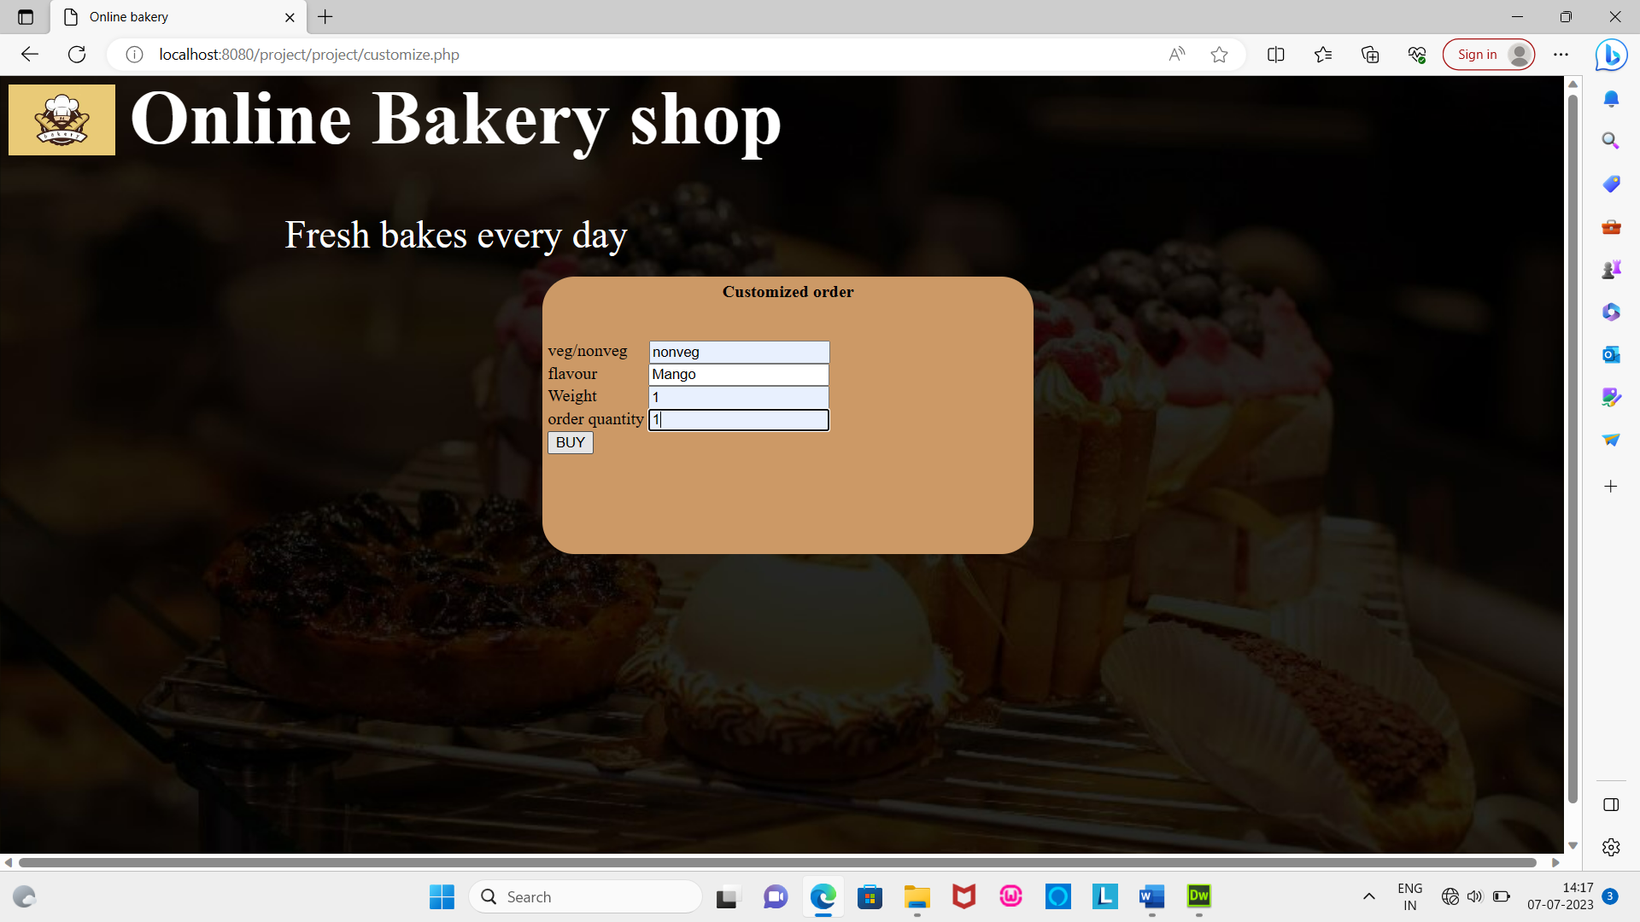 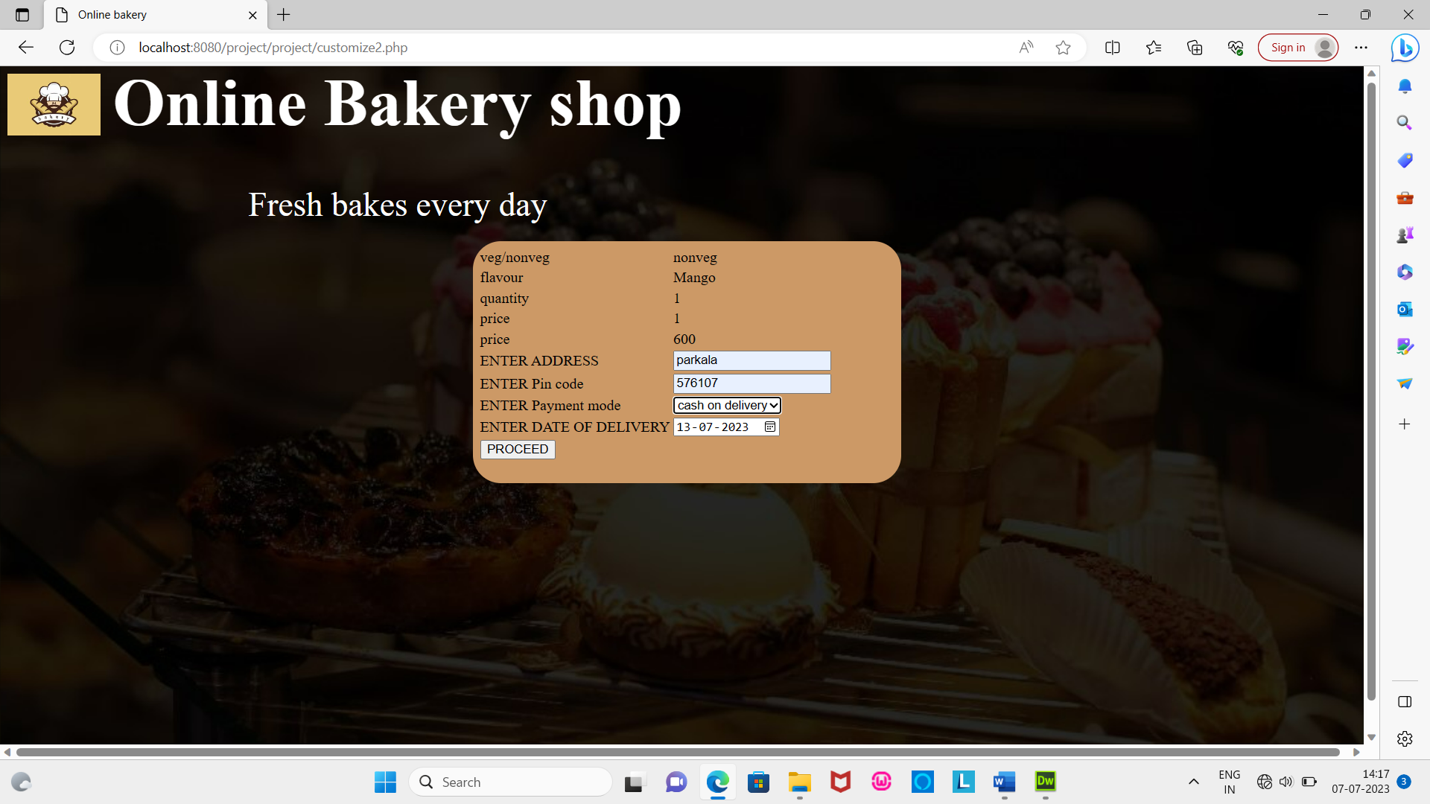

Sweets page

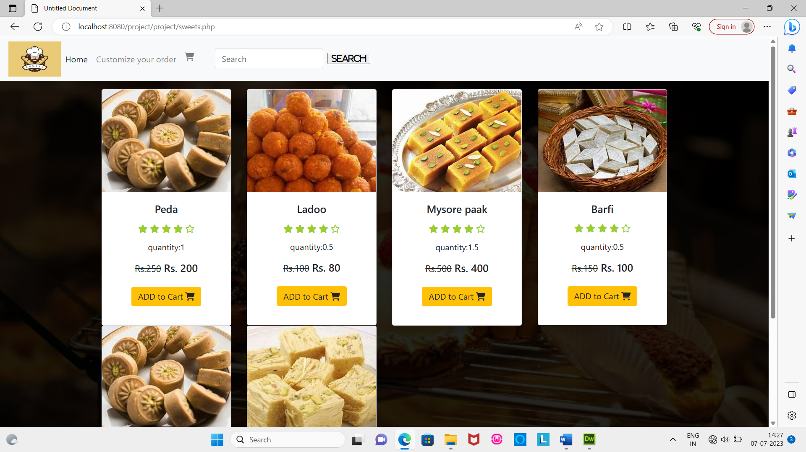

Juice page

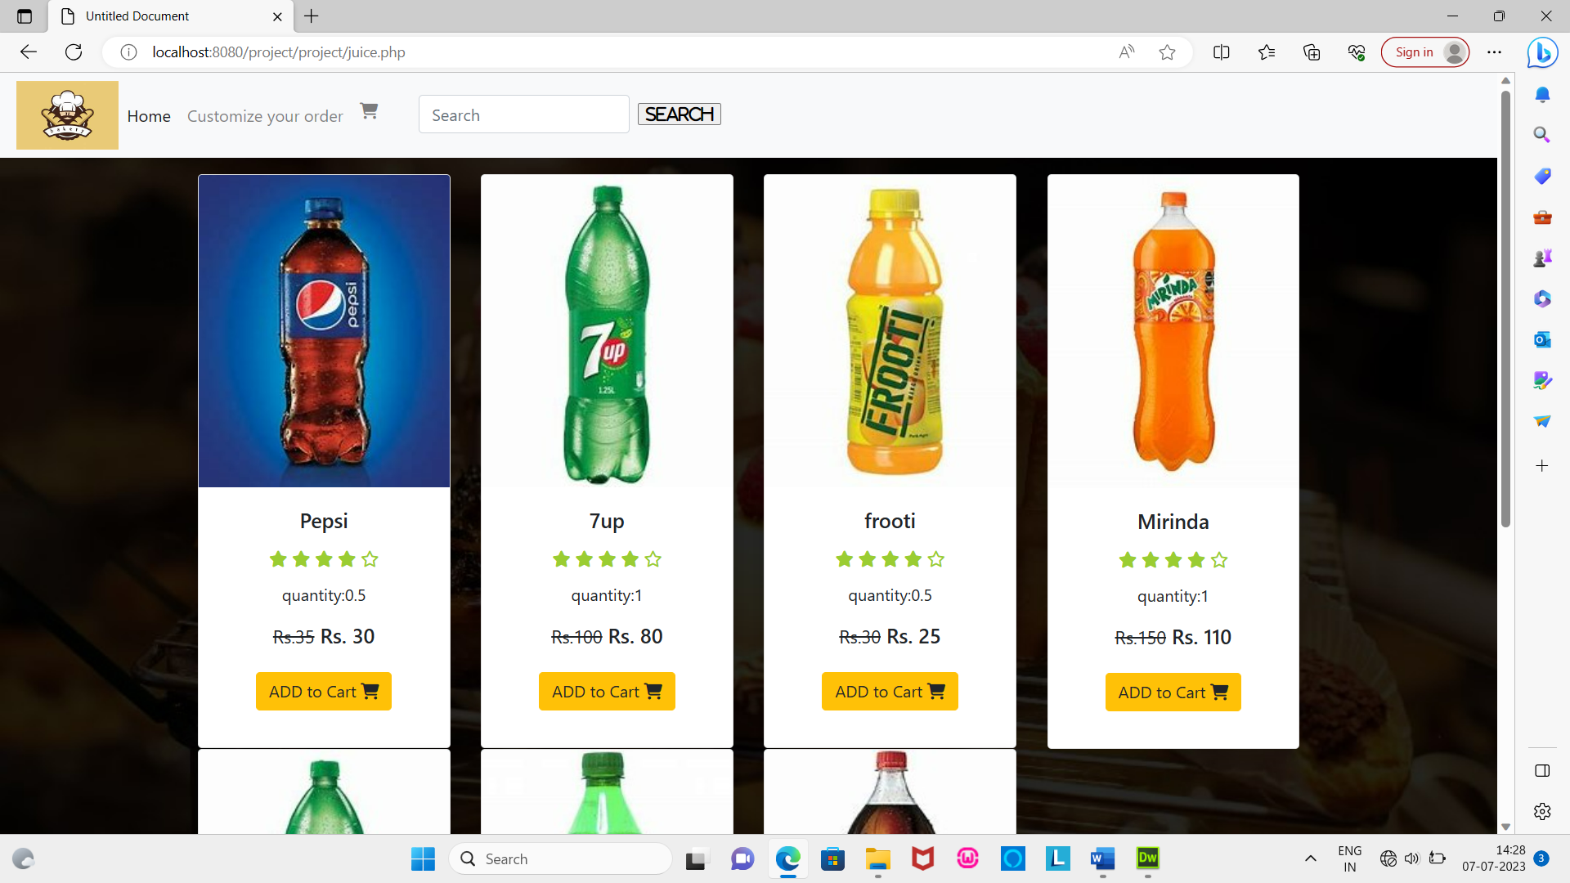

Cart

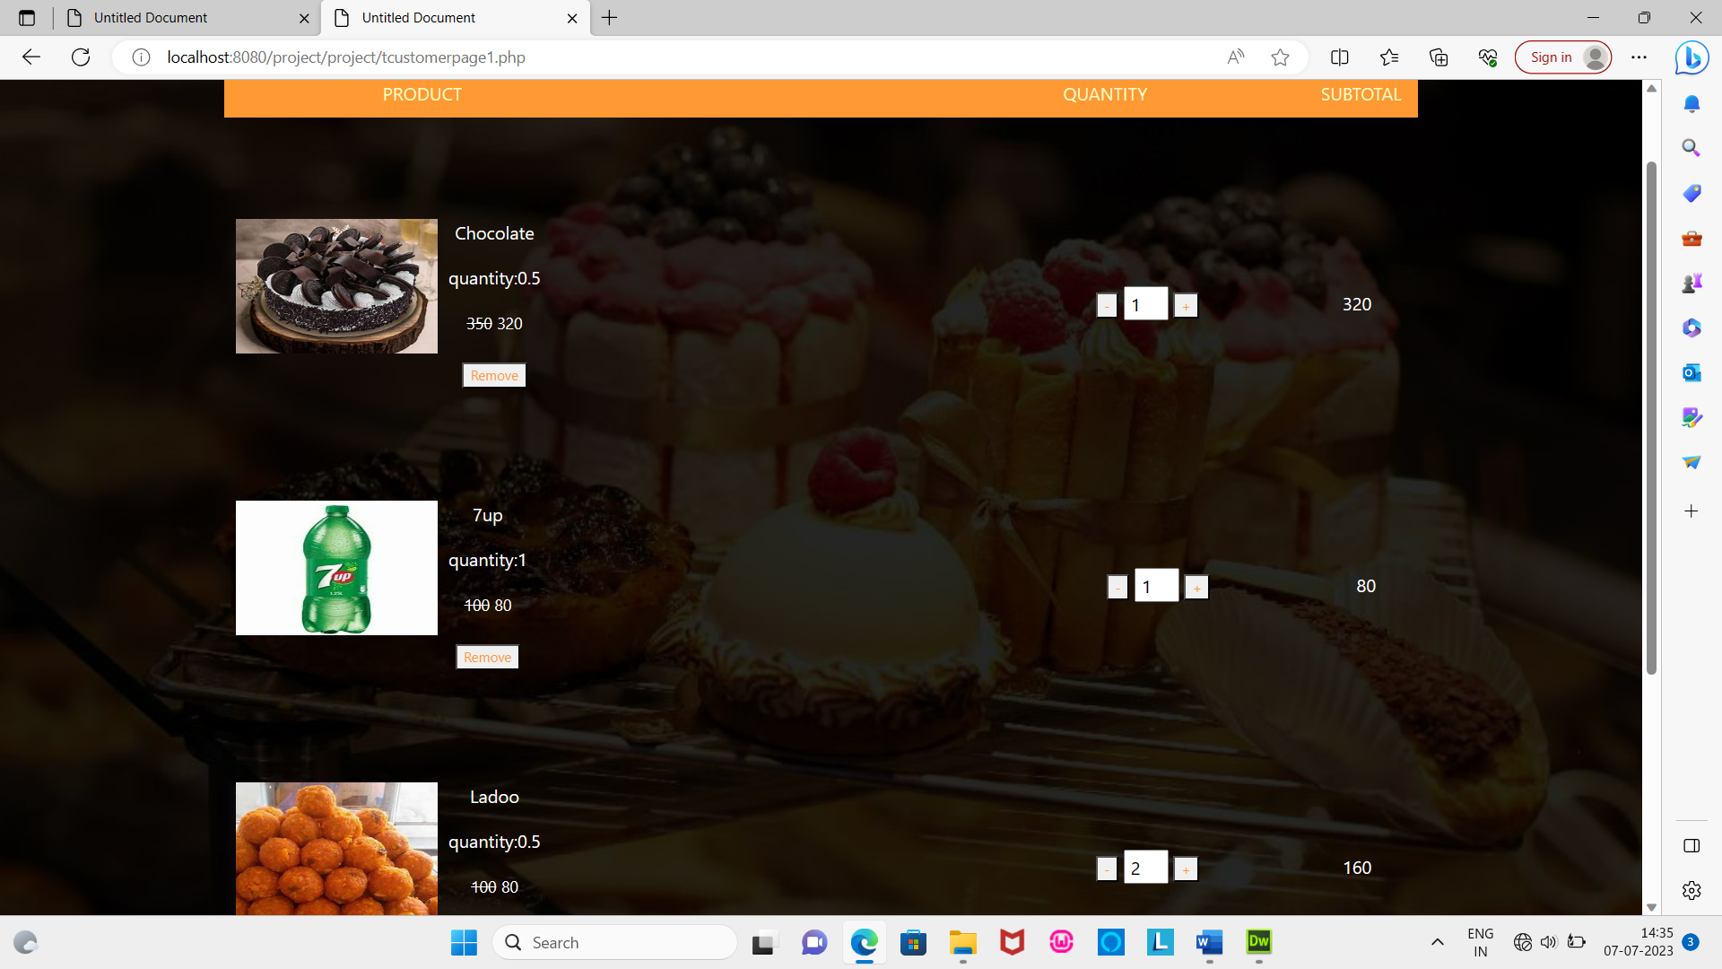

Bill

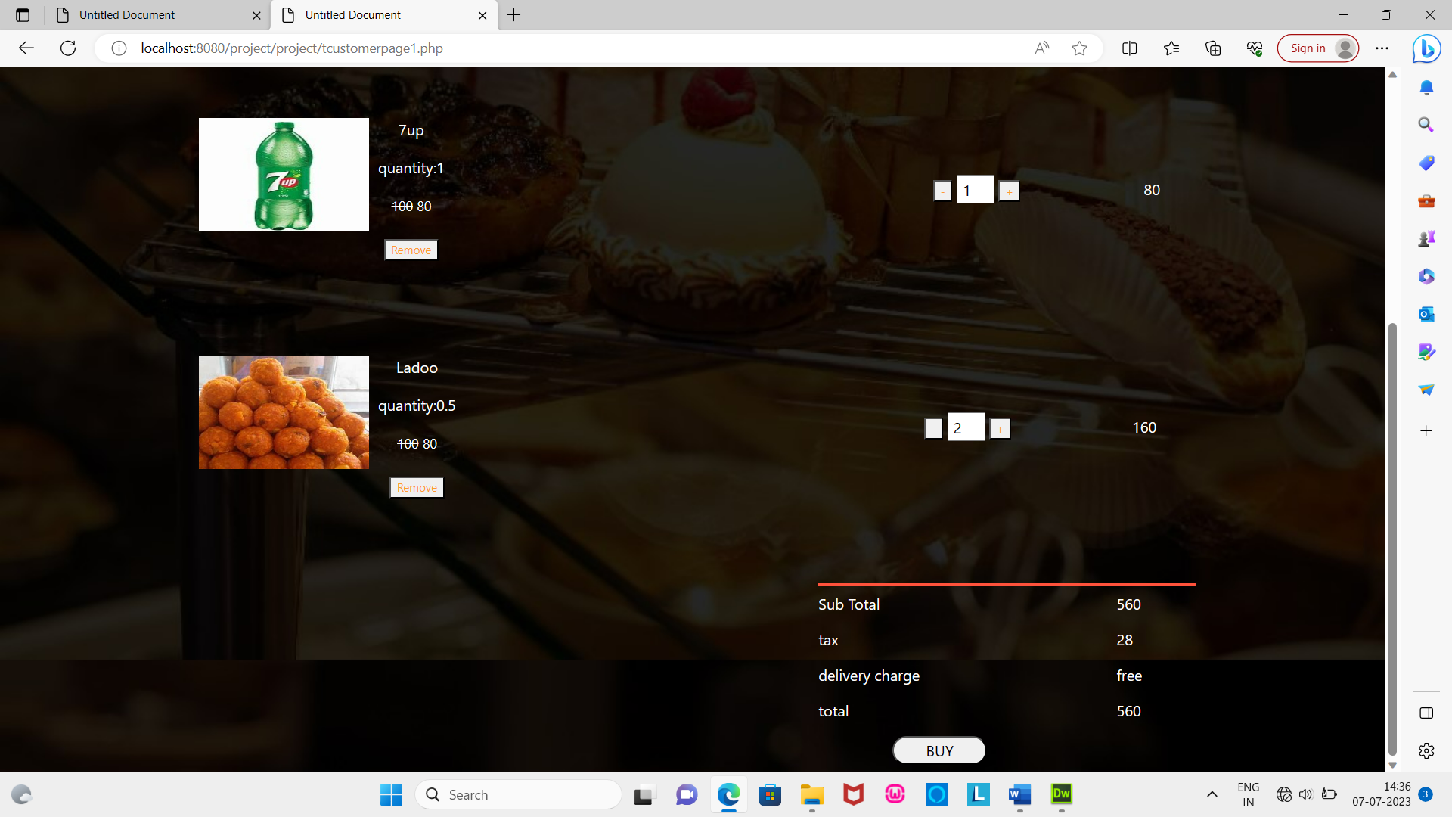 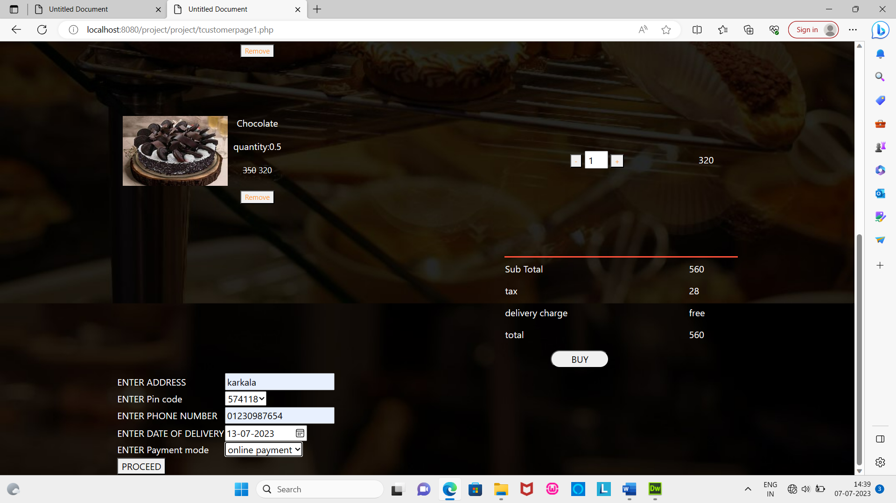

Online Payment

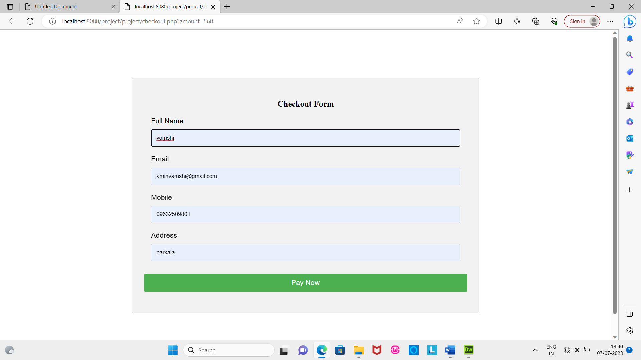

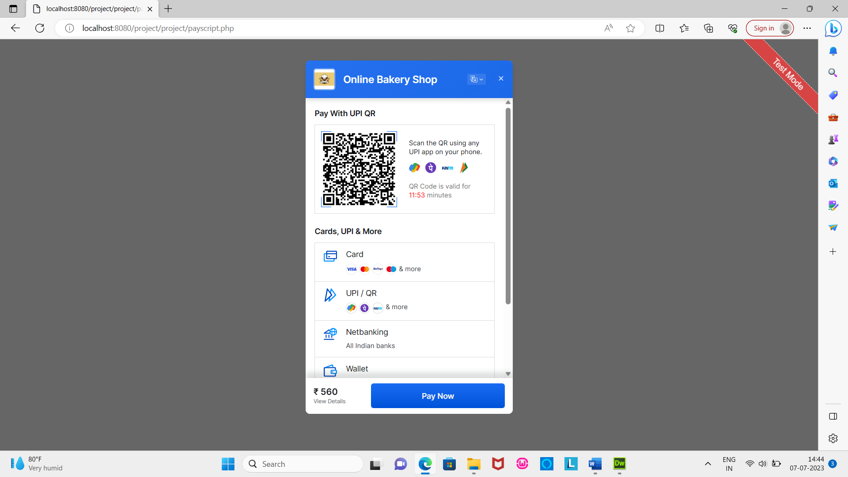 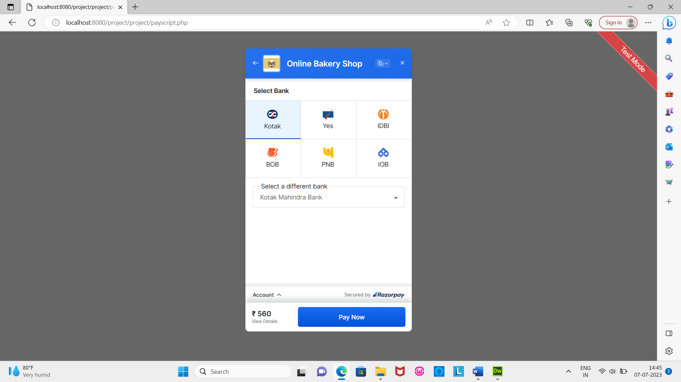 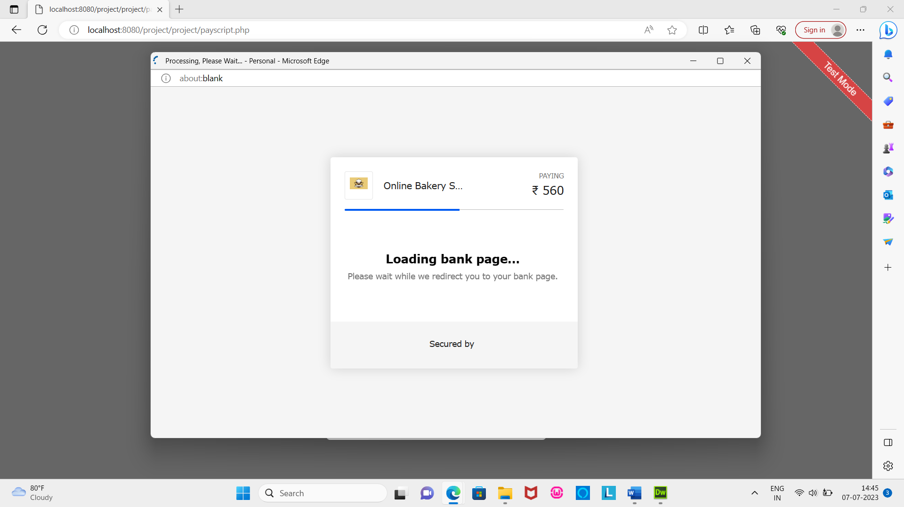

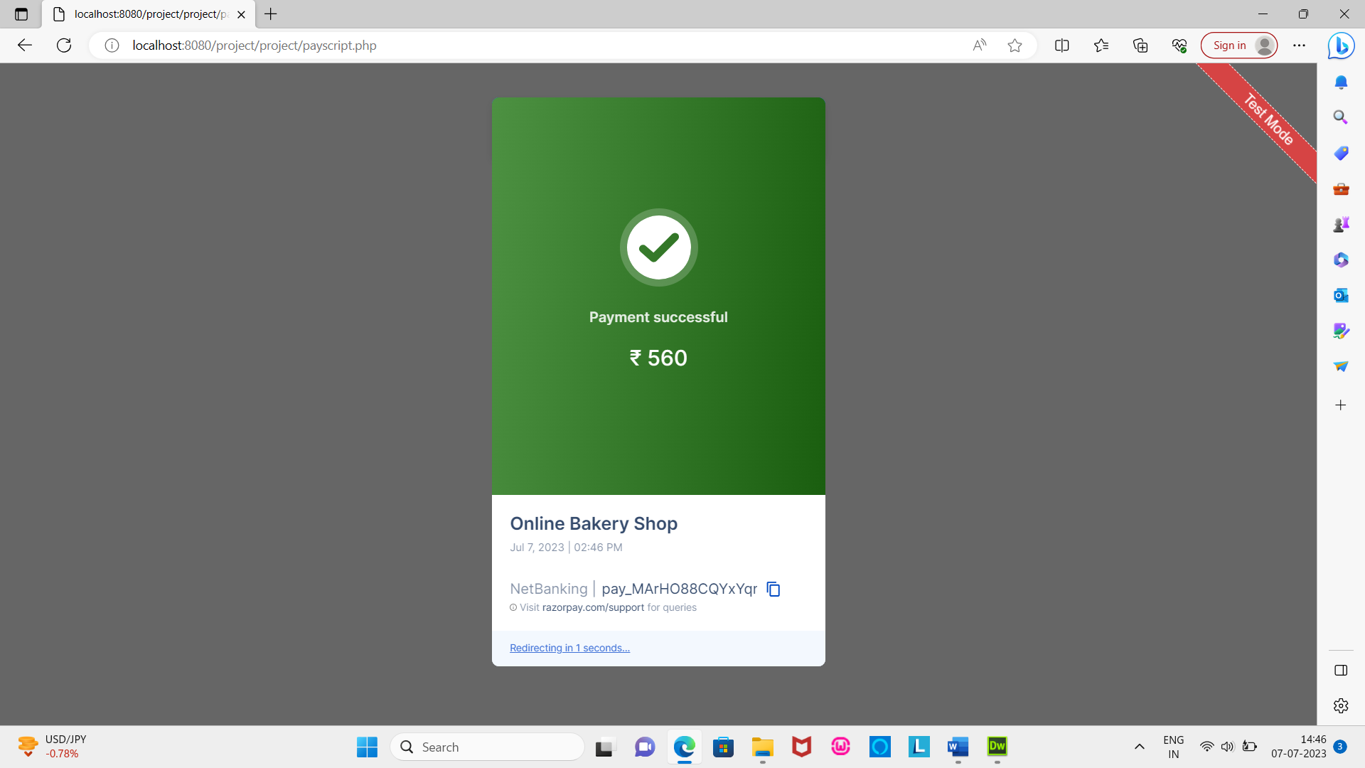

**Supplier View:**

Supplier login

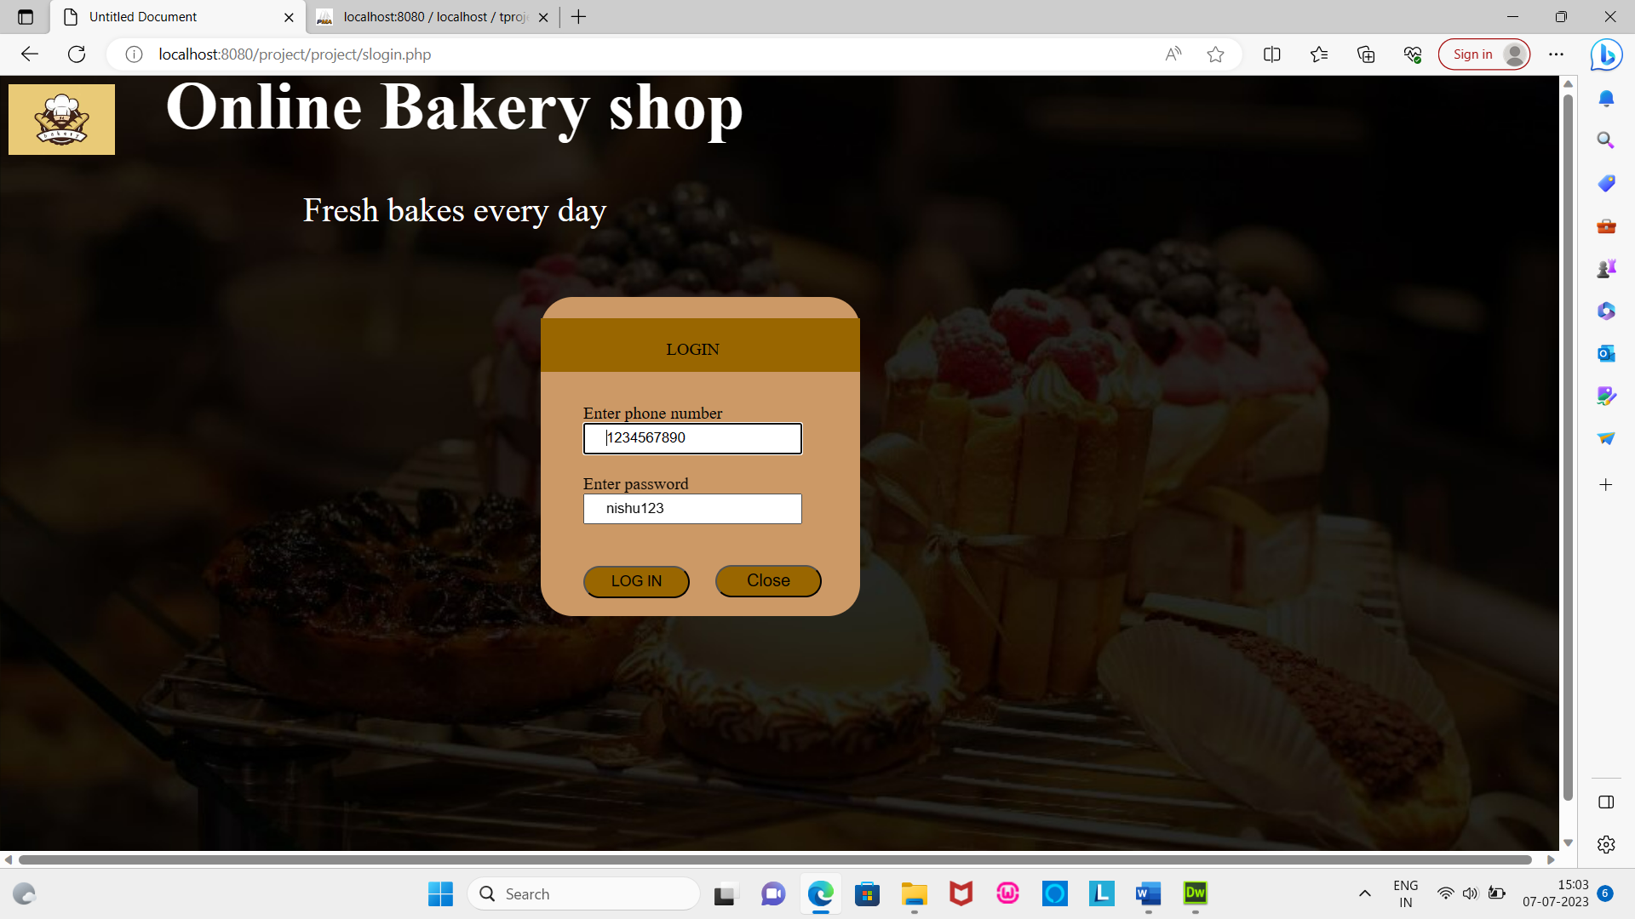

Supplier home

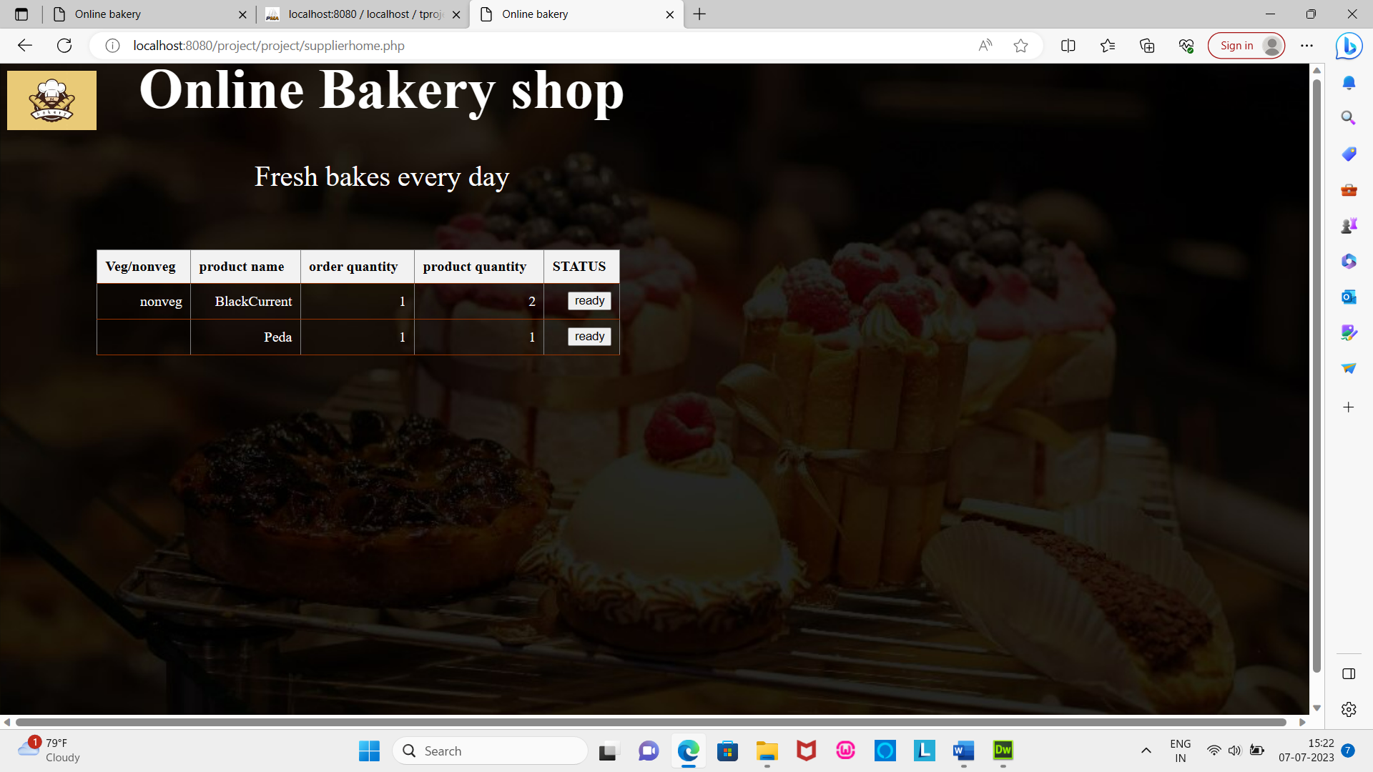

**7. Testing And Implementation**

Testing and implementation is the process, which tells the reality efficiency and the flexibility of the system design. Reliability means how much the user is expecting from the system. Flexibility tells how much the user is comfortable and hopes additional facilities with the system.

**Testing:**

Testing is vital to the success of the system. System testing makes a logical assumption that if all the part of the system is correct, the goal will be successively achieved. It is a critical element of software quality assurance and represents the ultimate review of specification design and coding. Testing presents interesting anomaly of the software. The testing phase involves testing of system using various test data. The first test of system to see whether it produces the correct output. When the software is tested the actual output is tested with the expected output. If there is a discrepancy the sequence of instruction must be traced to determine the problem. Breaking the program down into self-contained portions, each of which can be checked at certain key points facilities the process. The best program is worthless if it does not meet needs. The first step n system testing is to prepare a plan that will test all aspects of the system in a way that promotes its credibility among potential users. The design phase focuses on the detail implementation of the system recommended in the feasibility study. Emphasis is on translating performance specification into design specification. The design phase is a transition from a user-oriented document to document oriented to the programmers or database personnel. System design goes through two phases of development, logical and physical design. The logical design describes the input, output, database and procedures. Example: Dataflow Diagram. The physical design procures the working system by defining specification that tells the programmers exactly that what the candidates system must do. The development of software system involves a series of production activities where opportunities for injunction of human error are enormous. Error may occur at the very imperfectly specified as well as later design and development stages. Because of human inability to perform and perfection, software development is followed by a quantity assurance activity. Quantity assurance also places a vital role in the whole development of the system. The quantity assurance whole of the testing phase is the testing phase is to assure that completeness accuracy of the system and minimize the testing process. In the implementation phase, the goal is to provide a logical order of the testing the common view is to eliminate program errors. This is extremely difficult and time consuming since designer cannot prove 100% accuracy. Therefore all that can be one is to put system through a “fail test” cycle-determine what will make it fail. A successful, then is one that find errors.

**System Testing:**

Software testing is a critical element of software quantity assurance and represents the ultimate review of specifications, design and coding. The testing phase involves the testing of testing system using various test data. Preparation of test data plays a vital role in the system testing. After preparing the test data, the system under study is tested. Those test data, error where found and corrected by following testing steps and corrections were recorded for future reference. Thus a series testing is performed on the system before it is ready for implementation.

The various type of testing on system is:

* Unit testing
* Integrated testing
* Validation testing
* Output testing
* User acceptance testing

**Unit Testing:**

Unit testing focuses on verification efforts on the smallest unit of software design module. Using the unit test plans, prepared in the design phase of the system as guide important control paths are tested to uncover error within the boundary of the module. The interfaces of the each of the module under consideration are tested. Boundary condition was checked. All independent phases were exercised to ensure error handling path was tested. Each unit was thoroughly tested to check if it might fail in any possible situation. This testing was carried out during the programming itself. At the end of the testing phase, each unit was found to be working satisfactorily, as regarded to the expected output from the module.

**Integration Testing:**

Data can lost across an interface one module can have an adverse effect on another’s sub function, when combined may not produce the desired major function. Global data structure can present problems. Integration testing is a symmetric testing for constructing tests to unrecovered error associated with the interface .all modules are combined in these testing steps. Then the entire program was tested as a whole.

**Validation Testing:**

At the Culmination of the integration testing the software has completely assembled as a package interfacing error have been uncovered and corrected and a final series of software validation testing begins. Here we test the system n a manner that can be reasonably expected by the customer, the system is tested against the system requirement specification.

**Output Testing:**

After performing validation test the next phase is output test the system, since no system could be useful if it does not produce the desired output in the desired format. By considering the format of the report/output format is considered in two ways: one is the screen and the other is on the printed form.

**User-Acceptance Testing:**

User acceptance test of the system is factor for the success of the system. The system under Consideration was listed for the user acceptance by keeping constant touch with the perspective user of the system at the time of design, development and making changes.

**Testing plan:**

|  |  |
| --- | --- |
| **Test case** | **Test objectives** |
| 1 | Test for entering name. |
| 2 | Test for entering mobile number. |
| 3 | Test for user name for login. |
| 4 | Test for password for login. |
| 5 | Test for change password. |
| 6 | Test for removing product. |
| 7 | Test for valid date for product order. |

**Test case:1**

Objectives: Test for entering name.

Test data : Valid – Only letters and underscores are allowed.

Invalid - Characters other than letters and underscore.

Output: Valid – Allows record to be added to the database.

Invalid – Show the alert message.

Result: Valid – Record will be saved.

Invalid – Record will not be saved.

Conclusion: Both the valid and invalid results are tested. Output matches with the required results hence the test case is successful.

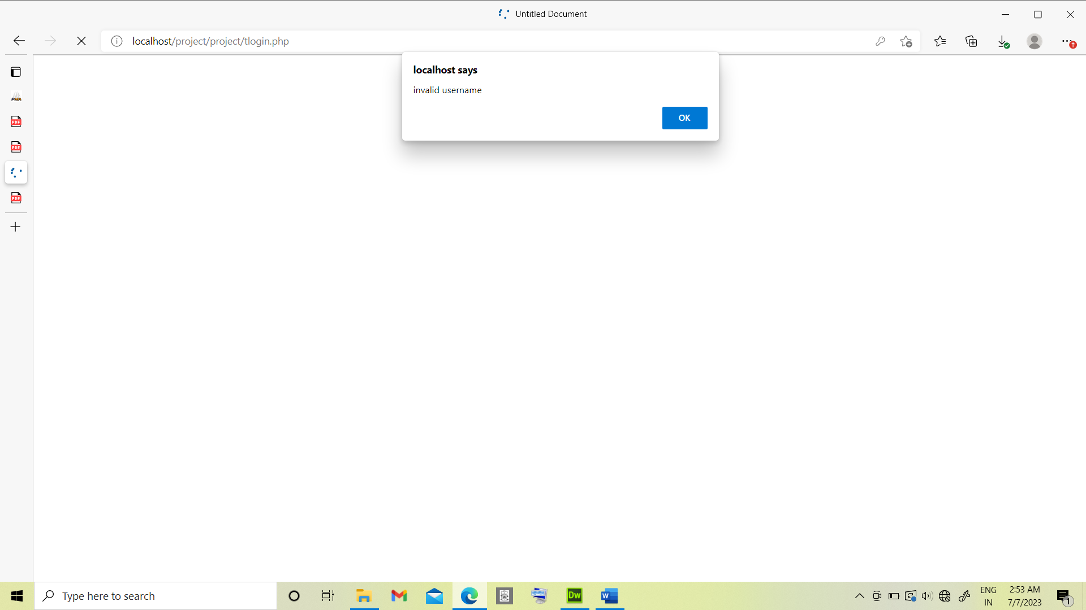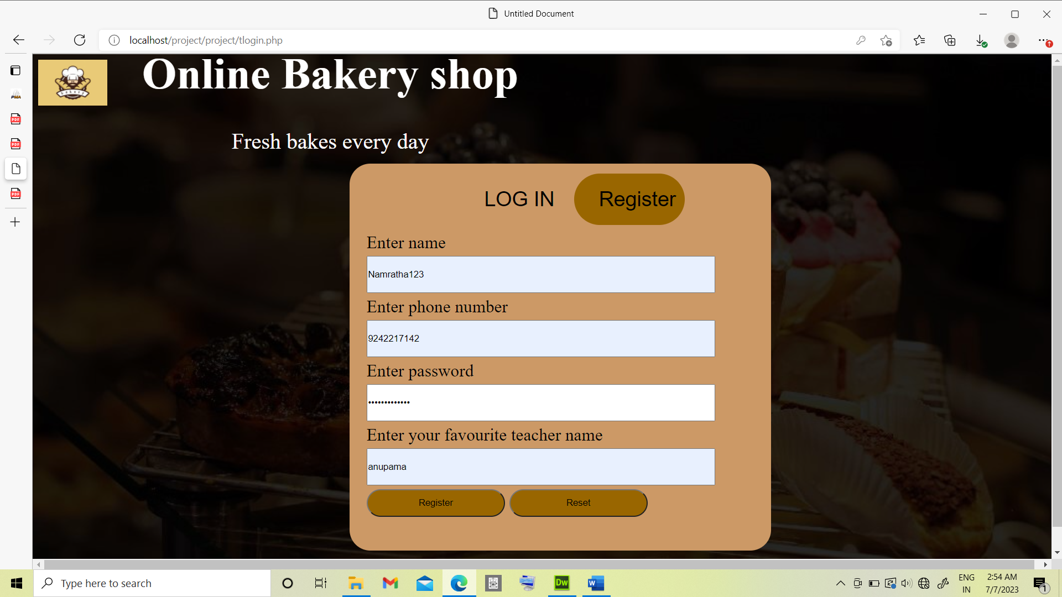

**Test case:2**

Objectives: Test for entering mobile number.

Test data : Valid – Only number are allowed and must contain only 10 digits.

Invalid – Non numeric characters and not contain 10 digits.

Output: Valid – Allows record to be added to the database.

Invalid – Show the alert message.

Result: Valid – Record will be saved.

Invalid – Record will not be saved.

Conclusion: Both the valid and invalid results are tested. Output matches with the required results hence the test case is successful.

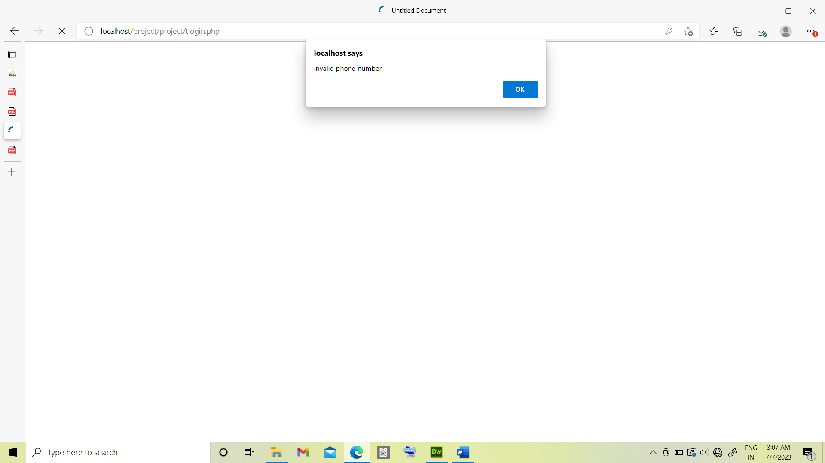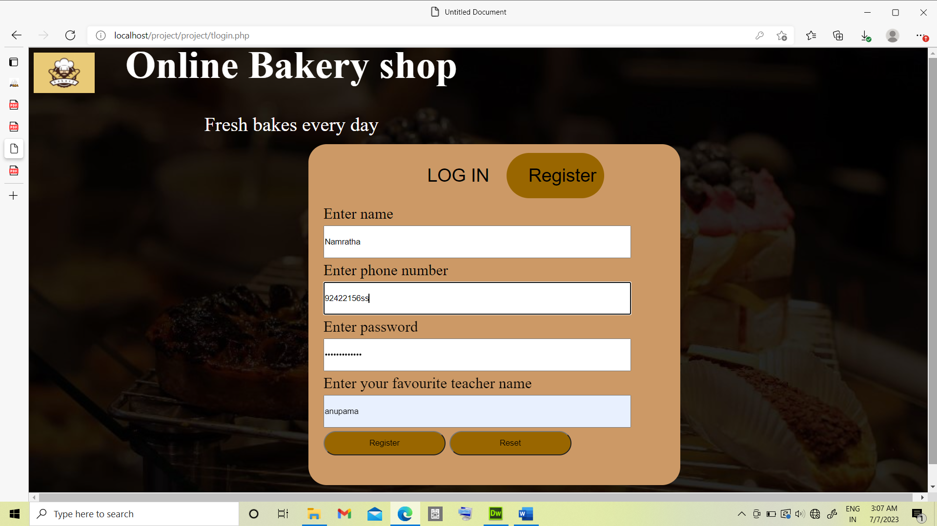

**Test case:3**

Objectives: Test for user name for login.

Test data : Valid – One of the valid user name to enter the next page.

Invalid – Use of invalid user name to enter to the next page.

Output: Valid –Enter into next page.

Invalid – Show the alert message.

Result: Valid – User allowed to enter to next page.

Invalid – User is prompted with an alert message.

Conclusion: Both the valid and invalid results are tested. Output matches with the required results hence the test case is successful.

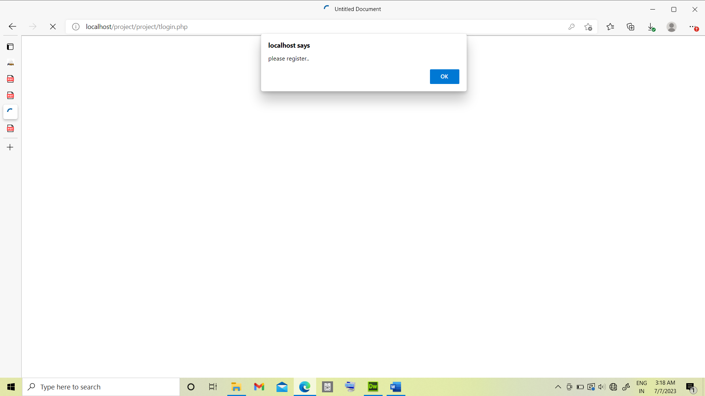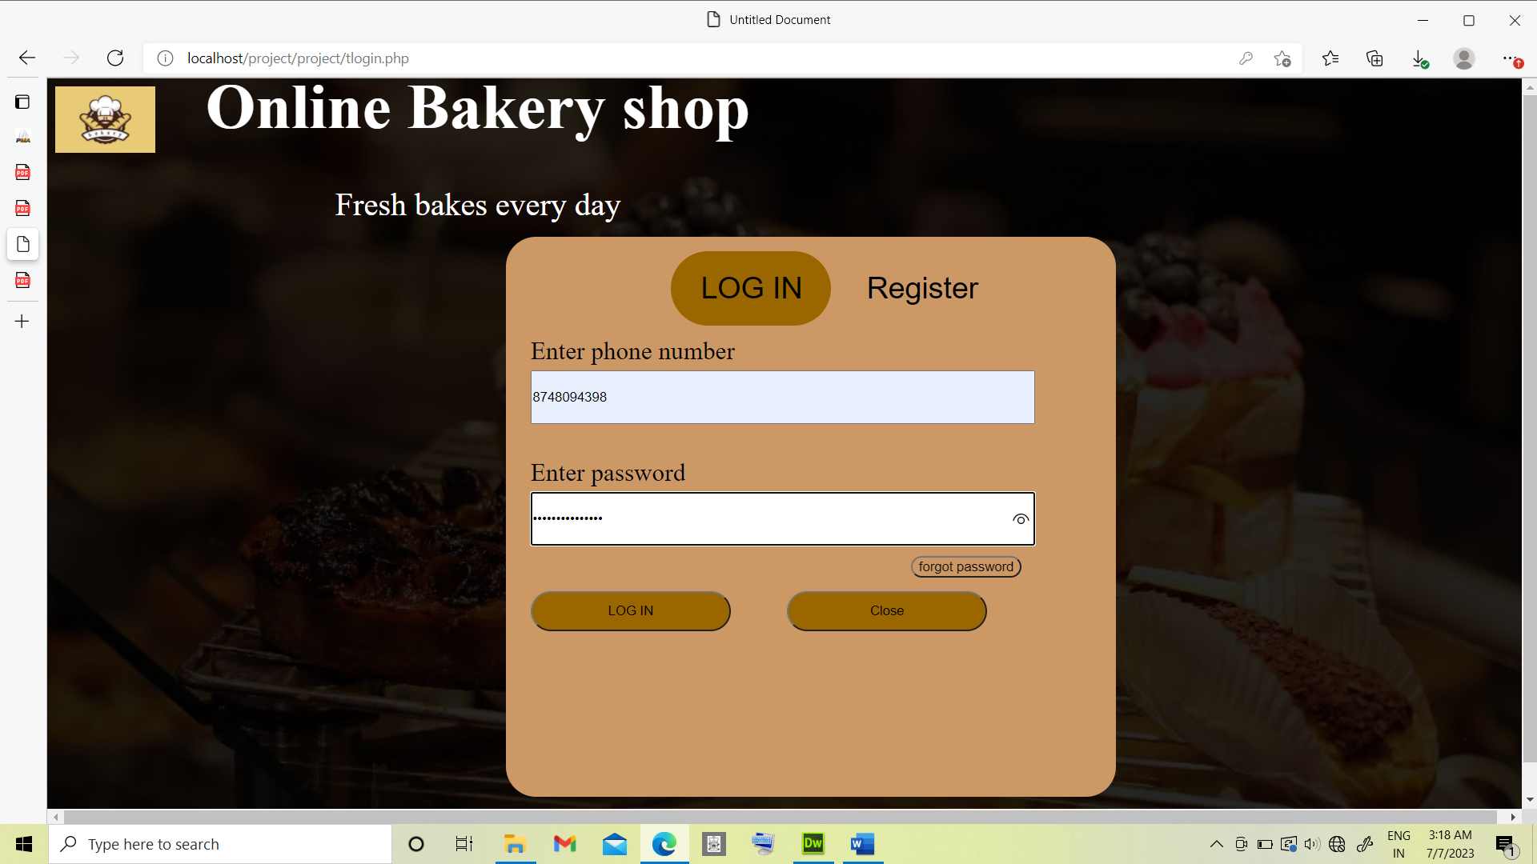

**Test case:4**

Objectives: Test for password for login.

Test data : Valid – One of the valid password to enter the next page.

Invalid – Use of invalid password to enter to the next page.

Output: Valid –Enter into next page.

Invalid – Show the alert message.

Result: Valid – User allowed to enter to next page.

Invalid – User is prompted with an alert message.

Conclusion: Both the valid and invalid results are tested. Output matches with the required results hence the test case is successful.

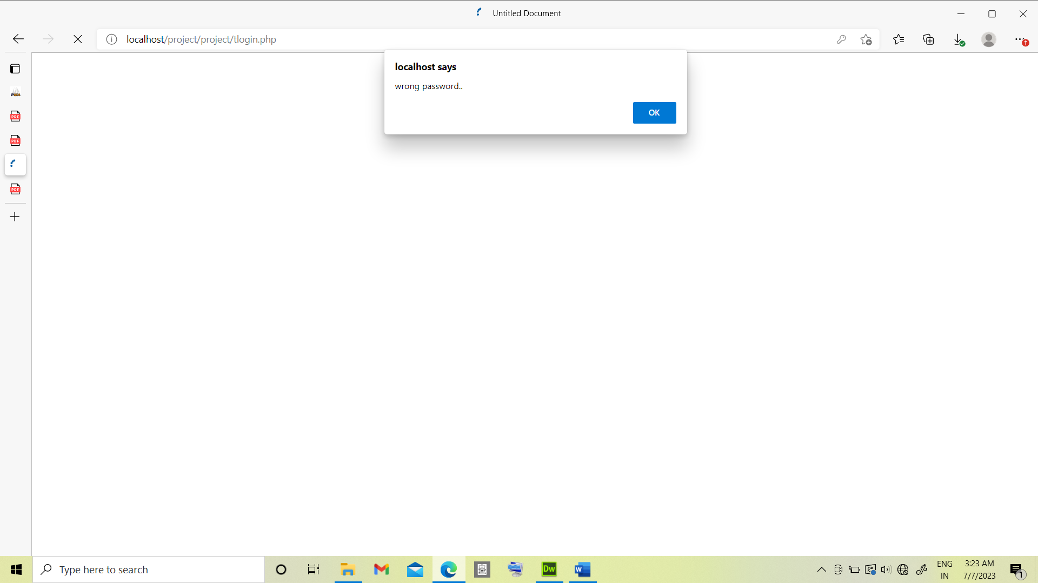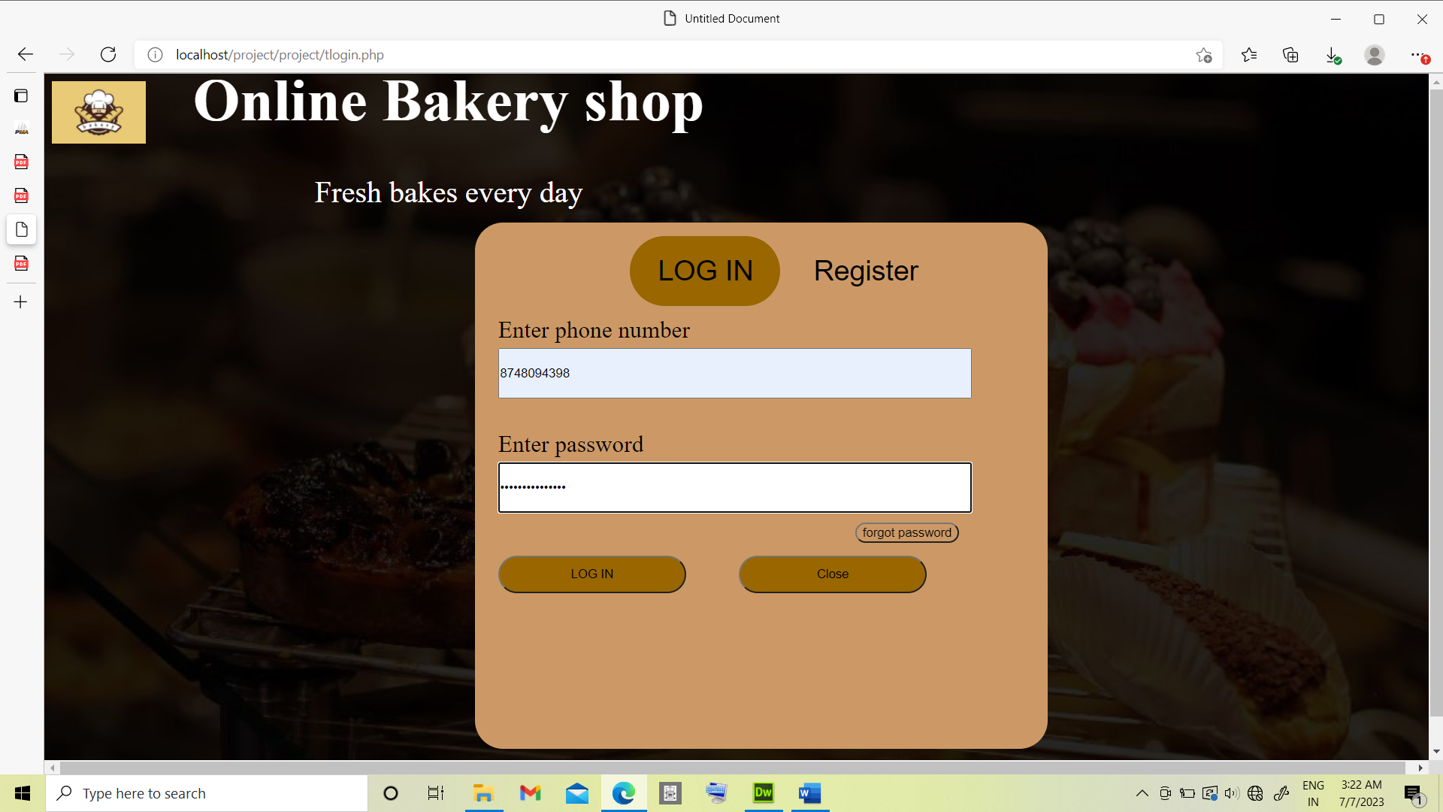

**Test case:5**

Objectives: Test for change password.

Test data : Valid – Valid answer for the security question to change the password.

Invalid – Invalid answer for the security question to change the password.

Output: Valid –Allows to change the password.

Invalid – Show the alert message.

Result: Valid – Password will be changed.

Invalid – Password is not updated.

Conclusion: Both the valid and invalid results are tested. Output matches with the required results hence the test case is successful.

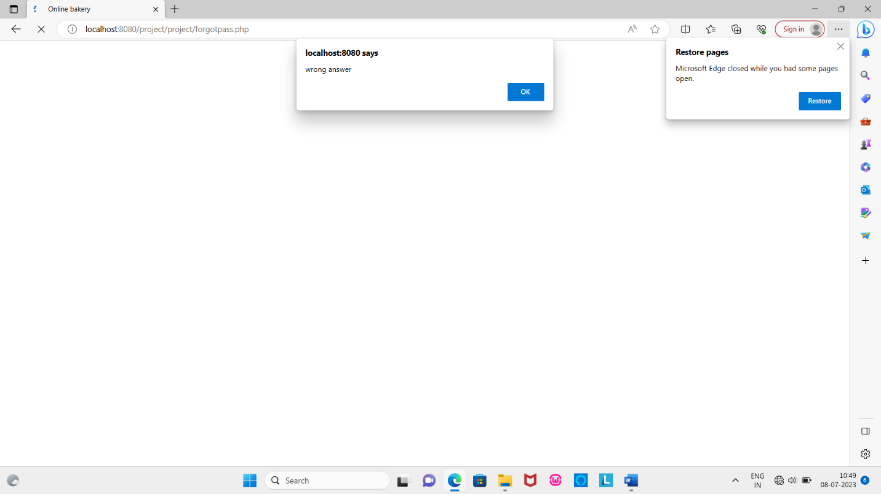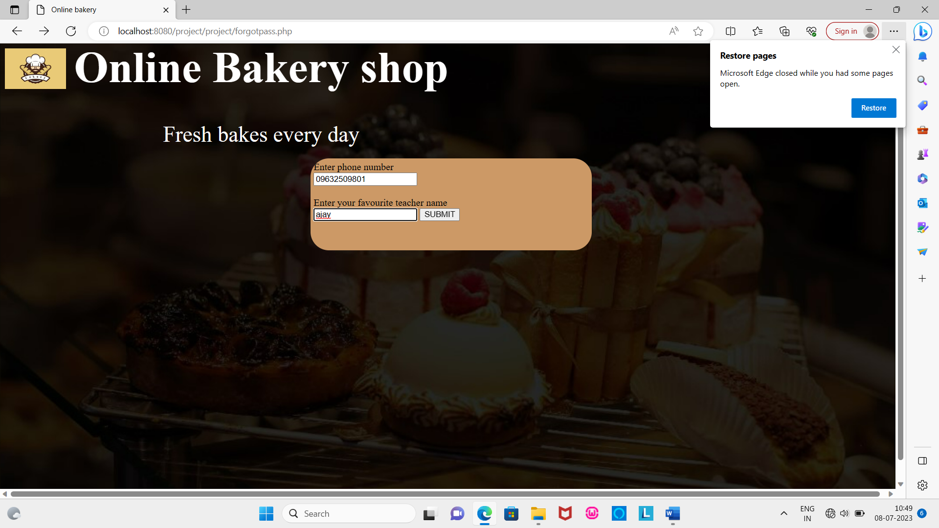

**Test case:6**

Objectives: Test for removing product.

Test data : Valid – Number of products to be removed is less than or equal to available products.

Invalid – Number of products to be removed is greatr than available products

Output: Valid –Allows to remove products.

Invalid – Show the alert message.

Result: Valid – Remove mentioned number of products.

Invalid – User is prompted with an alert message.

Conclusion: Both the valid and invalid results are tested. Output matches with the required results hence the test case is successful.

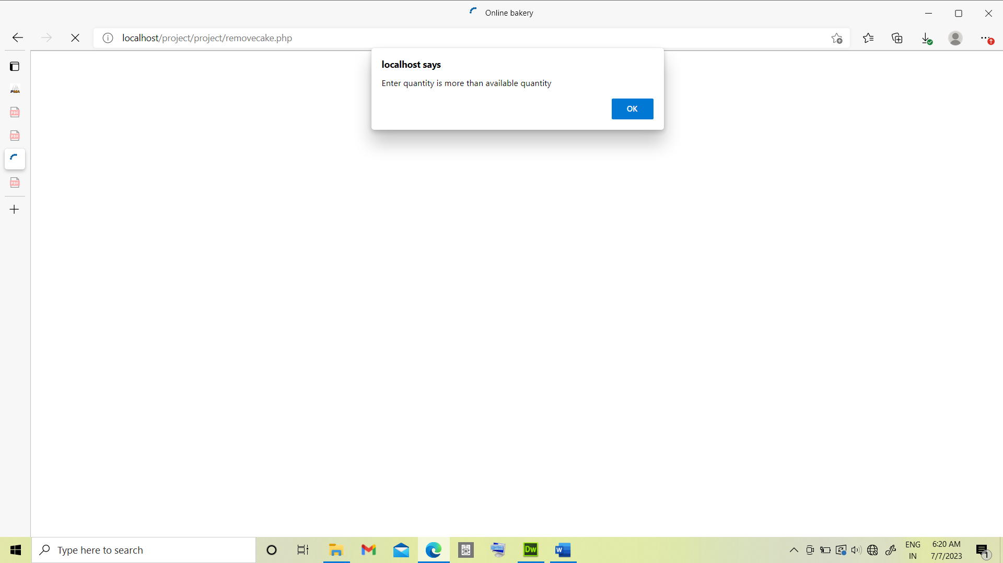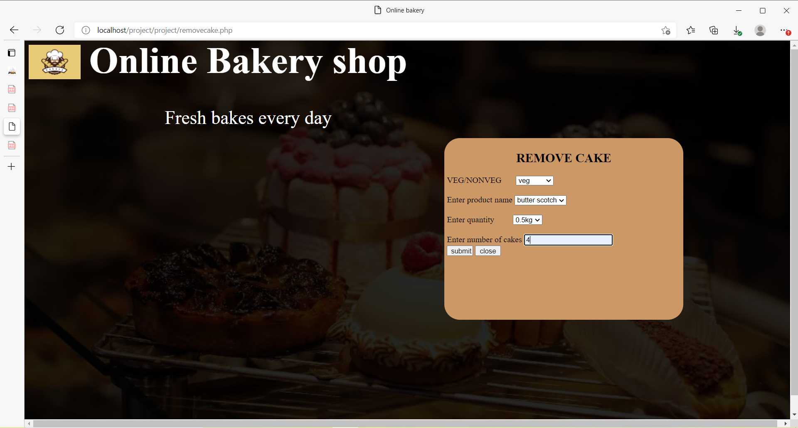

**Test case:7**

Objectives: Test for valid date for product order.

Test data : Valid – Entered date is on or after ordering date.

Invalid – Entered date is before ordering date.

Output: Valid –Allows to order for products.

Invalid – Show the alert message.

Result: Valid –Order is placed for product.

Invalid – User is prompted with an alert message and order process is cancelled.

Conclusion: Both the valid and invalid results are tested. Output matches with the required results hence the test case is successful.

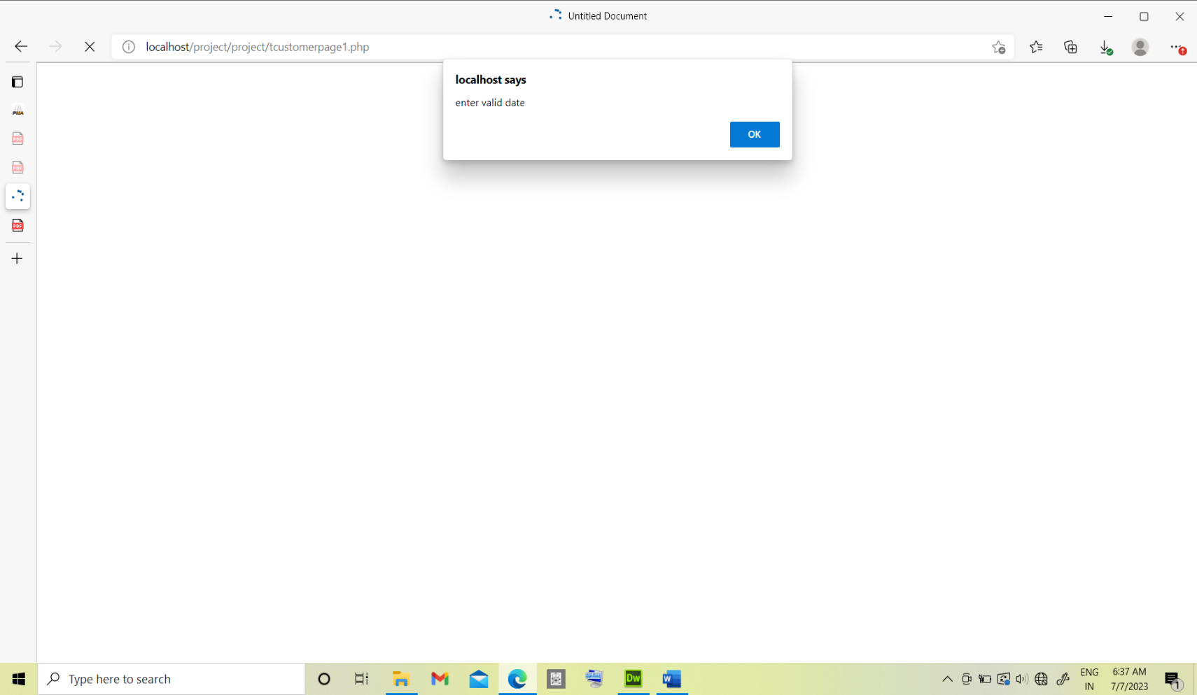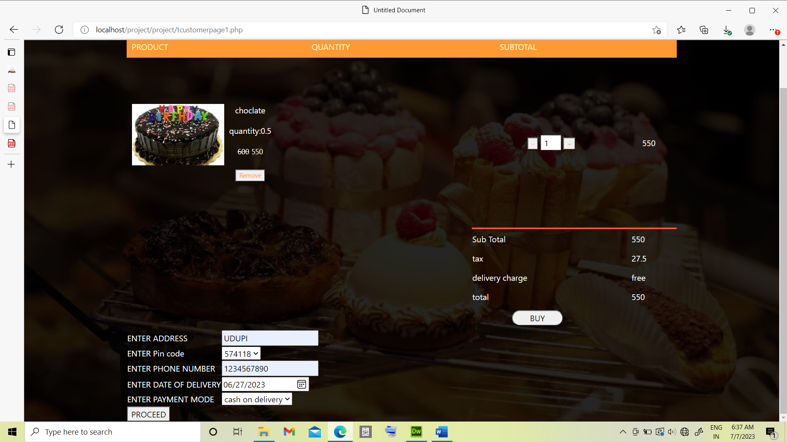

**Limitations of project:**

* On successful delivery of the product to the customer, actions are not undertaken.
* Providing customization facility to user.

**Future scope and further enhancement of the project:**

* Develop to work in mobile based operation system.
* Tracking of products purchased.
* Providing customization facility to user

**DEFINITIONS, ACRONYMS, ABBREVIATION**

* DFD: Data Flow Diagram
* CFD: Context Flow Diagram
* SQL: Structured Query Language
* ERD: Entity Relationship Diagram.
* CSS: Cascading Style Sheet.
* HTML: Hyper Text Markup Language.
* PHP: Hyper Text Preprocessor.

**BIBLIOGRAPHY:**

* An Integrated approach to Software Engineering: Pankaj Jalote.
* [www.google.com](http://www.google.com)
* [www.w3schools.com](http://www.w3schools.com)
* Chat.openai.com
* Youtube.com